You are given the heads of two sorted linked lists list1 and list2.

Merge the two lists into one **sorted** list. The list should be made by splicing together the nodes of the first two lists.

Return *the head of the merged linked list*.

**Example 1:**

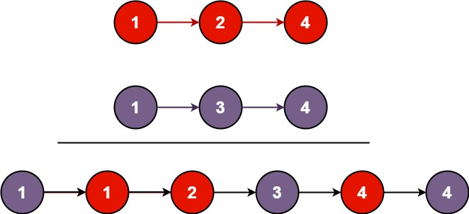

Input: list1 = [1,2,4], list2 = [1,3,4]  
Output: [1,1,2,3,4,4]

**Example 2:**

Input: list1 = [], list2 = []  
Output: []

**Example 3:**

Input: list1 = [], list2 = [0]  
Output: [0]

**Constraints:**

* The number of nodes in both lists is in the range [0, 50].
* -100 <= Node.val <= 100
* Both list1 and list2 are sorted in **non-decreasing** order.