You are given an m x n binary matrix grid where each cell is either 0 (empty) or 1 (occupied).

You are then given stamps of size stampHeight x stampWidth. We want to fit the stamps such that they follow the given **restrictions** and **requirements**:

1. Cover all the **empty** cells.
2. Do not cover any of the **occupied** cells.
3. We can put as **many** stamps as we want.
4. Stamps can **overlap** with each other.
5. Stamps are not allowed to be **rotated**.
6. Stamps must stay completely **inside** the grid.

Return true *if it is possible to fit the stamps while following the given restrictions and requirements. Otherwise, return* false.

**Example 1:**

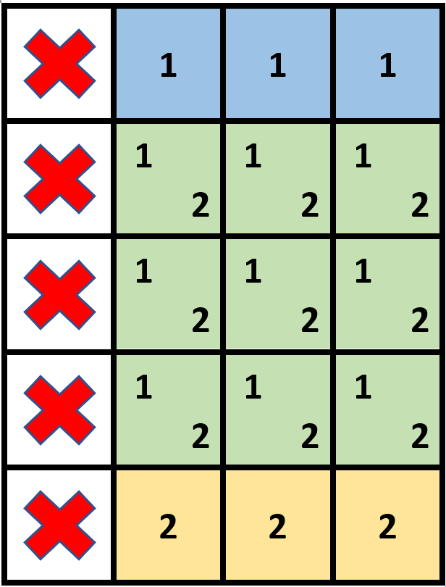

Input: grid = [[1,0,0,0],[1,0,0,0],[1,0,0,0],[1,0,0,0],[1,0,0,0]], stampHeight = 4, stampWidth = 3  
Output: true  
Explanation: We have two overlapping stamps (labeled 1 and 2 in the image) that are able to cover all the empty cells.

**Example 2:**

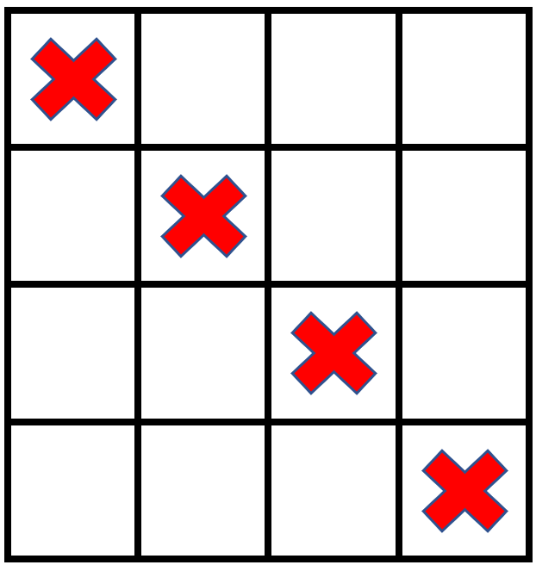

Input: grid = [[1,0,0,0],[0,1,0,0],[0,0,1,0],[0,0,0,1]], stampHeight = 2, stampWidth = 2   
Output: false   
Explanation: There is no way to fit the stamps onto all the empty cells without the stamps going outside the grid.

**Constraints:**

* m == grid.length
* n == grid[r].length
* 1 <= m, n <= 105
* 1 <= m * n <= 2 * 105
* grid[r][c] is either 0 or 1.
* 1 <= stampHeight, stampWidth <= 105