An n x n matrix is **valid** if every row and every column contains **all** the integers from 1 to n (**inclusive**).

Given an n x n integer matrix matrix, return true *if the matrix is* ***valid****.* Otherwise, return false.

**Example 1:**

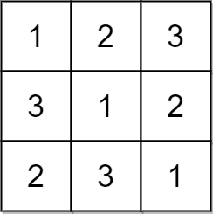

Input: matrix = [[1,2,3],[3,1,2],[2,3,1]]  
Output: true  
Explanation: In this case, n = 3, and every row and column contains the numbers 1, 2, and 3.  
Hence, we return true.

**Example 2:**

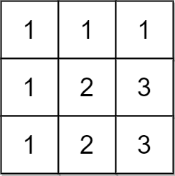

Input: matrix = [[1,1,1],[1,2,3],[1,2,3]]  
Output: false  
Explanation: In this case, n = 3, but the first row and the first column do not contain the numbers 2 or 3.  
Hence, we return false.

**Constraints:**

* n == matrix.length == matrix[i].length
* 1 <= n <= 100
* 1 <= matrix[i][j] <= n