Given the root of a binary tree, invert the tree, and return *its root*.

**Example 1:**

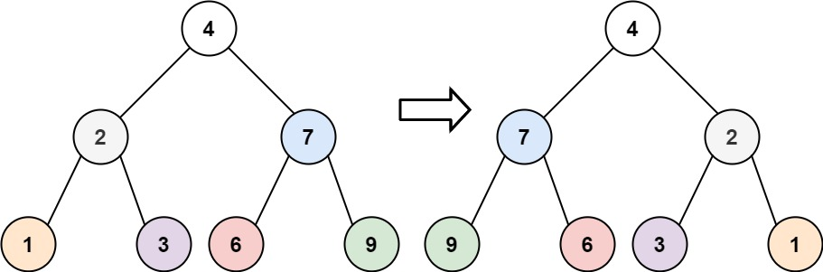

Input: root = [4,2,7,1,3,6,9]  
Output: [4,7,2,9,6,3,1]

**Example 2:**

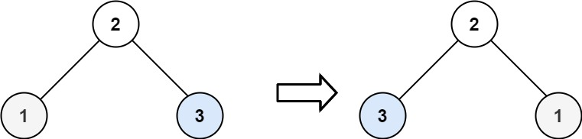

Input: root = [2,1,3]  
Output: [2,3,1]

**Example 3:**

Input: root = []  
Output: []

**Constraints:**

* The number of nodes in the tree is in the range [0, 100].
* -100 <= Node.val <= 100