Given the root of a binary tree, return *the number of nodes where the value of the node is equal to the* ***average*** *of the values in its* ***subtree***.

**Note:**

* The **average** of n elements is the **sum** of the n elements divided by n and **rounded down** to the nearest integer.
* A **subtree** of root is a tree consisting of root and all of its descendants.

**Example 1:**

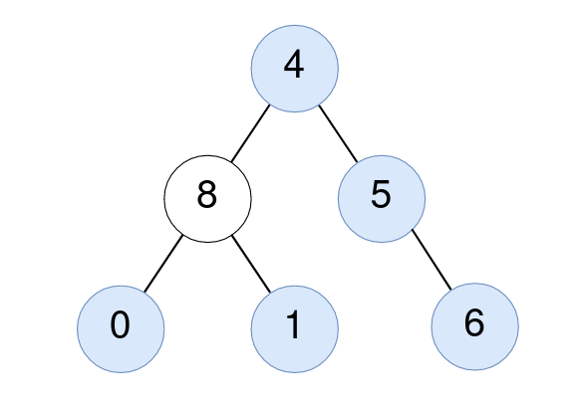

Input: root = [4,8,5,0,1,null,6]  
Output: 5  
Explanation:   
For the node with value 4: The average of its subtree is (4 + 8 + 5 + 0 + 1 + 6) / 6 = 24 / 6 = 4.  
For the node with value 5: The average of its subtree is (5 + 6) / 2 = 11 / 2 = 5.  
For the node with value 0: The average of its subtree is 0 / 1 = 0.  
For the node with value 1: The average of its subtree is 1 / 1 = 1.  
For the node with value 6: The average of its subtree is 6 / 1 = 6.

**Example 2:**



Input: root = [1]  
Output: 1  
Explanation: For the node with value 1: The average of its subtree is 1 / 1 = 1.

**Constraints:**

* The number of nodes in the tree is in the range [1, 1000].
* 0 <= Node.val <= 1000