Given the root of a binary search tree, and an integer k, return *the* kth *smallest value (****1-indexed****) of all the values of the nodes in the tree*.

**Example 1:**

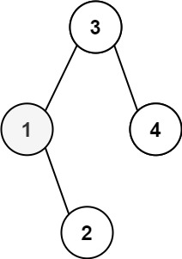

Input: root = [3,1,4,null,2], k = 1  
Output: 1

**Example 2:**

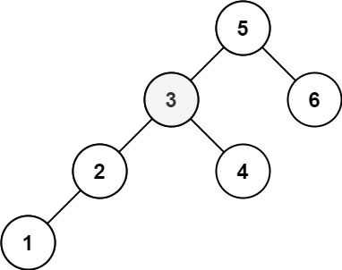

Input: root = [5,3,6,2,4,null,null,1], k = 3  
Output: 3

**Constraints:**

* The number of nodes in the tree is n.
* 1 <= k <= n <= 104
* 0 <= Node.val <= 104

**Follow up:** If the BST is modified often (i.e., we can do insert and delete operations) and you need to find the kth smallest frequently, how would you optimize?