You are given an integer n. There is an **undirected** graph with n nodes, numbered from 0 to n - 1. You are given a 2D integer array edges where edges[i] = [ai, bi] denotes that there exists an **undirected** edge connecting nodes ai and bi.

Return *the* ***number of pairs*** *of different nodes that are* ***unreachable*** *from each other*.

**Example 1:**

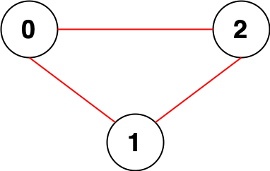

Input: n = 3, edges = [[0,1],[0,2],[1,2]]  
Output: 0  
Explanation: There are no pairs of nodes that are unreachable from each other. Therefore, we return 0.

**Example 2:**

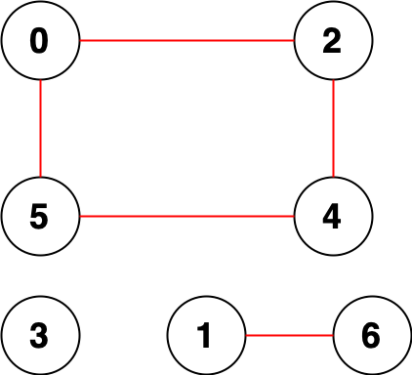

Input: n = 7, edges = [[0,2],[0,5],[2,4],[1,6],[5,4]]  
Output: 14  
Explanation: There are 14 pairs of nodes that are unreachable from each other:  
[[0,1],[0,3],[0,6],[1,2],[1,3],[1,4],[1,5],[2,3],[2,6],[3,4],[3,5],[3,6],[4,6],[5,6]].  
Therefore, we return 14.

**Constraints:**

* 1 <= n <= 105
* 0 <= edges.length <= 2 * 105
* edges[i].length == 2
* 0 <= ai, bi < n
* ai != bi
* There are no repeated edges.