You are given a **directed** graph of n nodes numbered from 0 to n - 1, where each node has **at most one** outgoing edge.

The graph is represented with a given **0-indexed** array edges of size n, indicating that there is a directed edge from node i to node edges[i]. If there is no outgoing edge from i, then edges[i] == -1.

You are also given two integers node1 and node2.

Return *the* ***index*** *of the node that can be reached from both* node1 *and* node2*, such that the* ***maximum*** *between the distance from* node1 *to that node, and from* node2 *to that node is* ***minimized***. If there are multiple answers, return the node with the **smallest** index, and if no possible answer exists, return -1.

Note that edges may contain cycles.

**Example 1:**

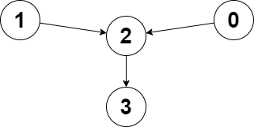

Input: edges = [2,2,3,-1], node1 = 0, node2 = 1  
Output: 2  
Explanation: The distance from node 0 to node 2 is 1, and the distance from node 1 to node 2 is 1.  
The maximum of those two distances is 1. It can be proven that we cannot get a node with a smaller maximum distance than 1, so we return node 2.

**Example 2:**

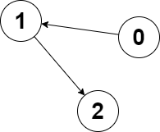

Input: edges = [1,2,-1], node1 = 0, node2 = 2  
Output: 2  
Explanation: The distance from node 0 to node 2 is 2, and the distance from node 2 to itself is 0.  
The maximum of those two distances is 2. It can be proven that we cannot get a node with a smaller maximum distance than 2, so we return node 2.

**Constraints:**

* n == edges.length
* 2 <= n <= 105
* -1 <= edges[i] < n
* edges[i] != i
* 0 <= node1, node2 < n