There is a tree (i.e. a connected, undirected graph with no cycles) consisting of n nodes numbered from 0 to n - 1 and exactly n - 1 edges.

You are given a **0-indexed** integer array vals of length n where vals[i] denotes the value of the ith node. You are also given a 2D integer array edges where edges[i] = [ai, bi] denotes that there exists an **undirected** edge connecting nodes ai and bi.

A **good path** is a simple path that satisfies the following conditions:

1. The starting node and the ending node have the **same** value.
2. All nodes between the starting node and the ending node have values **less than or equal to** the starting node (i.e. the starting node's value should be the maximum value along the path).

Return *the number of distinct good paths*.

Note that a path and its reverse are counted as the **same** path. For example, 0 -> 1 is considered to be the same as 1 -> 0. A single node is also considered as a valid path.

**Example 1:**

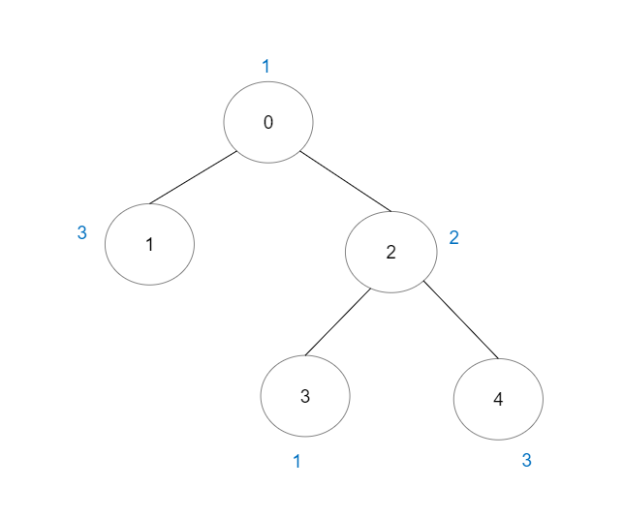

Input: vals = [1,3,2,1,3], edges = [[0,1],[0,2],[2,3],[2,4]]  
Output: 6  
Explanation: There are 5 good paths consisting of a single node.  
There is 1 additional good path: 1 -> 0 -> 2 -> 4.  
(The reverse path 4 -> 2 -> 0 -> 1 is treated as the same as 1 -> 0 -> 2 -> 4.)  
Note that 0 -> 2 -> 3 is not a good path because vals[2] > vals[0].

**Example 2:**

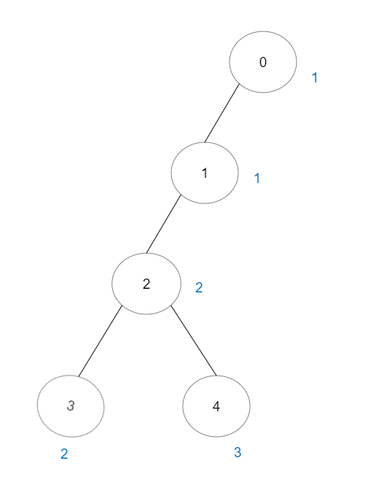

Input: vals = [1,1,2,2,3], edges = [[0,1],[1,2],[2,3],[2,4]]  
Output: 7  
Explanation: There are 5 good paths consisting of a single node.  
There are 2 additional good paths: 0 -> 1 and 2 -> 3.

**Example 3:**

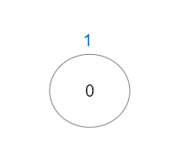

Input: vals = [1], edges = []  
Output: 1  
Explanation: The tree consists of only one node, so there is one good path.

**Constraints:**

* n == vals.length
* 1 <= n <= 3 * 104
* 0 <= vals[i] <= 105
* edges.length == n - 1
* edges[i].length == 2
* 0 <= ai, bi < n
* ai != bi
* edges represents a valid tree.