You are given the root of a **binary tree** with n nodes. Each node is assigned a unique value from 1 to n. You are also given an array queries of size m.

You have to perform m **independent** queries on the tree where in the ith query you do the following:

* **Remove** the subtree rooted at the node with the value queries[i] from the tree. It is **guaranteed** that queries[i] will **not** be equal to the value of the root.

Return *an array* answer *of size* m *where* answer[i] *is the height of the tree after performing the* ith *query*.

**Note**:

* The queries are independent, so the tree returns to its **initial** state after each query.
* The height of a tree is the **number of edges in the longest simple path** from the root to some node in the tree.

**Example 1:**

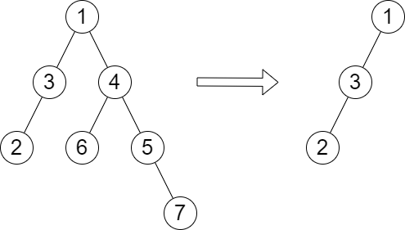

Input: root = [1,3,4,2,null,6,5,null,null,null,null,null,7], queries = [4]  
Output: [2]  
Explanation: The diagram above shows the tree after removing the subtree rooted at node with value 4.  
The height of the tree is 2 (The path 1 -> 3 -> 2).

**Example 2:**

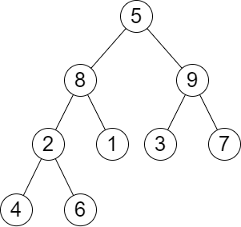

Input: root = [5,8,9,2,1,3,7,4,6], queries = [3,2,4,8]  
Output: [3,2,3,2]  
Explanation: We have the following queries:  
- Removing the subtree rooted at node with value 3. The height of the tree becomes 3 (The path 5 -> 8 -> 2 -> 4).  
- Removing the subtree rooted at node with value 2. The height of the tree becomes 2 (The path 5 -> 8 -> 1).  
- Removing the subtree rooted at node with value 4. The height of the tree becomes 3 (The path 5 -> 8 -> 2 -> 6).  
- Removing the subtree rooted at node with value 8. The height of the tree becomes 2 (The path 5 -> 9 -> 3).

**Constraints:**

* The number of nodes in the tree is n.
* 2 <= n <= 105
* 1 <= Node.val <= n
* All the values in the tree are **unique**.
* m == queries.length
* 1 <= m <= min(n, 104)
* 1 <= queries[i] <= n
* queries[i] != root.val