You are given a positive integer n representing n cities numbered from 1 to n. You are also given a **2D** array roads, where roads[i] = [ai, bi, costi] indicates that there is a **bidirectional** road between cities ai and bi with a cost of traveling equal to costi.

You can buy apples in **any** city you want, but some cities have different costs to buy apples. You are given the array appleCost where appleCost[i] is the cost of buying one apple from city i.

You start at some city, traverse through various roads, and eventually buy **exactly** one apple from **any** city. After you buy that apple, you have to return back to the city you **started** at, but now the cost of all the roads will be **multiplied** by a given factor k.

Given the integer k, return *an array* answer *of size* n *where* answer[i] *is the* ***minimum*** *total cost to buy an apple if you start at city* i.

**Example 1:**

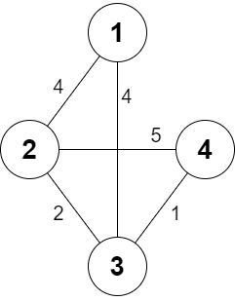

Input: n = 4, roads = [[1,2,4],[2,3,2],[2,4,5],[3,4,1],[1,3,4]], appleCost = [56,42,102,301], k = 2  
Output: [54,42,48,51]  
Explanation: The minimum cost for each starting city is the following:  
- Starting at city 1: You take the path 1 -> 2, buy an apple at city 2, and finally take the path 2 -> 1. The total cost is 4 + 42 + 4 * 2 = 54.  
- Starting at city 2: You directly buy an apple at city 2. The total cost is 42.  
- Starting at city 3: You take the path 3 -> 2, buy an apple at city 2, and finally take the path 2 -> 3. The total cost is 2 + 42 + 2 * 2 = 48.  
- Starting at city 4: You take the path 4 -> 3 -> 2 then you buy at city 2, and finally take the path 2 -> 3 -> 4. The total cost is 1 + 2 + 42 + 1 * 2 + 2 * 2 = 51.

**Example 2:**

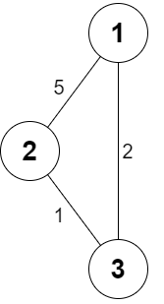

Input: n = 3, roads = [[1,2,5],[2,3,1],[3,1,2]], appleCost = [2,3,1], k = 3  
Output: [2,3,1]  
Explanation: It is always optimal to buy the apple in the starting city.

**Constraints:**

* 2 <= n <= 1000
* 1 <= roads.length <= 1000
* 1 <= ai, bi <= n
* ai != bi
* 1 <= costi <= 105
* appleCost.length == n
* 1 <= appleCost[i] <= 105
* 1 <= k <= 100
* There are no repeated edges.