Given the head of a linked list, reverse the nodes of the list k at a time, and return *the modified list*.

k is a positive integer and is less than or equal to the length of the linked list. If the number of nodes is not a multiple of k then left-out nodes, in the end, should remain as it is.

You may not alter the values in the list's nodes, only nodes themselves may be changed.

**Example 1:**

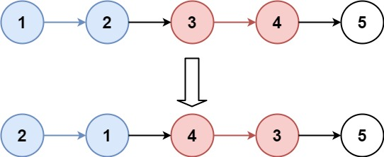

Input: head = [1,2,3,4,5], k = 2  
Output: [2,1,4,3,5]

**Example 2:**

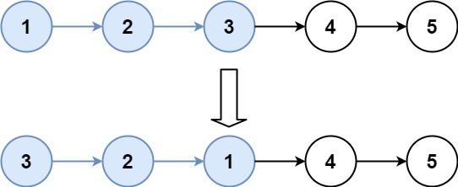

Input: head = [1,2,3,4,5], k = 3  
Output: [3,2,1,4,5]

**Constraints:**

* The number of nodes in the list is n.
* 1 <= k <= n <= 5000
* 0 <= Node.val <= 1000

**Follow-up:** Can you solve the problem in O(1) extra memory space?