Given the root of a binary search tree and a target value, return *the value in the BST that is closest to the* target. If there are multiple answers, print the smallest.

**Example 1:**

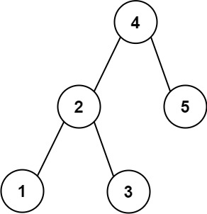

Input: root = [4,2,5,1,3], target = 3.714286  
Output: 4

**Example 2:**

Input: root = [1], target = 4.428571  
Output: 1

**Constraints:**

* The number of nodes in the tree is in the range [1, 104].
* 0 <= Node.val <= 109
* -109 <= target <= 109