There is a line chart consisting of n points connected by line segments. You are given a **1-indexed** integer array y. The kth point has coordinates (k, y[k]). There are no horizontal lines; that is, no two consecutive points have the same y-coordinate.

We can draw an infinitely long horizontal line. Return *the* ***maximum*** *number of points of intersection of the line with the chart*.

**Example 1:**

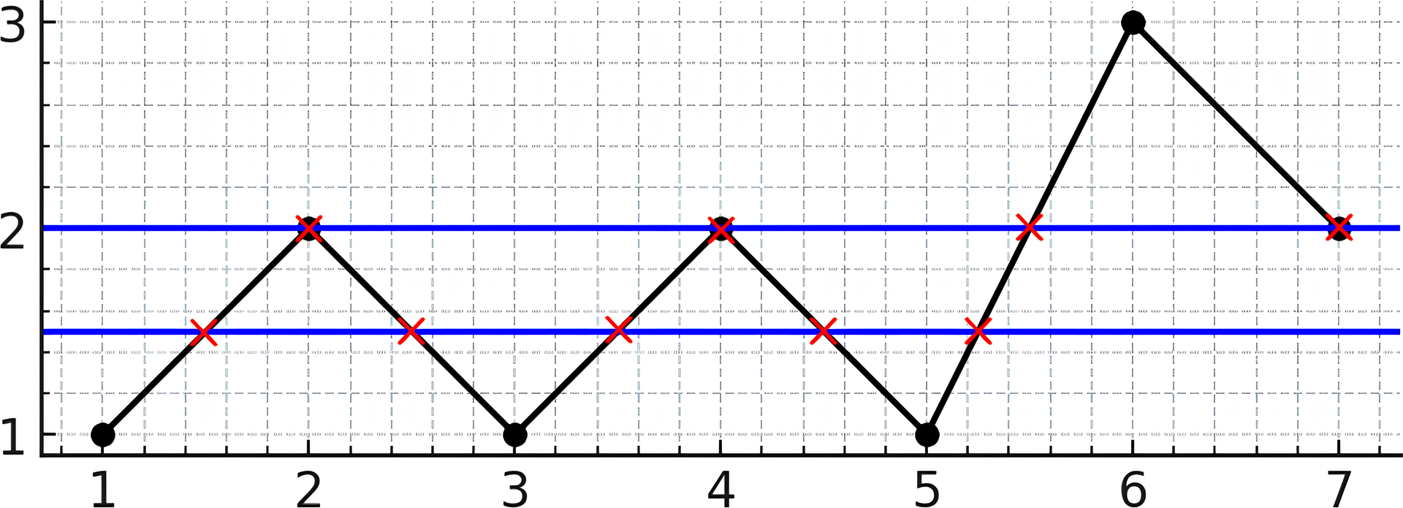

Input: y = [1,2,1,2,1,3,2]  
Output: 5  
Explanation: As you can see in the image above, the line y = 1.5 has 5 intersections with the chart (in red crosses). You can also see the line y = 2 which intersects the chart in 4 points (in red crosses). It can be shown that there is no horizontal line intersecting the chart at more than 5 points. So the answer would be 5.

**Example 2:**

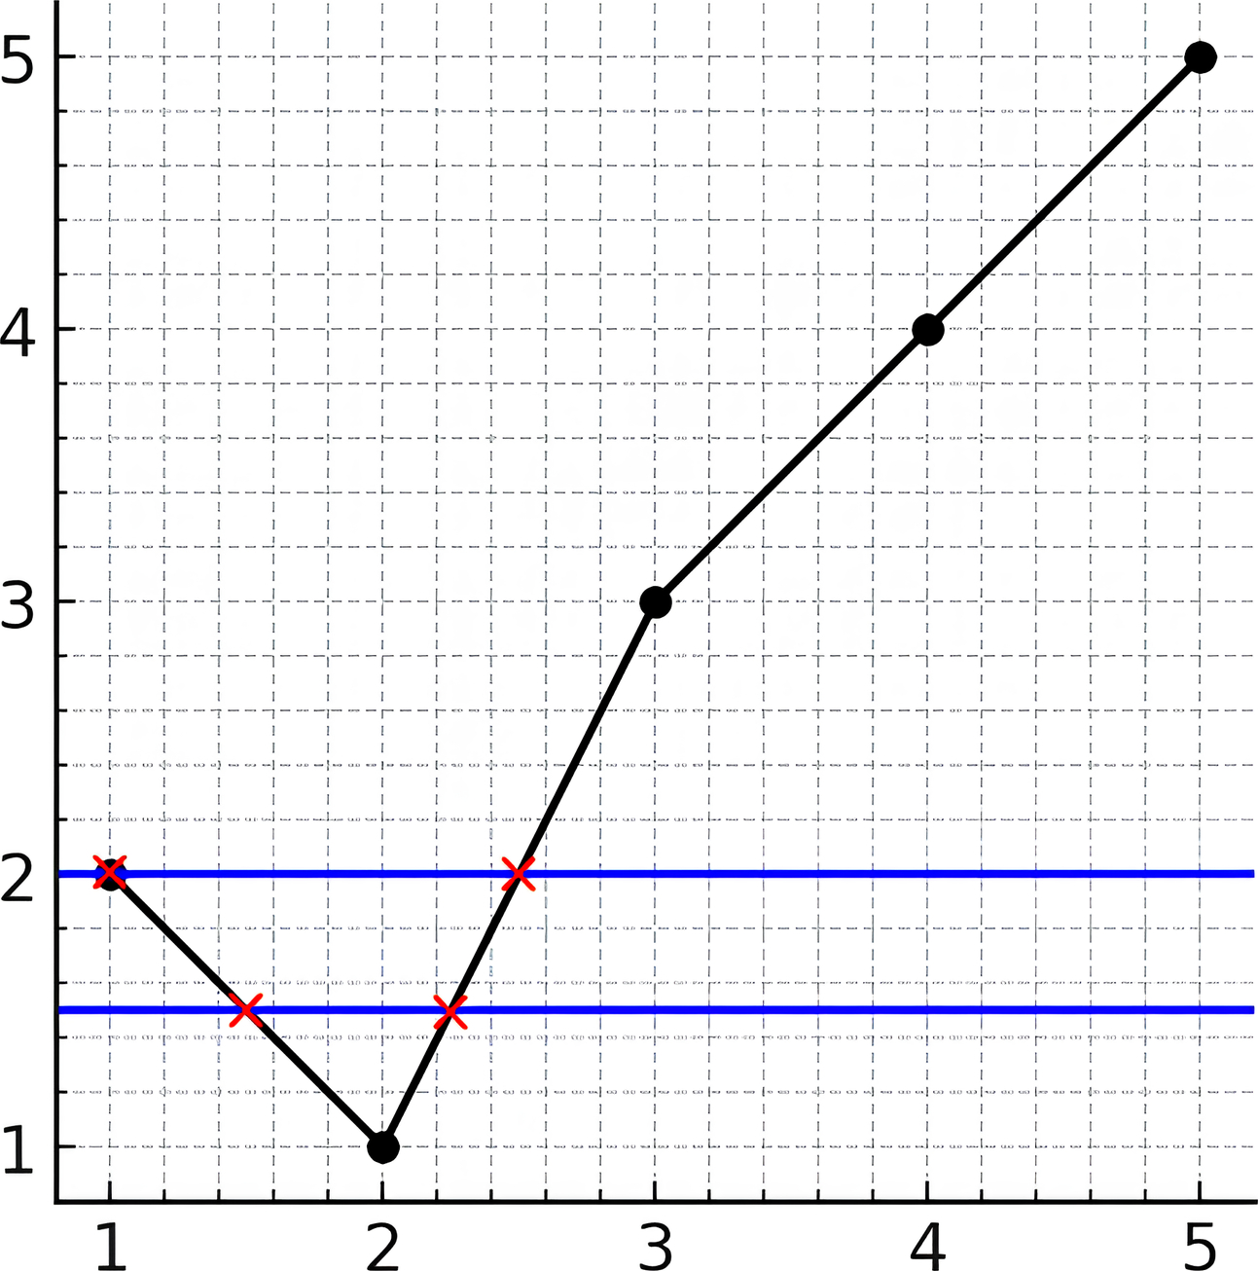

Input: y = [2,1,3,4,5]  
Output: 2  
Explanation: As you can see in the image above, the line y = 1.5 has 2 intersections with the chart (in red crosses). You can also see the line y = 2 which intersects the chart in 2 points (in red crosses). It can be shown that there is no horizontal line intersecting the chart at more than 2 points. So the answer would be 2.

**Constraints:**

* 2 <= y.length <= 105
* 1 <= y[i] <= 109
* y[i] != y[i + 1] for i in range [1, n - 1]