Given the root of a binary tree, return ***the vertical order traversal*** *of its nodes' values*. (i.e., from top to bottom, column by column).

If two nodes are in the same row and column, the order should be from **left to right**.

**Example 1:**

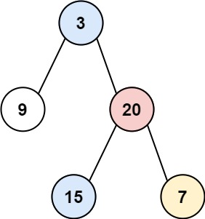

Input: root = [3,9,20,null,null,15,7]  
Output: [[9],[3,15],[20],[7]]

**Example 2:**

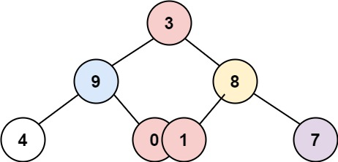

Input: root = [3,9,8,4,0,1,7]  
Output: [[4],[9],[3,0,1],[8],[7]]

**Example 3:**

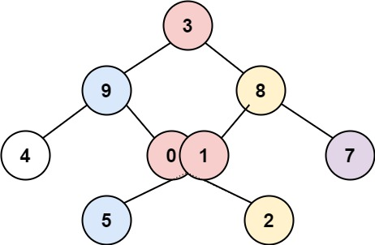

Input: root = [3,9,8,4,0,1,7,null,null,null,2,5]  
Output: [[4],[9,5],[3,0,1],[8,2],[7]]

**Constraints:**

* The number of nodes in the tree is in the range [0, 100].
* -100 <= Node.val <= 100