You have a graph of n nodes. You are given an integer n and an array edges where edges[i] = [ai, bi] indicates that there is an edge between ai and bi in the graph.

Return *the number of connected components in the graph*.

**Example 1:**

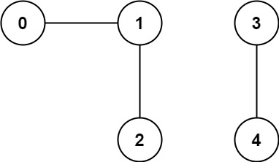

Input: n = 5, edges = [[0,1],[1,2],[3,4]]  
Output: 2

**Example 2:**

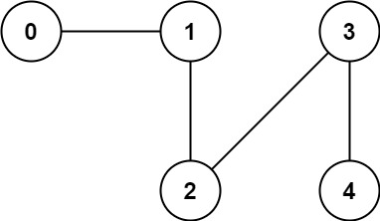

Input: n = 5, edges = [[0,1],[1,2],[2,3],[3,4]]  
Output: 1

**Constraints:**

* 1 <= n <= 2000
* 1 <= edges.length <= 5000
* edges[i].length == 2
* 0 <= ai <= bi < n
* ai != bi
* There are no repeated edges.