Given the root of a binary tree, collect a tree's nodes as if you were doing this:

* Collect all the leaf nodes.
* Remove all the leaf nodes.
* Repeat until the tree is empty.

**Example 1:**

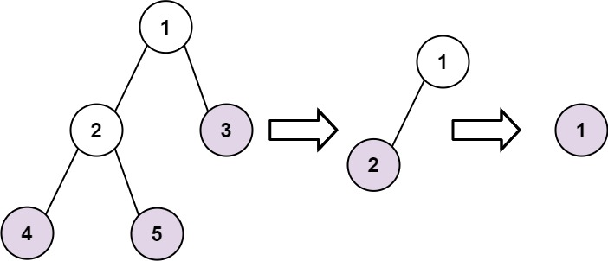

Input: root = [1,2,3,4,5]  
Output: [[4,5,3],[2],[1]]  
Explanation:  
[[3,5,4],[2],[1]] and [[3,4,5],[2],[1]] are also considered correct answers since per each level it does not matter the order on which elements are returned.

**Example 2:**

Input: root = [1]  
Output: [[1]]

**Constraints:**

* The number of nodes in the tree is in the range [1, 100].
* -100 <= Node.val <= 100