There is an m x n rectangular island that borders both the **Pacific Ocean** and **Atlantic Ocean**. The **Pacific Ocean** touches the island's left and top edges, and the **Atlantic Ocean** touches the island's right and bottom edges.

The island is partitioned into a grid of square cells. You are given an m x n integer matrix heights where heights[r][c] represents the **height above sea level** of the cell at coordinate (r, c).

The island receives a lot of rain, and the rain water can flow to neighboring cells directly north, south, east, and west if the neighboring cell's height is **less than or equal to** the current cell's height. Water can flow from any cell adjacent to an ocean into the ocean.

Return *a* ***2D list*** *of grid coordinates* result *where* result[i] = [ri, ci] *denotes that rain water can flow from cell* (ri, ci) *to* ***both*** *the Pacific and Atlantic oceans*.

**Example 1:**

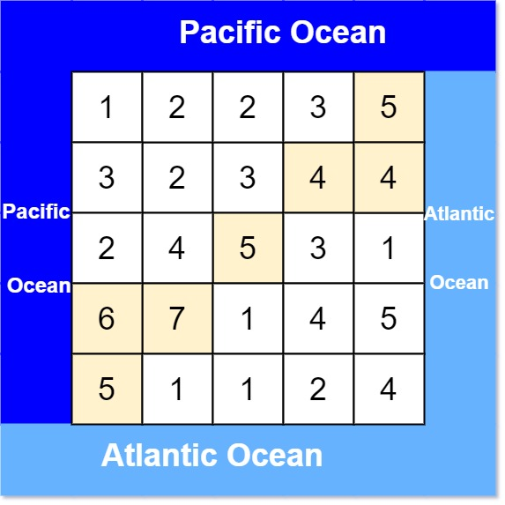

Input: heights = [[1,2,2,3,5],[3,2,3,4,4],[2,4,5,3,1],[6,7,1,4,5],[5,1,1,2,4]]  
Output: [[0,4],[1,3],[1,4],[2,2],[3,0],[3,1],[4,0]]  
Explanation: The following cells can flow to the Pacific and Atlantic oceans, as shown below:  
[0,4]: [0,4] -> Pacific Ocean   
  [0,4] -> Atlantic Ocean  
[1,3]: [1,3] -> [0,3] -> Pacific Ocean   
  [1,3] -> [1,4] -> Atlantic Ocean  
[1,4]: [1,4] -> [1,3] -> [0,3] -> Pacific Ocean   
  [1,4] -> Atlantic Ocean  
[2,2]: [2,2] -> [1,2] -> [0,2] -> Pacific Ocean   
  [2,2] -> [2,3] -> [2,4] -> Atlantic Ocean  
[3,0]: [3,0] -> Pacific Ocean   
  [3,0] -> [4,0] -> Atlantic Ocean  
[3,1]: [3,1] -> [3,0] -> Pacific Ocean   
  [3,1] -> [4,1] -> Atlantic Ocean  
[4,0]: [4,0] -> Pacific Ocean   
 [4,0] -> Atlantic Ocean  
Note that there are other possible paths for these cells to flow to the Pacific and Atlantic oceans.

**Example 2:**

Input: heights = [[1]]  
Output: [[0,0]]  
Explanation: The water can flow from the only cell to the Pacific and Atlantic oceans.

**Constraints:**

* m == heights.length
* n == heights[r].length
* 1 <= m, n <= 200
* 0 <= heights[r][c] <= 105