Given an m x n matrix board where each cell is a battleship 'X' or empty '.', return *the number of the* ***battleships*** *on* board.

**Battleships** can only be placed horizontally or vertically on board. In other words, they can only be made of the shape 1 x k (1 row, k columns) or k x 1 (k rows, 1 column), where k can be of any size. At least one horizontal or vertical cell separates between two battleships (i.e., there are no adjacent battleships).

**Example 1:**

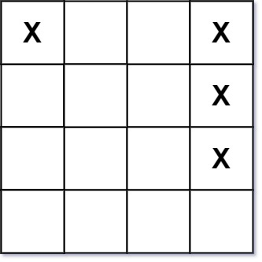

Input: board = [["X",".",".","X"],[".",".",".","X"],[".",".",".","X"]]  
Output: 2

**Example 2:**

Input: board = [["."]]  
Output: 0

**Constraints:**

* m == board.length
* n == board[i].length
* 1 <= m, n <= 200
* board[i][j] is either '.' or 'X'.

**Follow up:** Could you do it in one-pass, using only O(1) extra memory and without modifying the values board?