You have n coins and you want to build a staircase with these coins. The staircase consists of k rows where the ith row has exactly i coins. The last row of the staircase **may be** incomplete.

Given the integer n, return *the number of* ***complete rows*** *of the staircase you will build*.

**Example 1:**

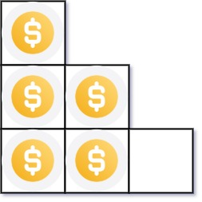

Input: n = 5  
Output: 2  
Explanation: Because the 3rd row is incomplete, we return 2.

**Example 2:**

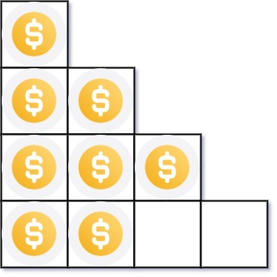

Input: n = 8  
Output: 3  
Explanation: Because the 4th row is incomplete, we return 3.

**Constraints:**

* 1 <= n <= 231 - 1