Given a root node reference of a BST and a key, delete the node with the given key in the BST. Return *the* ***root node reference*** *(possibly updated) of the BST*.

Basically, the deletion can be divided into two stages:

1. Search for a node to remove.
2. If the node is found, delete the node.

**Example 1:**

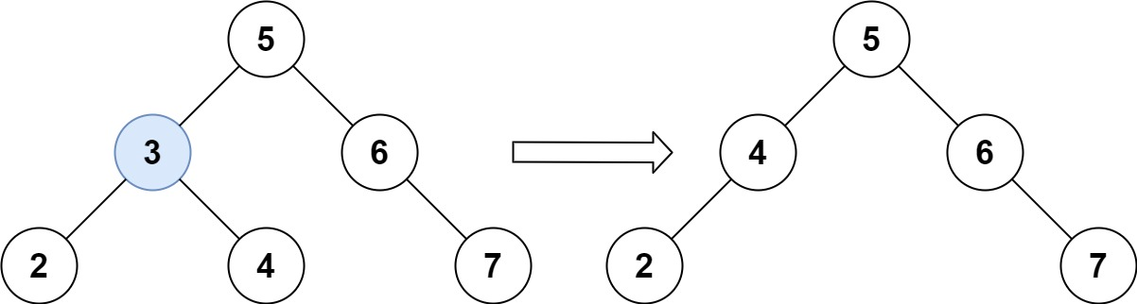

Input: root = [5,3,6,2,4,null,7], key = 3  
Output: [5,4,6,2,null,null,7]  
Explanation: Given key to delete is 3. So we find the node with value 3 and delete it.  
One valid answer is [5,4,6,2,null,null,7], shown in the above BST.  
Please notice that another valid answer is [5,2,6,null,4,null,7] and it's also accepted.

**Example 2:**

Input: root = [5,3,6,2,4,null,7], key = 0  
Output: [5,3,6,2,4,null,7]  
Explanation: The tree does not contain a node with value = 0.

**Example 3:**

Input: root = [], key = 0  
Output: []

**Constraints:**

* The number of nodes in the tree is in the range [0, 104].
* -105 <= Node.val <= 105
* Each node has a **unique** value.
* root is a valid binary search tree.
* -105 <= key <= 105

**Follow up:** Could you solve it with time complexity O(height of tree)?