Given the root of a binary tree, return *the length of the* ***diameter*** *of the tree*.

The **diameter** of a binary tree is the **length** of the longest path between any two nodes in a tree. This path may or may not pass through the root.

The **length** of a path between two nodes is represented by the number of edges between them.

**Example 1:**

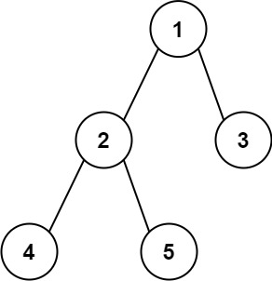

Input: root = [1,2,3,4,5]  
Output: 3  
Explanation: 3 is the length of the path [4,2,1,3] or [5,2,1,3].

**Example 2:**

Input: root = [1,2]  
Output: 1

**Constraints:**

* The number of nodes in the tree is in the range [1, 104].
* -100 <= Node.val <= 100