The **boundary** of a binary tree is the concatenation of the **root**, the **left boundary**, the **leaves** ordered from left-to-right, and the **reverse order** of the **right boundary**.

The **left boundary** is the set of nodes defined by the following:

* The root node's left child is in the left boundary. If the root does not have a left child, then the left boundary is **empty**.
* If a node in the left boundary and has a left child, then the left child is in the left boundary.
* If a node is in the left boundary, has **no** left child, but has a right child, then the right child is in the left boundary.
* The leftmost leaf is **not** in the left boundary.

The **right boundary** is similar to the **left boundary**, except it is the right side of the root's right subtree. Again, the leaf is **not** part of the **right boundary**, and the **right boundary** is empty if the root does not have a right child.

The **leaves** are nodes that do not have any children. For this problem, the root is **not** a leaf.

Given the root of a binary tree, return *the values of its* ***boundary***.

**Example 1:**

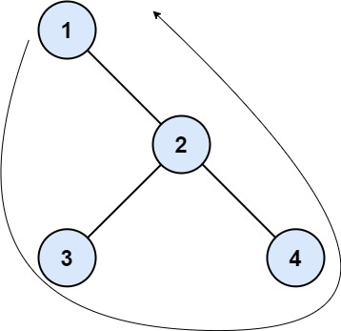

Input: root = [1,null,2,3,4]  
Output: [1,3,4,2]  
Explanation:  
- The left boundary is empty because the root does not have a left child.  
- The right boundary follows the path starting from the root's right child 2 -> 4.  
 4 is a leaf, so the right boundary is [2].  
- The leaves from left to right are [3,4].  
Concatenating everything results in [1] + [] + [3,4] + [2] = [1,3,4,2].

**Example 2:**

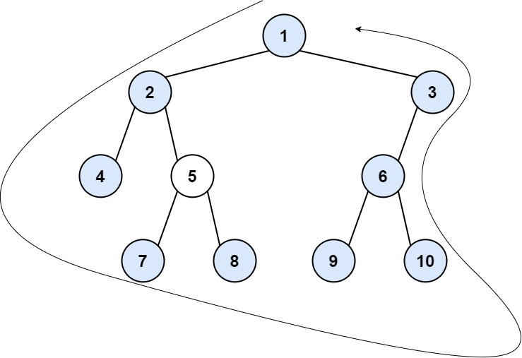

Input: root = [1,2,3,4,5,6,null,null,null,7,8,9,10]  
Output: [1,2,4,7,8,9,10,6,3]  
Explanation:  
- The left boundary follows the path starting from the root's left child 2 -> 4.  
 4 is a leaf, so the left boundary is [2].  
- The right boundary follows the path starting from the root's right child 3 -> 6 -> 10.  
 10 is a leaf, so the right boundary is [3,6], and in reverse order is [6,3].  
- The leaves from left to right are [4,7,8,9,10].  
Concatenating everything results in [1] + [2] + [4,7,8,9,10] + [6,3] = [1,2,4,7,8,9,10,6,3].

**Constraints:**

* The number of nodes in the tree is in the range [1, 104].
* -1000 <= Node.val <= 1000