Design a data structure that simulates an in-memory file system.

Implement the FileSystem class:

* FileSystem() Initializes the object of the system.
* List<String> ls(String path)
  + If path is a file path, returns a list that only contains this file's name.
  + If path is a directory path, returns the list of file and directory names **in this directory**.
* The answer should in **lexicographic order**.
* void mkdir(String path) Makes a new directory according to the given path. The given directory path does not exist. If the middle directories in the path do not exist, you should create them as well.
* void addContentToFile(String filePath, String content)
  + If filePath does not exist, creates that file containing given content.
  + If filePath already exists, appends the given content to original content.
* String readContentFromFile(String filePath) Returns the content in the file at filePath.

**Example 1:**

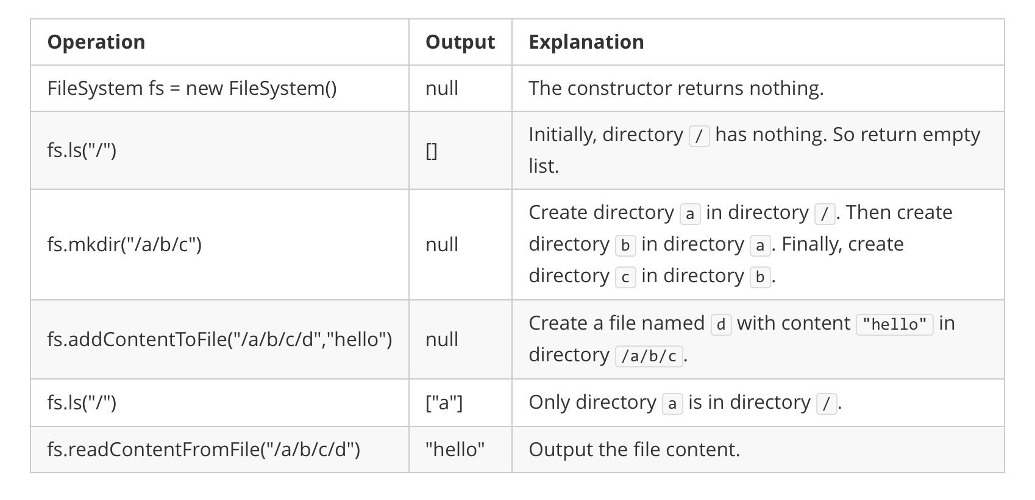

Input  
["FileSystem", "ls", "mkdir", "addContentToFile", "ls", "readContentFromFile"]  
[[], ["/"], ["/a/b/c"], ["/a/b/c/d", "hello"], ["/"], ["/a/b/c/d"]]  
Output  
[null, [], null, null, ["a"], "hello"]  
  
Explanation  
FileSystem fileSystem = new FileSystem();  
fileSystem.ls("/"); // return []  
fileSystem.mkdir("/a/b/c");  
fileSystem.addContentToFile("/a/b/c/d", "hello");  
fileSystem.ls("/"); // return ["a"]  
fileSystem.readContentFromFile("/a/b/c/d"); // return "hello"

**Constraints:**

* 1 <= path.length, filePath.length <= 100
* path and filePath are absolute paths which begin with '/' and do not end with '/' except that the path is just "/".
* You can assume that all directory names and file names only contain lowercase letters, and the same names will not exist in the same directory.
* You can assume that all operations will be passed valid parameters, and users will not attempt to retrieve file content or list a directory or file that does not exist.
* 1 <= content.length <= 50
* At most 300 calls will be made to ls, mkdir, addContentToFile, and readContentFromFile.