Given the root node of a binary tree, your task is to create a string representation of the tree following a specific set of formatting rules. The representation should be based on a preorder traversal of the binary tree and must adhere to the following guidelines:

* **Node Representation**: Each node in the tree should be represented by its integer value.
* **Parentheses for Children**: If a node has at least one child (either left or right), its children should be represented inside parentheses. Specifically:
  + If a node has a left child, the value of the left child should be enclosed in parentheses immediately following the node's value.
  + If a node has a right child, the value of the right child should also be enclosed in parentheses. The parentheses for the right child should follow those of the left child.
* **Omitting Empty Parentheses**: Any empty parentheses pairs (i.e., ()) should be omitted from the final string representation of the tree, with one specific exception: when a node has a right child but no left child. In such cases, you must include an empty pair of parentheses to indicate the absence of the left child. This ensures that the one-to-one mapping between the string representation and the original binary tree structure is maintained.
* In summary, empty parentheses pairs should be omitted when a node has only a left child or no children. However, when a node has a right child but no left child, an empty pair of parentheses must precede the representation of the right child to reflect the tree's structure accurately.

**Example 1:**

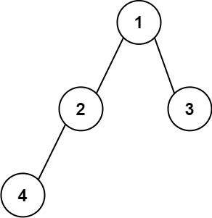

Input: root = [1,2,3,4]  
Output: "1(2(4))(3)"  
Explanation: Originally, it needs to be "1(2(4)())(3()())", but you need to omit all the empty parenthesis pairs. And it will be "1(2(4))(3)".

**Example 2:**

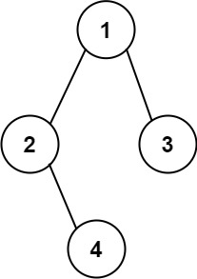

Input: root = [1,2,3,null,4]  
Output: "1(2()(4))(3)"  
Explanation: Almost the same as the first example, except the () after 2 is necessary to indicate the absence of a left child for 2 and the presence of a right child.

**Constraints:**

* The number of nodes in the tree is in the range [1, 104].
* -1000 <= Node.val <= 1000