Given the root of a binary tree and two integers val and depth, add a row of nodes with value val at the given depth depth.

Note that the root node is at depth 1.

The adding rule is:

* Given the integer depth, for each not null tree node cur at the depth depth - 1, create two tree nodes with value val as cur's left subtree root and right subtree root.
* cur's original left subtree should be the left subtree of the new left subtree root.
* cur's original right subtree should be the right subtree of the new right subtree root.
* If depth == 1 that means there is no depth depth - 1 at all, then create a tree node with value val as the new root of the whole original tree, and the original tree is the new root's left subtree.

**Example 1:**

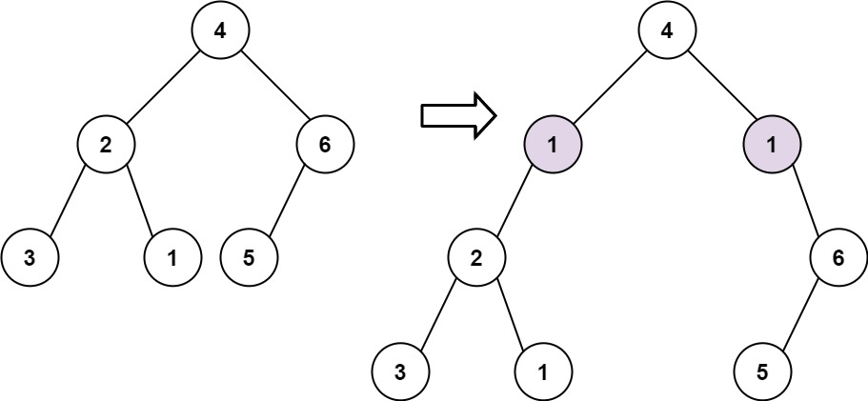

Input: root = [4,2,6,3,1,5], val = 1, depth = 2  
Output: [4,1,1,2,null,null,6,3,1,5]

**Example 2:**

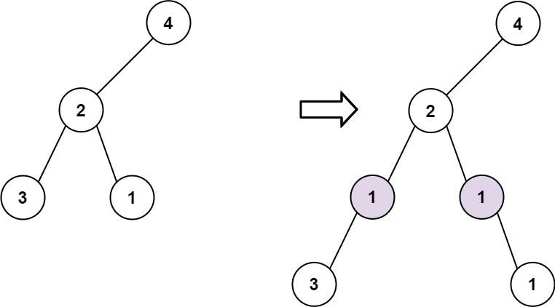

Input: root = [4,2,null,3,1], val = 1, depth = 3  
Output: [4,2,null,1,1,3,null,null,1]

**Constraints:**

* The number of nodes in the tree is in the range [1, 104].
* The depth of the tree is in the range [1, 104].
* -100 <= Node.val <= 100
* -105 <= val <= 105
* 1 <= depth <= the depth of tree + 1