On an 2 x 3 board, there are five tiles labeled from 1 to 5, and an empty square represented by 0. A **move** consists of choosing 0 and a 4-directionally adjacent number and swapping it.

The state of the board is solved if and only if the board is [[1,2,3],[4,5,0]].

Given the puzzle board board, return *the least number of moves required so that the state of the board is solved*. If it is impossible for the state of the board to be solved, return -1.

**Example 1:**

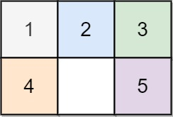

Input: board = [[1,2,3],[4,0,5]]  
Output: 1  
Explanation: Swap the 0 and the 5 in one move.

**Example 2:**

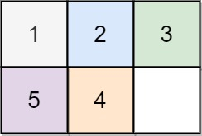

Input: board = [[1,2,3],[5,4,0]]  
Output: -1  
Explanation: No number of moves will make the board solved.

**Example 3:**

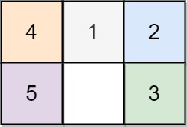

Input: board = [[4,1,2],[5,0,3]]  
Output: 5  
Explanation: 5 is the smallest number of moves that solves the board.  
An example path:  
After move 0: [[4,1,2],[5,0,3]]  
After move 1: [[4,1,2],[0,5,3]]  
After move 2: [[0,1,2],[4,5,3]]  
After move 3: [[1,0,2],[4,5,3]]  
After move 4: [[1,2,0],[4,5,3]]  
After move 5: [[1,2,3],[4,5,0]]

**Constraints:**

* board.length == 2
* board[i].length == 3
* 0 <= board[i][j] <= 5
* Each value board[i][j] is **unique**.