There is an **undirected** graph with n nodes, where each node is numbered between 0 and n - 1. You are given a 2D array graph, where graph[u] is an array of nodes that node u is adjacent to. More formally, for each v in graph[u], there is an undirected edge between node u and node v. The graph has the following properties:

* There are no self-edges (graph[u] does not contain u).
* There are no parallel edges (graph[u] does not contain duplicate values).
* If v is in graph[u], then u is in graph[v] (the graph is undirected).
* The graph may not be connected, meaning there may be two nodes u and v such that there is no path between them.

A graph is **bipartite** if the nodes can be partitioned into two independent sets A and B such that **every** edge in the graph connects a node in set A and a node in set B.

Return true *if and only if it is* ***bipartite***.

**Example 1:**

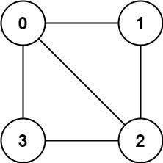

Input: graph = [[1,2,3],[0,2],[0,1,3],[0,2]]  
Output: false  
Explanation: There is no way to partition the nodes into two independent sets such that every edge connects a node in one and a node in the other.

**Example 2:**

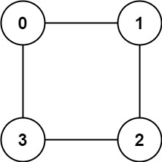

Input: graph = [[1,3],[0,2],[1,3],[0,2]]  
Output: true  
Explanation: We can partition the nodes into two sets: {0, 2} and {1, 3}.

**Constraints:**

* graph.length == n
* 1 <= n <= 100
* 0 <= graph[u].length < n
* 0 <= graph[u][i] <= n - 1
* graph[u] does not contain u.
* All the values of graph[u] are **unique**.
* If graph[u] contains v, then graph[v] contains u.