There are n cities connected by some number of flights. You are given an array flights where flights[i] = [fromi, toi, pricei] indicates that there is a flight from city fromi to city toi with cost pricei.

You are also given three integers src, dst, and k, return ***the cheapest price*** *from* src *to* dst *with at most* k *stops.* If there is no such route, return -1.

**Example 1:**

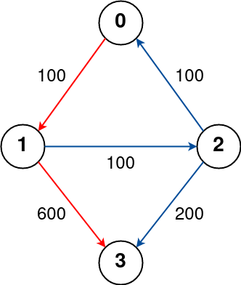

Input: n = 4, flights = [[0,1,100],[1,2,100],[2,0,100],[1,3,600],[2,3,200]], src = 0, dst = 3, k = 1  
Output: 700  
Explanation:  
The graph is shown above.  
The optimal path with at most 1 stop from city 0 to 3 is marked in red and has cost 100 + 600 = 700.  
Note that the path through cities [0,1,2,3] is cheaper but is invalid because it uses 2 stops.

**Example 2:**

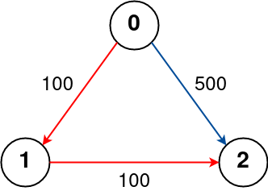

Input: n = 3, flights = [[0,1,100],[1,2,100],[0,2,500]], src = 0, dst = 2, k = 1  
Output: 200  
Explanation:  
The graph is shown above.  
The optimal path with at most 1 stop from city 0 to 2 is marked in red and has cost 100 + 100 = 200.

**Example 3:**

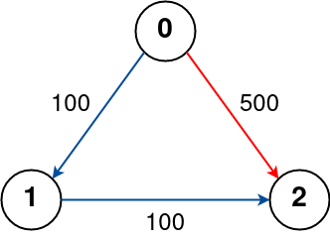

Input: n = 3, flights = [[0,1,100],[1,2,100],[0,2,500]], src = 0, dst = 2, k = 0  
Output: 500  
Explanation:  
The graph is shown above.  
The optimal path with no stops from city 0 to 2 is marked in red and has cost 500.

**Constraints:**

* 1 <= n <= 100
* 0 <= flights.length <= (n * (n - 1) / 2)
* flights[i].length == 3
* 0 <= fromi, toi < n
* fromi != toi
* 1 <= pricei <= 104
* There will not be any multiple flights between two cities.
* 0 <= src, dst, k < n
* src != dst