Given an m x n grid of characters board and a string word, return true *if* word *exists in the grid*.

The word can be constructed from letters of sequentially adjacent cells, where adjacent cells are horizontally or vertically neighboring. The same letter cell may not be used more than once.

**Example 1:**

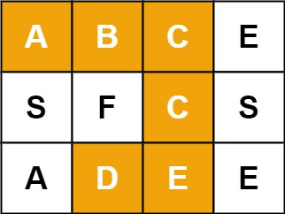

Input: board = [["A","B","C","E"],["S","F","C","S"],["A","D","E","E"]], word = "ABCCED"  
Output: true

**Example 2:**

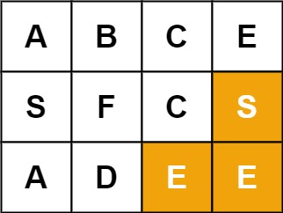

Input: board = [["A","B","C","E"],["S","F","C","S"],["A","D","E","E"]], word = "SEE"  
Output: true

**Example 3:**

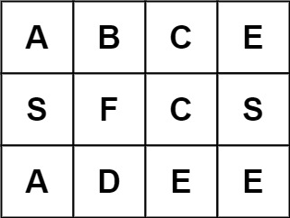

Input: board = [["A","B","C","E"],["S","F","C","S"],["A","D","E","E"]], word = "ABCB"  
Output: false

**Constraints:**

* m == board.length
* n = board[i].length
* 1 <= m, n <= 6
* 1 <= word.length <= 15
* board and word consists of only lowercase and uppercase English letters.

**Follow up:** Could you use search pruning to make your solution faster with a larger board?