You have two types of tiles: a 2 x 1 domino shape and a tromino shape. You may rotate these shapes.

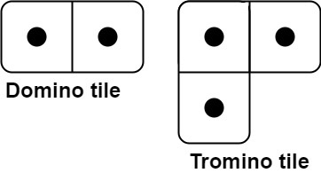

Given an integer n, return *the number of ways to tile an* 2 x n *board*. Since the answer may be very large, return it **modulo** 109 + 7.

In a tiling, every square must be covered by a tile. Two tilings are different if and only if there are two 4-directionally adjacent cells on the board such that exactly one of the tilings has both squares occupied by a tile.

**Example 1:**

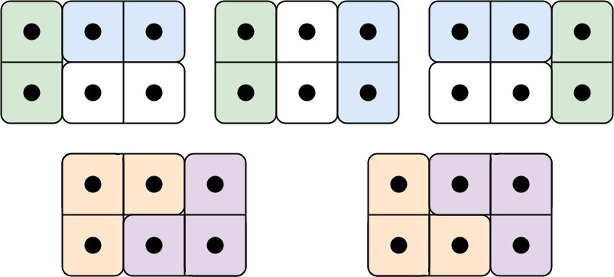

Input: n = 3  
Output: 5  
Explanation: The five different ways are show above.

**Example 2:**

Input: n = 1  
Output: 1

**Constraints:**

* 1 <= n <= 1000