Given a directed acyclic graph (**DAG**) of n nodes labeled from 0 to n - 1, find all possible paths from node 0 to node n - 1 and return them in **any order**.

The graph is given as follows: graph[i] is a list of all nodes you can visit from node i (i.e., there is a directed edge from node i to node graph[i][j]).

**Example 1:**

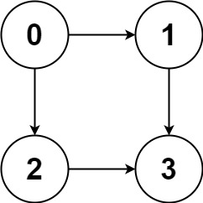

Input: graph = [[1,2],[3],[3],[]]  
Output: [[0,1,3],[0,2,3]]  
Explanation: There are two paths: 0 -> 1 -> 3 and 0 -> 2 -> 3.

**Example 2:**

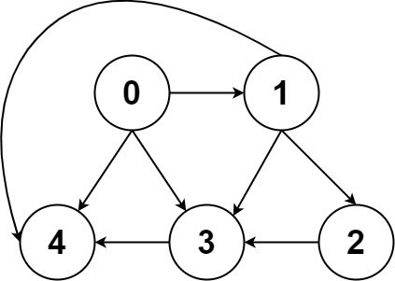

Input: graph = [[4,3,1],[3,2,4],[3],[4],[]]  
Output: [[0,4],[0,3,4],[0,1,3,4],[0,1,2,3,4],[0,1,4]]

**Constraints:**

* n == graph.length
* 2 <= n <= 15
* 0 <= graph[i][j] < n
* graph[i][j] != i (i.e., there will be no self-loops).
* All the elements of graph[i] are **unique**.
* The input graph is **guaranteed** to be a **DAG**.