There is a directed graph of n nodes with each node labeled from 0 to n - 1. The graph is represented by a **0-indexed** 2D integer array graph where graph[i] is an integer array of nodes adjacent to node i, meaning there is an edge from node i to each node in graph[i].

A node is a **terminal node** if there are no outgoing edges. A node is a **safe node** if every possible path starting from that node leads to a **terminal node** (or another safe node).

Return *an array containing all the* ***safe nodes*** *of the graph*. The answer should be sorted in **ascending** order.

**Example 1:**

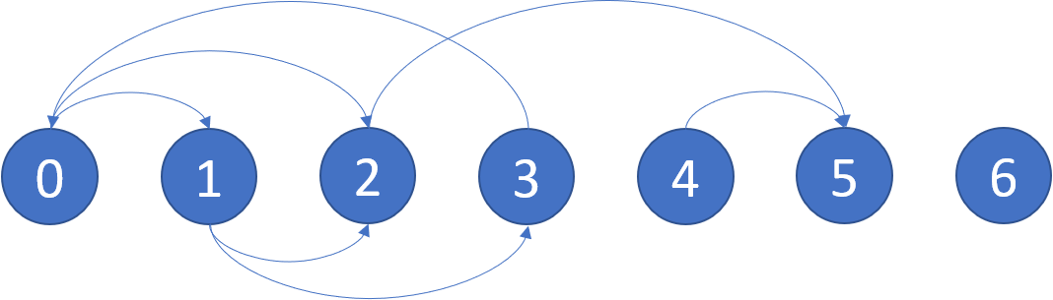

Input: graph = [[1,2],[2,3],[5],[0],[5],[],[]]  
Output: [2,4,5,6]  
Explanation: The given graph is shown above.  
Nodes 5 and 6 are terminal nodes as there are no outgoing edges from either of them.  
Every path starting at nodes 2, 4, 5, and 6 all lead to either node 5 or 6.

**Example 2:**

Input: graph = [[1,2,3,4],[1,2],[3,4],[0,4],[]]  
Output: [4]  
Explanation:  
Only node 4 is a terminal node, and every path starting at node 4 leads to node 4.

**Constraints:**

* n == graph.length
* 1 <= n <= 104
* 0 <= graph[i].length <= n
* 0 <= graph[i][j] <= n - 1
* graph[i] is sorted in a strictly increasing order.
* The graph may contain self-loops.
* The number of edges in the graph will be in the range [1, 4 * 104].