You have an undirected, connected graph of n nodes labeled from 0 to n - 1. You are given an array graph where graph[i] is a list of all the nodes connected with node i by an edge.

Return *the length of the shortest path that visits every node*. You may start and stop at any node, you may revisit nodes multiple times, and you may reuse edges.

**Example 1:**

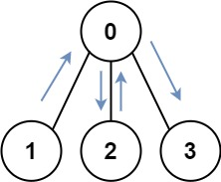

Input: graph = [[1,2,3],[0],[0],[0]]  
Output: 4  
Explanation: One possible path is [1,0,2,0,3]

**Example 2:**

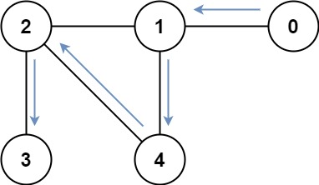

Input: graph = [[1],[0,2,4],[1,3,4],[2],[1,2]]  
Output: 4  
Explanation: One possible path is [0,1,4,2,3]

**Constraints:**

* n == graph.length
* 1 <= n <= 12
* 0 <= graph[i].length < n
* graph[i] does not contain i.
* If graph[a] contains b, then graph[b] contains a.
* The input graph is always connected.