The chess knight has a **unique movement**, it may move two squares vertically and one square horizontally, or two squares horizontally and one square vertically (with both forming the shape of an **L**). The possible movements of chess knight are shown in this diagram:

A chess knight can move as indicated in the chess diagram below:

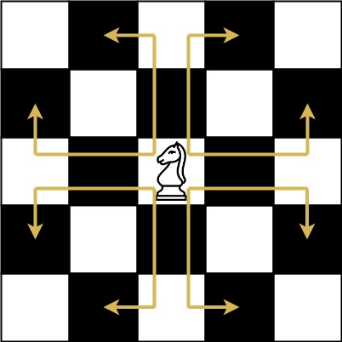

We have a chess knight and a phone pad as shown below, the knight **can only stand on a numeric cell** (i.e. blue cell).

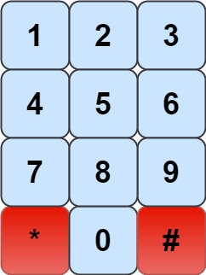

Given an integer n, return how many distinct phone numbers of length n we can dial.

You are allowed to place the knight **on any numeric cell** initially and then you should perform n - 1 jumps to dial a number of length n. All jumps should be **valid** knight jumps.

As the answer may be very large, **return the answer modulo** 109 + 7.

**Example 1:**

Input: n = 1  
Output: 10  
Explanation: We need to dial a number of length 1, so placing the knight over any numeric cell of the 10 cells is sufficient.

**Example 2:**

Input: n = 2  
Output: 20  
Explanation: All the valid number we can dial are [04, 06, 16, 18, 27, 29, 34, 38, 40, 43, 49, 60, 61, 67, 72, 76, 81, 83, 92, 94]

**Example 3:**

Input: n = 3131  
Output: 136006598  
Explanation: Please take care of the mod.

**Constraints:**

* 1 <= n <= 5000