Given the root node of a binary search tree and two integers low and high, return *the sum of values of all nodes with a value in the* ***inclusive*** *range* [low, high].

**Example 1:**

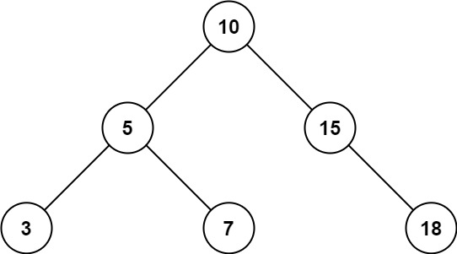

Input: root = [10,5,15,3,7,null,18], low = 7, high = 15  
Output: 32  
Explanation: Nodes 7, 10, and 15 are in the range [7, 15]. 7 + 10 + 15 = 32.

**Example 2:**

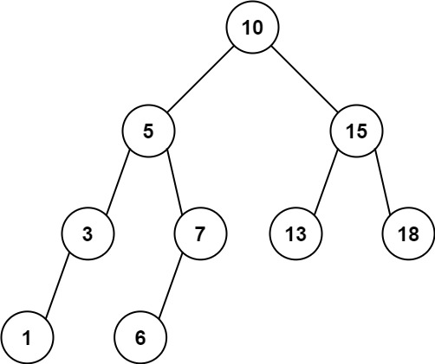

Input: root = [10,5,15,3,7,13,18,1,null,6], low = 6, high = 10  
Output: 23  
Explanation: Nodes 6, 7, and 10 are in the range [6, 10]. 6 + 7 + 10 = 23.

**Constraints:**

* The number of nodes in the tree is in the range [1, 2 * 104].
* 1 <= Node.val <= 105
* 1 <= low <= high <= 105
* All Node.val are **unique**.