Given an array of integers arr, return *true if and only if it is a valid mountain array*.

Recall that arr is a mountain array if and only if:

* arr.length >= 3
* There exists some i with 0 < i < arr.length - 1 such that:
  + arr[0] < arr[1] < ... < arr[i - 1] < arr[i]
  + arr[i] > arr[i + 1] > ... > arr[arr.length - 1]

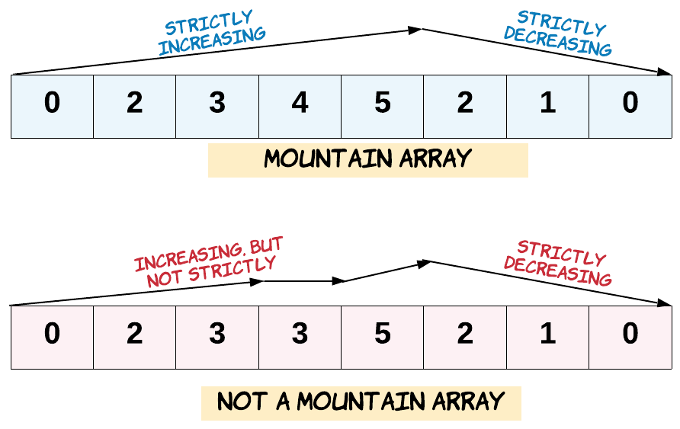

**Example 1:**

Input: arr = [2,1]  
Output: false

**Example 2:**

Input: arr = [3,5,5]  
Output: false

**Example 3:**

Input: arr = [0,3,2,1]  
Output: true

**Constraints:**

* 1 <= arr.length <= 104
* 0 <= arr[i] <= 104