Given an integer n, return *all the structurally unique* ***BST'****s (binary search trees), which has exactly* n *nodes of unique values from* 1 *to* n. Return the answer in **any order**.

**Example 1:**

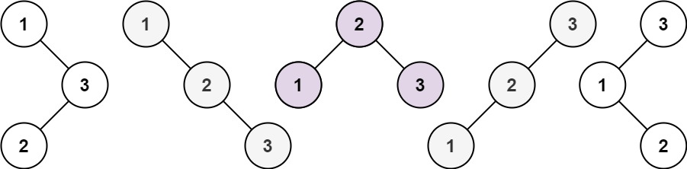

Input: n = 3  
Output: [[1,null,2,null,3],[1,null,3,2],[2,1,3],[3,1,null,null,2],[3,2,null,1]]

**Example 2:**

Input: n = 1  
Output: [[1]]

**Constraints:**

* 1 <= n <= 8