Given an integer n, return *the number of structurally unique* ***BST'****s (binary search trees) which has exactly* n *nodes of unique values from* 1 *to* n.

**Example 1:**

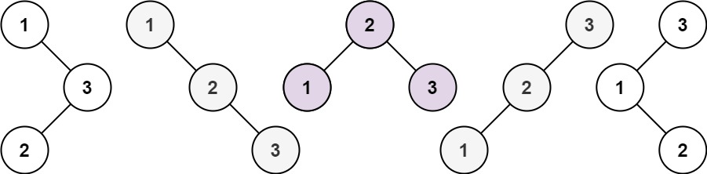

Input: n = 3  
Output: 5

**Example 2:**

Input: n = 1  
Output: 1

**Constraints:**

* 1 <= n <= 19