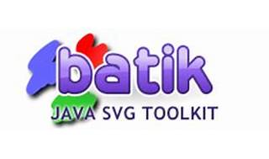



Explore

**Apache Batik** is a **Java toolkit** for creating, manipulating, and viewing **Scalable Vector Graphics (SVG)** images. [It supports the SVG specification, animation, scripting, interactivity, and various formats of conversion1](https://xmlgraphics.apache.org/batik/).

Here are **five free reference links** where you can learn more about Apache Batik:

1. [**Apache™ Batik Project**](https://xmlgraphics.apache.org/batik/): The official project page provides detailed information, documentation, and downloads[1](https://xmlgraphics.apache.org/batik/).
2. [**Download Apache™ Batik**](https://xmlgraphics.apache.org/batik/download.html): Access the latest releases and archive distributions from mirror sites[2](https://xmlgraphics.apache.org/batik/download.html).
3. [**Wikipedia - Apache Batik**](https://en.wikipedia.org/wiki/Apache_Batik): Learn about the history, features, and usage of Batik in this Wikipedia article[3](https://en.wikipedia.org/wiki/Apache_Batik).
4. [**Batik Tutorial**](https://xmlgraphics.apache.org/batik/): A step-by-step tutorial covering various aspects of using Batik for SVG manipulation and rendering.
5. [**Batik Examples**](https://xmlgraphics.apache.org/batik/): Explore practical examples demonstrating how to work with Batik in real-world scenarios.

Happy learning! 🚀🎨