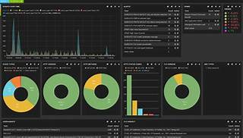

Explore

**Suricata** is an **open-source detection engine** that serves as both an **intrusion detection system (IDS)** and an **intrusion prevention system (IPS)**. [Developed by the **Open Information Security Foundation (OSIF)**, it uses a rule set and signature language to **detect and prevent threats**1](https://resources.infosecinstitute.com/topics/network-security-101/suricata-what-is-it-and-how-can-we-use-it/)[2](https://bing.com/search?q=what+is+suricata).

Here are **five free reference links** where you can learn more about Suricata:

1. [**Suricata Overview | Rapid7 Blog**](https://www.rapid7.com/blog/post/2017/02/21/suricata-overview/): This article provides an overview of Suricata, its history, and its role as an IDS and IPS[3](https://www.rapid7.com/blog/post/2017/02/21/suricata-overview/).
2. [**What is Suricata? Intro to a Best of Breed Open Source IDS and IPS**](https://securityboulevard.com/2019/06/what-is-suricata-intro-to-a-best-of-breed-open-source-ids-and-ips/): Learn about Suricata’s capabilities, including deep packet inspection and pattern matching for threat detection[4](https://securityboulevard.com/2019/06/what-is-suricata-intro-to-a-best-of-breed-open-source-ids-and-ips/).
3. [**Suricata Official Website**](https://suricata.io/): Explore Suricata’s high-performance, open-source network analysis, and threat detection software[5](https://suricata.io/).
4. [**Suricata Training Courses**](https://suricata.io/learn/public-training/): Dive into public training sessions covering intrusion analysis, threat hunting, and network security monitoring[6](https://suricata.io/learn/public-training/).
5. [**Suricata Webinars**](https://suricata.io/learn/): Access recorded webinars hosted by Suricata team members and partners, offering insights on various relevant topics[7](https://suricata.io/learn/).

Happy learning! 🚀🔍