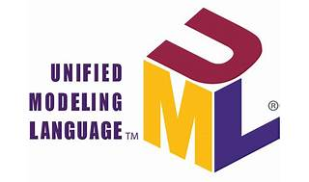

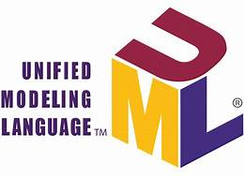

Explore

[**Unified Modeling Language (UML)** is a standardized modeling language used in software engineering to **visualize, specify, construct, and document** system artifacts, including software components and business models1](https://www.guru99.com/uml-tutorial.html)[2](https://www.visual-paradigm.com/tutorials/)[3](https://www.udemy.com/course/visual-paradigm-essential/).

Here are **five free reference links** where you can learn UML:

1. **Guru99 UML Tutorial**: This comprehensive tutorial covers topics like use cases, object diagrams, component diagrams, state diagrams, and more. [It’s suitable for beginners and provides step-by-step guidance1](https://www.guru99.com/uml-tutorial.html). You can access it [here](https://www.guru99.com/uml-tutorial.html).
2. **Visual Paradigm Tutorials**: Visual Paradigm offers free tutorials on UML, BPMN, and other modeling techniques. [Learn about UML diagrams, notations, relationships, and tools](https://www.guru99.com/uml-tutorial.html)[2](https://www.visual-paradigm.com/tutorials/). Explore the tutorials [here](https://www.visual-paradigm.com/tutorials/).
3. **Udemy - Visual Paradigm Essential**: This free Udemy course teaches essential skills in software design and modeling, including UML. [Dive into UML, BPMN, and SysML with Visual Paradigm](https://www.guru99.com/uml-tutorial.html)[3](https://www.udemy.com/course/visual-paradigm-essential/). Enroll in the course [here](https://www.udemy.com/course/visual-paradigm-essential/).
4. **TechTerms UML Definition**: TechTerms explains UML as an industry-standard modeling language for visualizing complex software systems. [Discover how different parts of a software system interact using UML diagrams](https://www.guru99.com/uml-tutorial.html)[4](https://www.tutorialspoint.com/uml/index.htm). Read more [here](https://techterms.com/definition/uml).
5. **Tutorialspoint UML Tutorial**: Tutorialspoint provides an overview of UML, its history, and various diagram types. [Learn about class diagrams, object diagrams, use case diagrams, and more](https://www.guru99.com/uml-tutorial.html)[4](https://www.tutorialspoint.com/uml/index.htm). Access the tutorial [here](https://www.tutorialspoint.com/uml/index.htm).

Happy learning! 🌟