FINAL LONG WEATHER DJF FIGURE
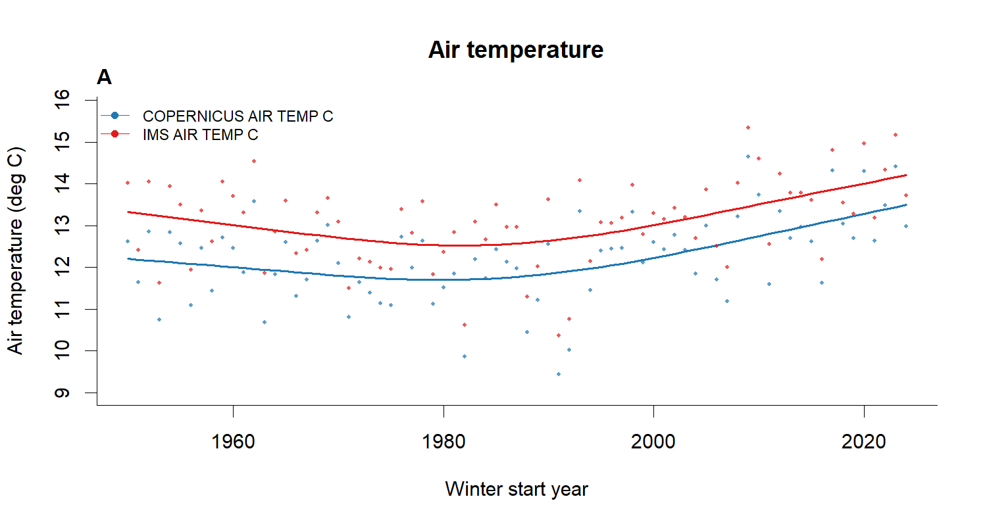 | 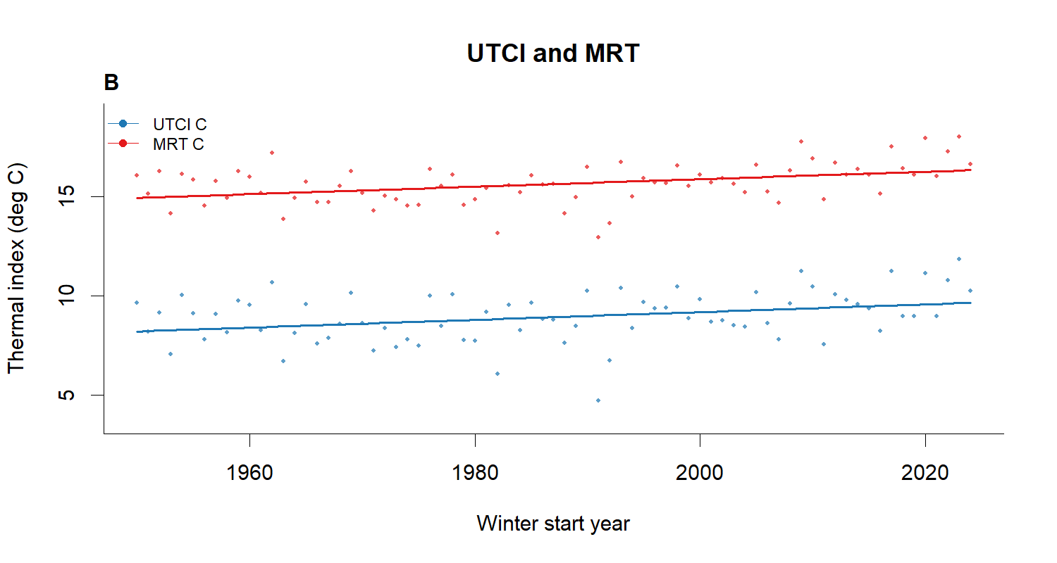
A | B
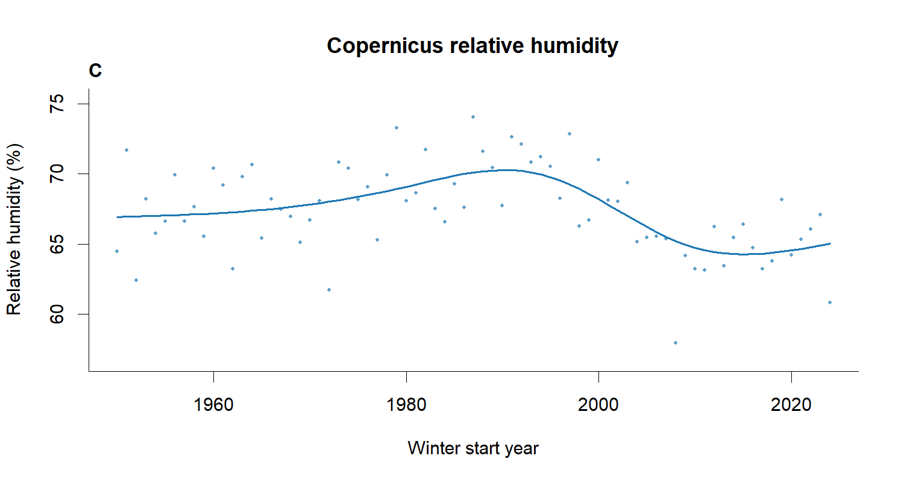 | 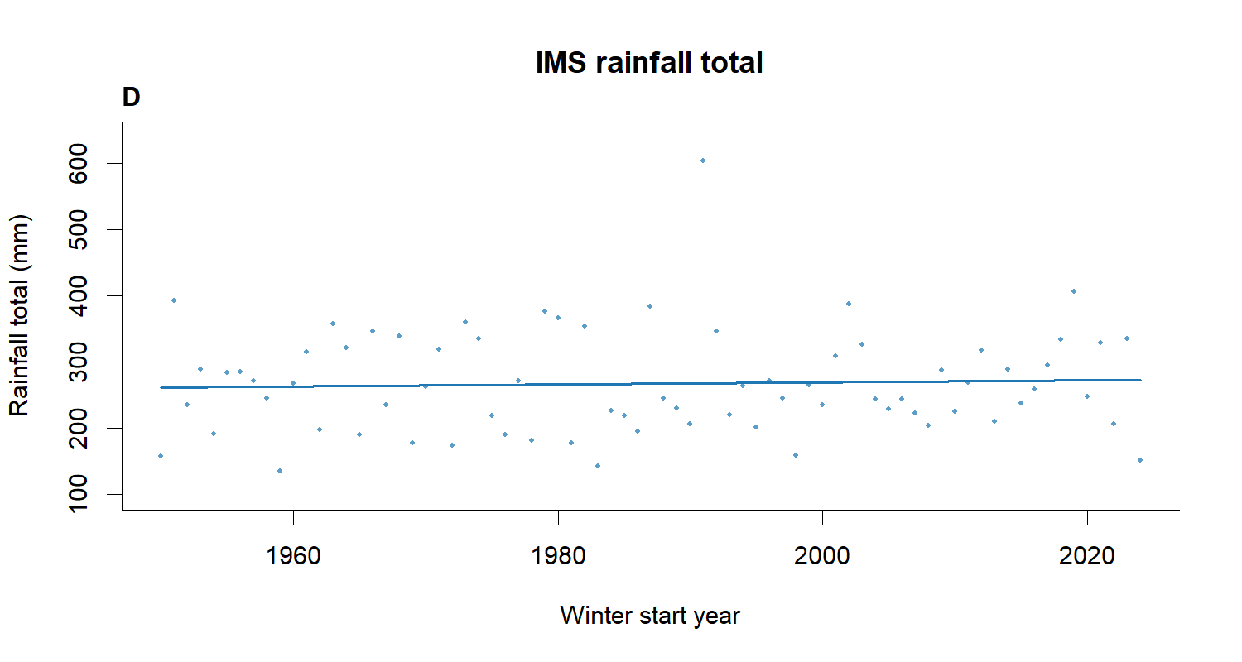
C | D
Panels and CSV companion were generated from the same frozen numerical authority.

