ENG 301 – Computer Vision
Smart Targeting System
with Real-Time Object Detection, Tracking, and Optimized Servo Control
Nguyen Huynh Duc
- Introduction:
This project focuses on building a simple real-time system that combines object detection, tracking and depth estimation using a stereo camera setup and a YOLOv8 deep learning model. The goal is to detect specific milk bottle brands, tracking its movement by Kalman filter and estimate their distances from the camera using stereo disparity.
1.1 Features and operations:
Real-Time object detection
The system uses a custom-trained YOLOv8 model (neural network) to detect specific milk bottle brands (Fami, TH True Milk, Vinamilk) from a live camera.
Advanced image preprocessing
Each camera frame is enhanced by using grayscale conversion, histogram equalization, and Gaussian blur before detection, which improves accuracy under varying lighting and background conditions.
Object tracking with Kalman Filter
To handle noisy object positions when , the system uses a Kalman filter to predict and smooth object center coordinates across frames, resulting in stable laser motion.
Color-based region isolation
To improve the reliability of color-based object detection, the system converts each frame from the RGB color space to HSV (Hue, Saturation, Value), which allows the system to isolate specific colors, such as red, green, or blue of bottle more effectively, independent of lighting changes.
For example, if I try to detect a Fami milk bottle in shadow. Its yellow body looks almost a mixture of violet and gray in RGB $→$ YOLO might miss it or assign low confidence.
Optimized laser motion by calculate depth information of object and optimized the visit order by using Kruskal's MST Algorithm
When multiple bottles are detected, the system calculates the shortest path, which is the distance between objects and camera in a frame using camera calibration and then visit all objects using Kruskal’s algorithm followed by Depth-First Search to determine visit order to minimize total servo movement.
Why it important ?
Due to the constraint of the resources, I couldn’t demo many objects detection but in real life practice when we have to detect hundred of objects in a frame. Without any optimized order when visiting each object, in some robot application, the servo will move without any logic, which will lead to the unnecessary mechanical wear, energy inefficiency, and potential damage to the hardware.
1.2 Application:
This project, which is just a draft and foundational implementation for educational purpose demonstrates how computer vision and robotics can be integrated for practical real-world automation, which could be included in some warehouse automation in some factory like sorting parcels, picking items from shelves or in some smart kitchen when there is a need to visit or interact with each object individually, etc.
- Method:
2.1 Structure of the application:
The structure of the application consists of five main process: image preprocessing, object detection, tracking, and servo control. First, real time video frames are captured from a Logitech camera. These frames undergo common preprocessing step (grayscale, Gaussian blue, etc), including conversion to HSV color space and binary morphological operations, to isolate relevant color regions and enhance detection robustness and accuracy. The preprocessed images are then passed to a highly custom-YOLOv8 object detection model, which identifies target milk bottle brands and provides bounding box coordinates. Each detected object is then assigned a Kalman filter, which predicts and smooths the object's center across each frames captured, leading to consistent tracking of its movement in a frame. Then, a stereo camera setup was used to estimate the depth information of each object, which will determine the visit order of laser controlled by servos. Finally, a dual attached servo mechanism translates/map the filtered object positions into angular (x, y) that guide a laser pointer to the center of each target.
2.2 Implementation of each module:
- Object detection:
Uses a custom-trained YOLOv8 model loaded with 256 self-taken images as input data. Then, some key parameters were tunned many times to obtain the high accuracy in result: learning_rate to controls how quickly the model adapts, batch_size to fix with each GPU, with some augmentation parameters: saturation, brightness, and hue, which helps the model become more robust with different lightning conditions (although the result is still not totally perfect)
- Preprocessing steps:
The process involves converting to grayscale, applying a Gaussian blur mask to reduce noise, and enhancing contrast for better detection, which is the common framework that was used extensively in every image processing step that we’ve practiced in class. Additionally, a WLS filter was also applied to enhance details, improve both visibility and image fusion in scenes when we calculate depth in stereo vision.
- Kalman Filter:
Model selection: a constant velocity model. Because we're tracking the 2D center (x, y) of an object and its motion is generally smooth frame-to-frame., which changes linear over time and the velocity remains constant unless a measurement changes it.
The chosen matrices:
State transition matrix = $\left[\begin{matrix}1 & 0 & 1 & 0 \\ 0 & 1 & 0 & 1 \\ 0 & 0 & 1 & 0 \\ 0 & 0 & 0 & 1\end{matrix}\right]$, this matrix was derived from the kinematic equation.

Measurement matrix H = $\left[\begin{matrix}1 & 0 & 0 & 0 \\ 0 & 1 & 0 & 0\end{matrix}\right]$, which only measures position, not velocity

Initial covariance matrix $P_{0}$ = $\left[\begin{matrix}1000 & 0 & 0 & 0 \\ 0 & 1000 & 0 & 0 \\ 0 & 0 & 1000 & 0 \\ 0 & 0 & 0 & 1000\end{matrix}\right]$,
this represents initial uncertainty in the state. By setting it large (1000), this helps the filter learn really quickly in the first few frames because it’s like telling the filter that: “I don’t know anything about the initial state. Let the measurements guide me.” In simple terms, the larger the value, the more uncertainty. However, if the value is too large, the system would become extremely jumpy because it dramatically overreacts to the early measurement. I have tried the value larger than 1000 and the result is really unstable.

Measurement noise covariance R = $\left[\begin{matrix}5 & 0 \\ 0 & 5\end{matrix}\right]$, this value 5 means that we would expect some $±$ 5 pixels uncertainty in cx and cy in YOLO detection.

Process noise covariance Q = $\left[\begin{matrix}1 & 0 & 0 & 0 \\ 0 & 1 & 0 & 0 \\ 0 & 0 & 1 & 0 \\ 0 & 0 & 0 & 1\end{matrix}\right]$ , represents uncertainty in motion model like giving the filter “wiggle room” to adapt to real movement. In simpler term, the lower is it, the more we trust the model’s prediction but assume it’s smooth, slow motion. Because when we move these objects, we mostly don’t suddenly change its direction so it’s acceptable to set value small and I have tried and it still work well.

*For the case we have to increase the value: capture ball’s movement in football match because these movement is unpredictable.

- Stereo vision and depth estimation:
I Used OpenCV’s Stereo SGBM and highly tunned the parameters in that (numDisparities, blockSize, disparityMaxDifference,.etc) to enhance the performance combining with WLS filter to smooth out noise disparity and refine the disparity map in the captured video.
Then, convert disparity to distance using:
Depth = $\frac{disparity × focal length}{baseline}$ (baseline = 0.075 - in my setup, focal length = 1360).

- Depth-based prioritized visit:
Based on the depth information just calculated, I then applied the Kruskal algorithm to reorder objects by depth so that closer milk bottles are processed or targeted first by laser. (Because this concept is more related in mathematical and data structure field than in computer vision so we won’t discuss much in here).
Checklist table
 | Developed/coded by me | Implemented/Support by existing libraries
Object detection | I did tune some parameters to enhance the accuracy with support of YOLOv8 | Yes, YOLOv8
Image preprocessing | Yes | OpenCV
Kalman tracking filter | Yes. From tunning the parameters to choosing the value of matrices | Yes. KalmanFilter
Stereo vision and depth estimation | Yes. Tunning the parameter, Applying WLS filtering, and logic to prioritize red color in Depth Map. | Yes. OpenCV
Depth-based prioritized visit: | Yes. Most of the logic was implemented from scratch. | No

Result:
Experimental setup:
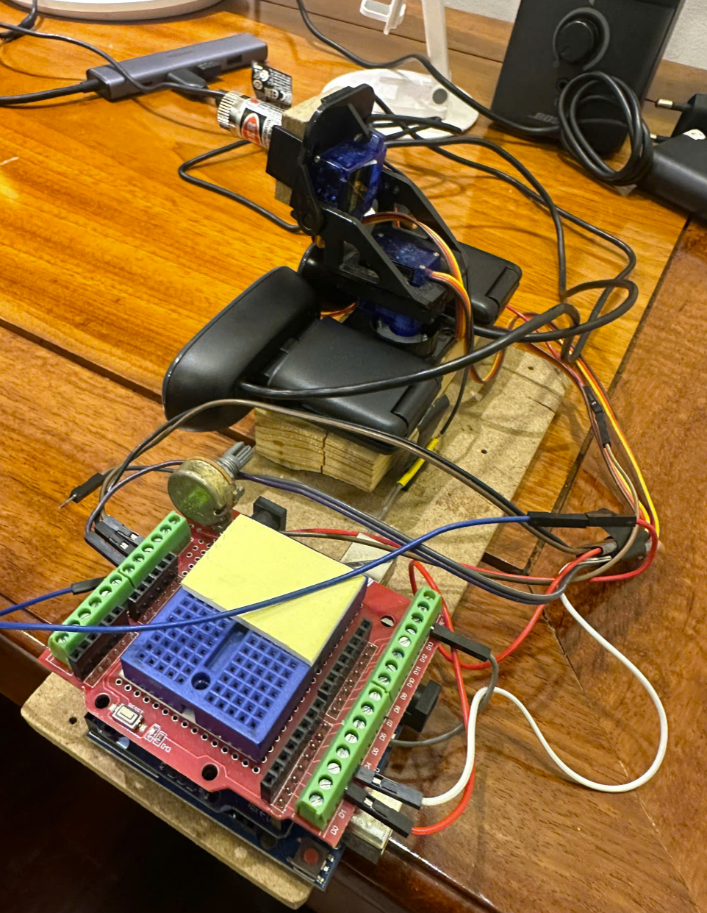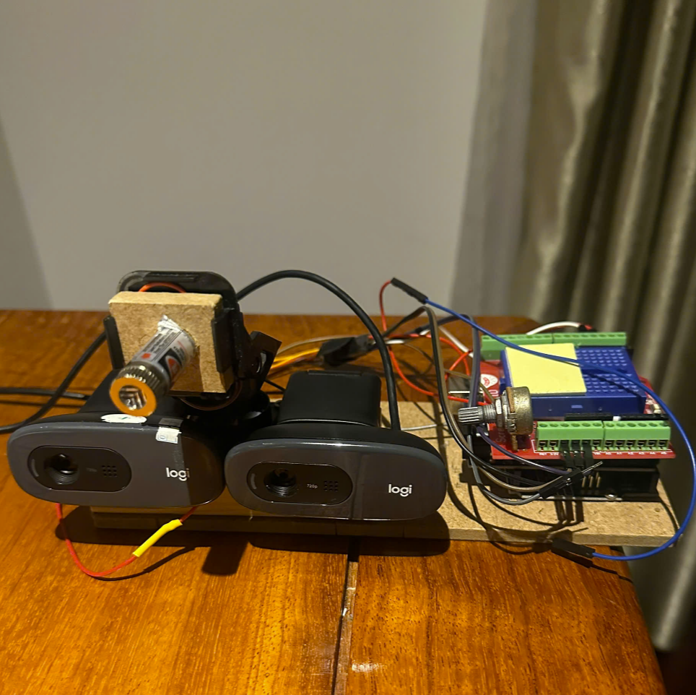
Object detection accuracy:
The training model’s result with preprocessing:
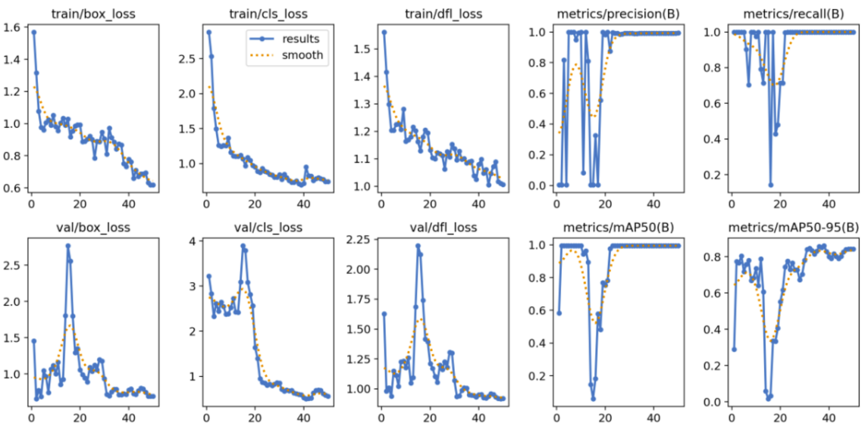
The training results show that the model effectively learned to detect and classify the target milk bottle. Both training and validation losses (box, classification, and DFL) decrease steadily (which is a good sign), with minor fluctuations early but they still have strong convergence overall. Evaluation metrics such as precision, recall, and mAP50 reach near-perfect scores by the end of training, while mAP50-95 stabilizes around 0.84, indicating high detection accuracy even under stricter thresholds. These results confirm that the model generalizes well and is suitable for real-time application.
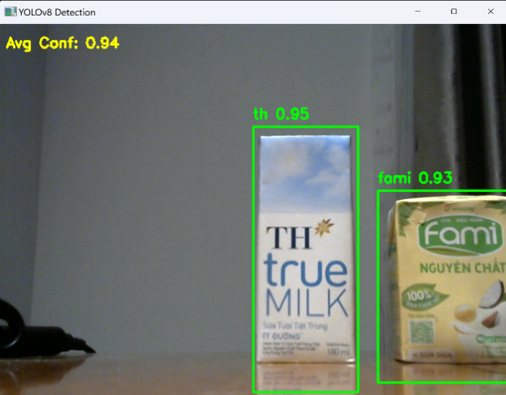
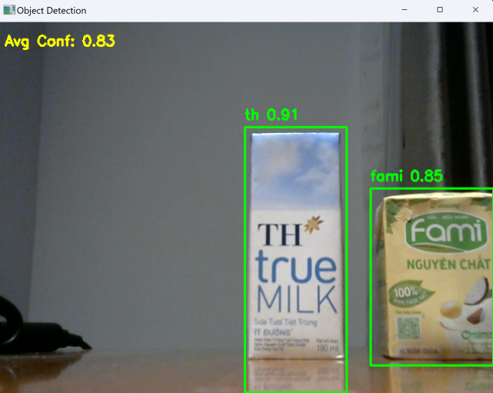
Without preprocessing With preprocessing + HSV

After applying the preprocessing steps, the detection performance did improve when the average confidence gain from 0.83 to 0.94, which make it became more stable and consistent, with reduced noise and fewer false positives. As a result, the system was better able to distinguish the target from the background, leading to more accurate position estimates for the next tracking steps.
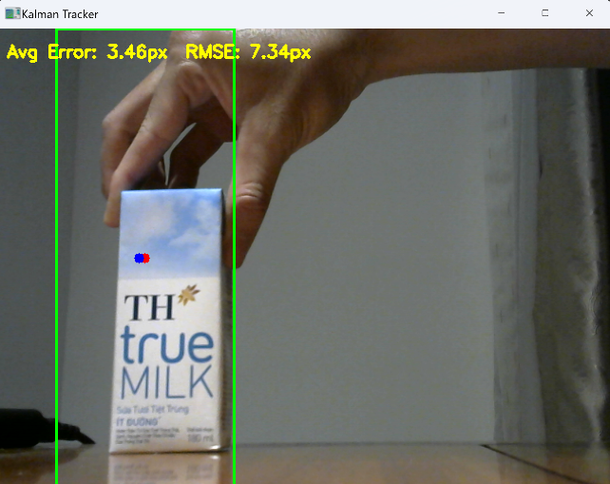
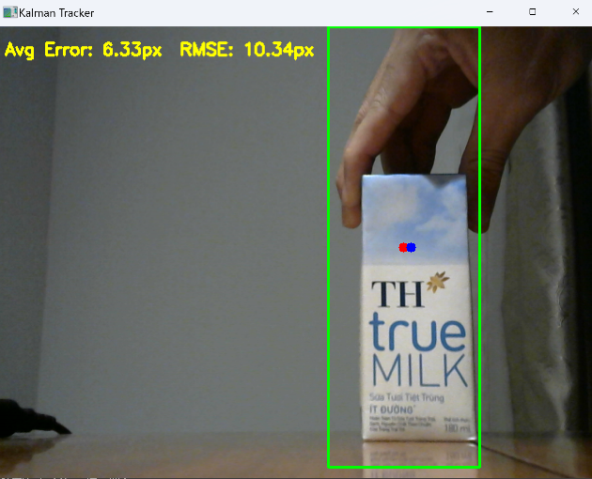
Kalman filter result:
Tracking milk bottle’s movement with Kalman filter
The results above indicate that the Kalman filter is quite effective in improving tracking accuracy by smoothing the estimated object positions over time. As you can see in the left image, the tracking shows an average error of 6.33px and an RMSE of 10.34px, while the right image demonstrates a significant improvement with an average error reduced to 3.46px and an RMSE of 7.34px, which shows that the filter is capable of refining the prediction and has better convergence over time.
- The drop in average error shows that the filter is effective at predicting and smoothing object positions across frames, even when the actual detected position might not be perfect every frame(the lightning condition is different when the bottle milk in the right image receive more light than the left). These results meet the expectations for using Kalman filters in visual tracking because they show a clear improvement in positional accuracy.

Stereo vision result:
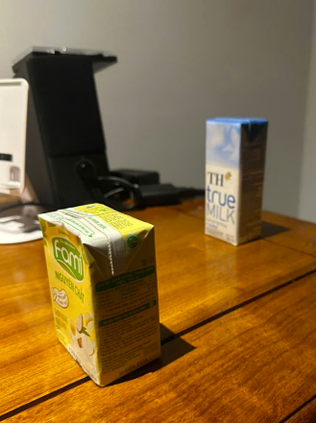
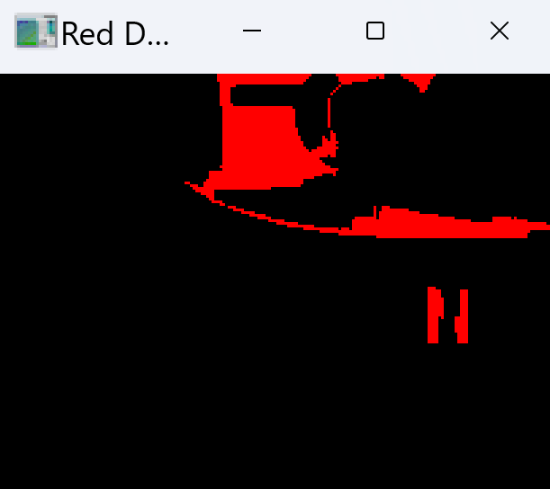
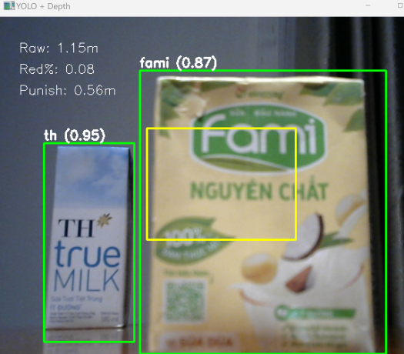
The result distance of object detected The red detection when object is close Object’s position
As you can see from the result image, the distance of Fami milk (0.87m) is closer to the camera compared to the distance of TH (0.95m) in stereo vision. The punishment factor which is calculated by the % of red detection was used to enhance the result when the depth map analyzes how much % red is in the ROI when creating a mask where the warm color channel is high (>180) and other cold color channels (blue) is set to low to get the "red percentage" of the ROI. A smoothing WLS filter was also applied to improve stability.
The punishment factor here I calculated by multiplying the red percentage by an custom adjusted multiplier (I choose 9 in the code). Then, subtracting this punishment factor from the raw distance to get the final distance of each object detected.
The results meet the expectations for using Stereo vision because it can estimate the distance of objects in depth map with a minor error (the gap of the distance between object it capture and in real world measurement is quite small).
Mapping to servo angles (x,y) to control laser:
I have already demo in class.
Checklist table:
All main functions and some additional functions of the application working | Yes | Demo in class (Object detection, object’s movement tracking, visit object in order based on distance calculated by depth information)
Computer vision concepts was applied | Yes | Neural networks, Tracking (Kalman filter), Image processing, Color space, Stereo vision
There’s rich test data | Yes | Over 256 images were taken in different angles and light condition (then was cropped manually) used as input to train and tune the parameters of the model (in Google Colab)  Here is the data: data
The accuracy is high | Quite high but not totally correct | The system sometimes track the TH true milk bottle’s shape incorrect if it’s in the unideal condition.

Conclusion:
In this project, I have developed a real-time object detection based on neural network model and revise some key knowledge of depth estimation system using two camera setup combined with a tracking Kalman filter we have learned in this class. First, I could revise some fundamental preprocessing steps to enhance the quality of the detection and then incorporated a Kalman filter to smooth the object tracking process. Through experimentation, I learned how to define a constant velocity motion model, construct appropriate state transition (F), observation (H), process noise (Q), measurement noise (R), and initial uncertainty (P) matrices, and tune them to balance between prediction and measurement. Secondly, I have learned how to compute disparity maps using the SGBM algorithm with WLS filtering, and estimates object distances by converting disparity to real world depth and apply a “red punishment” logic to penalize the depth value if the detected region contains a high concentration of red pixels in the colorized JET depth map. The result is a robust integration of AI-based vision and classical computer vision techniques that we have already learned and practiced in this class so far.

