**EE 474 Winter 2017 Lab 3:**

**Switch Debouncing and Using Libraries with the LCD**



**University of Washington**

**by Ryan Linden, Khalid Alzuhair, and Brandon Ngo**

**February 3, 2017**

**Question 1: How many addressable registers are in the MPU-6050? (refer to the datasheet, register reference and example code)**

Looking at the example code, there are 114 **addressable** registers defined at the beginning of the code. The last addressable register defined in the example code is 117, and with address 0 this would include 118 total registers.

However, there were some undefined registers in the example code as seen in **Figure 2,** which are the registers that are not addressable and why there are only 114 addressable registers.

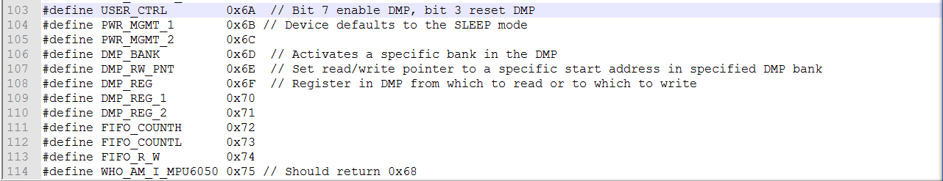

**Figure 1. A snippet indicating there are 114 addressable registers in the MPU-6050 based on the number of defines in the example code.**

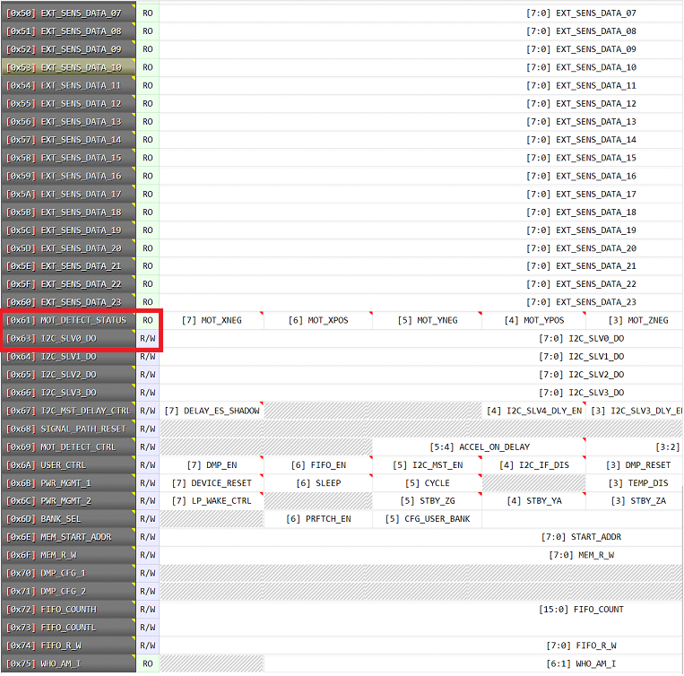

**Figure 2. A snippet of the MPU_6050 Online Register Reference. Notice that the register addresses skip 0x62 and go from 0x61 to 0x63.**

### Question 2: What is the data format of I2C messages written to the MPU-6050?

### The data format of I2C messages written to the MPU-6050 follows this format as seen in **Figure 3**.

### 1 Bit: Start Condition

### 7 Bits: Address

### 1 Bit: R/W

### 1 Bit: Acknowledge Transfer

### 8 Bits: Register Data

### 1 Bit: Acknowledge Signal

### 1 Bit: Stop Condition

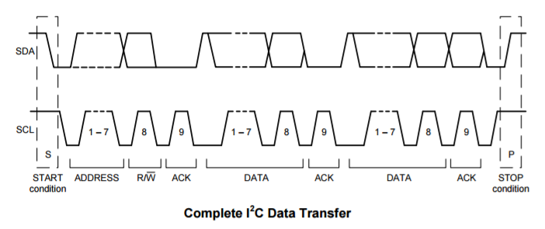

**Figure 3. A diagram of the data format of I2C messages written to the MPU-6050.**

**Question 3: What factors affect the smoothness of your spinning cube sketch when using the raw data from the MPU-6050? Is averaging the data any help?**

### Factors that affect the smoothness of our spinning cube sketch when using the raw data from the MPU-6050 include noise from possible hardware issues that could result in garbage values during a transmission. Averaging these error values with good values results in the spinning cube sketch being smoother.

**Question 4: What is the performance cost of the Quaternion-based approach in part 3 over using raw data in part 2? Explain your measurement procedure.**

**The performance of cost of the Quarternion-based approach in part 3 is $\frac{2.27}{.66}=3.44$ times slower than using the raw data in part 2 due to calculation of the Quarternion values.**

**We timed how long it took for the program to calculate all the Quarternion values for part 3 and compared it to the time it took to get the raw data from the MPU6050 in order to calculate the performance cost.**

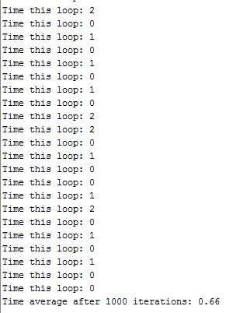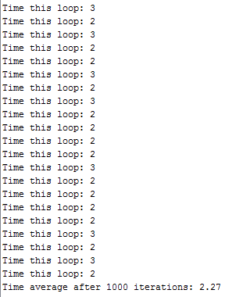

**Figure 4. A snippet of the time average after 1000 iterations using the Quarternion-based approach on the left and a snippet of the time average after 1000 iterations using raw data on the right.**