Electrocardiogram using a Teensy Microcontroller

Khalid Alzuhair
ID: 1360167
alzuhair@uw.edu
Ryan Linden
ID: 1571298
rlinden@uw.com
Brandon Ngo
ID: 1462375
ngo12@uw.edu

ABSTRACT
Information about the heart can be extracted by means of measuring electrical activity. Electrodes are placed on the skin, and differentials in electrical activity can be monitored to produce a signal that represents the heart muscle’s activity. Using this signal, heart conditions as well as heart rate can be monitored to identify the cardiovascular condition of a person. The system that extracts and processes the signal is called an Electrocardiogram. Using a Teensy 3.1 microcontroller as the main processing board, an Electrocardiogram was developed to monitor these heart conditions. The user places their fingers or thumbs on two electrodes and the results are displayed on an LCD screen controlled by the Teensy. This is useful in identifying heart conditions that the user may want to be aware of in case the condition is treatable.
Keywords
Electrocardiogram (ECG)
Liquid Crystal Display (LCD)
Serial Peripheral Interface (SPI)
Programmable Delay Block (PDB)
Analog to Digital Converter (ADC)

INTRODUCTION
The purpose of building this Electrocardiogram is to gain experience interacting with microcontrollers, as well as creating a useful device that can identify heart complications. To complete the electrocardiogram, it is necessary to connect the Teensy 3.1 microcontroller to external peripherals. These peripherals include a Bluetooth device to send ECG data for display, an LCD screen for visual feedback, and buttons and potentiometers for user-interface interaction. The Teensy is also connected to a circuit that has two electrodes, where the heart monitor information is gathered from.
Digital signal processing is used to modify the signal in order to both display a more recognizable signal on the LCD screen, and to filter the signal in a way that allows desirable data points to be easier to analyze algorithmically.
The electrocardiogram is useful because it can detect heart irregularities. It is important to be aware of this information because it can help treat and prevent heart complications in order to prevent sudden cardiac trauma. The electrocardiogram can analyze the users’ heart rate as well as arrhythmic conditions or other symptoms that one would want to be aware of.

DISCUSSION

Hardware Specifications

Microcontroller
Teensy 3.1 microcontroller using a Cortex-M4 processor clocked at 48MHz. It contains 256K flash memory and 64K RAM. Useful features for our purposes include 34 digital I/O pins and 21 analog inputs, as well as a DAC resolution of 12 bits and ADC resolutions of 16 bits (13 usable).

Analog Front-end
- INA128U (Instrumentation amplifier)
- MCP6004 (Operational amplifier)
- Discrete components for signal conditioning
- Dog tags used for electrodes

Bluetooth Module
The Bluefruit module was used, which is an Adafruit branded Bluetooth module that communicates on the SPI bus.

Display and SD card
The ILI9341_t3 LCD is used for display, which also has an SD card reader on the back.

Buttons and Potentiometers
- Push button
- Potentiometer (10K Ohm)

Hardware Theory-of-operation

Microcontroller
The Teensy 3.1 microcontroller was used to interact with all peripherals, as well as for running the main program and processing the ECG data.

Analog Front-end
Two electrodes are used to measure the heart’s electrical activity. This signal is amplified using an INA128U instrumentation amplifier. The signal is then passed through a band pass filter with frequencies centered around 1Hz and 40Hz to reduce external noise in the signal. Additionally, the signal passes through a 60Hz band reject filter in order to remove unwanted noise due to the mains power supply which operates using an AC signal at 60Hz. This filtering is done using a MCP6004 operational amplifier. The buffered output is then sent to one of the Teensy microcontroller’s analog input pins.

Bluetooth Module
An Adafruit branded Bluetooth module called “Bluefruit” was used in this project. The Teensy communicates to it using the SPI protocol. A smart phone application for the Bluefruit is then used to display the received data, as well as plot large data sets graphically.

Display and SD card
The ILI9341_t3 LCD is used to display relevant information and communicates with the Teensy using the SPI protocol. The display shows menu items that can be interacted with using a button and potentiometer. The ECG data is displayed on the display in real time, providing useful information about the heart to the user. The display also has an SD card reader that communicates on the SPI bus. The ECG data is written to the SD card after the program completes. The files can then be read from in order to plot the data on the Bluefruit application.

Buttons and Potentiometers
These peripherals are used for user interaction for the program. One button is used to advance the menu selections. The potentiometer is used to cycle through options listed on the LCD.

Software Theory-of-operation
APPS USED
This section describes the reason behind our choice of the sampling rate based on the range of an average heart rate. The filtering process that was implemented in software is also explained.

Sampling Rate
The ECG software used a sampling rate of 250 Hz. The Programmable Delay Block on the Teensy 3.1 microcontroller was set with a period to read the Analog Digital Converter Channel 250 times per second. We determined that this sampling frequency was adequate for the ECG based on the range of an average maximum heart rate.
The average maximum heart rate is peaked at 200 beats per minute for a person 20 years of age according to [1]. This would correspond to a frequency of 3.33 Hz. With increasing age, this value decreases. The Nyquist frequency would then be around 6.66 -7 Hz. As a result, a sampling frequency of 250 Hz would be more than adequate for an average heart rate according to the Nyquist frequency.

Filtering
The output of the ECG circuit that was read from the ADC channel was fairly noisy. In order to produce a cleaner signal, the raw data was put into a filtering process. The raw ECG signal is filtered, differentiated, squared, and integrated during the filtering process.
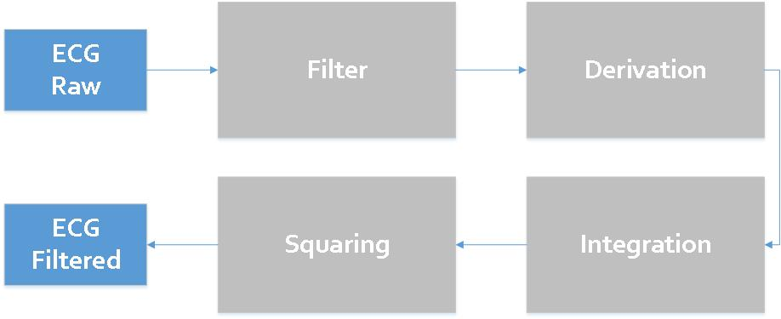
Figure 1. The filtering process that was implemented in software.

Butterworth bandpass filter
The ECG raw signal can be corrupted by a number of noise sources, such as 60 Hz power line noise, muscular activity, and interference from nearby electronic devices, which is why filtering the signal is a necessary step. To filter the signal a 2nd order Butterworth bandpass filter with cutoffs o 3-18 Hz, with a transfer function:
H(z) = (0.16 -0.16 z⁻²)/ (1 -1.65 z⁻¹ + 0.68 z⁻²)
Figure 2 and Figure 3 show the magnitude and phase response of the implemented bandpass filter. The BPF plot in Figure 4, shows the output of the BPS of some sample data that was used in designing the filter.

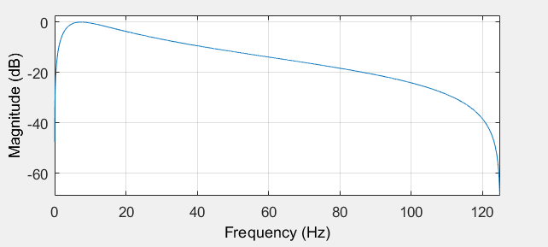
Figure 2. The magnitude response of the bandpass filter.

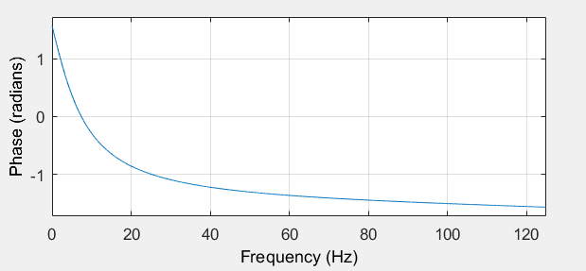
Figure 3. The phase response of the bandpass filter.

Differentiator
The output of the filtered signal goes to a differantiator to provide the QRS slope information. The transfer function of the ised differantiator can be seen below:
H(z) = 0.1 (2 + z⁻¹ – z⁻³ - 2 z⁻⁴ )
The differantiator plot in shows a sample output after applying that filter.
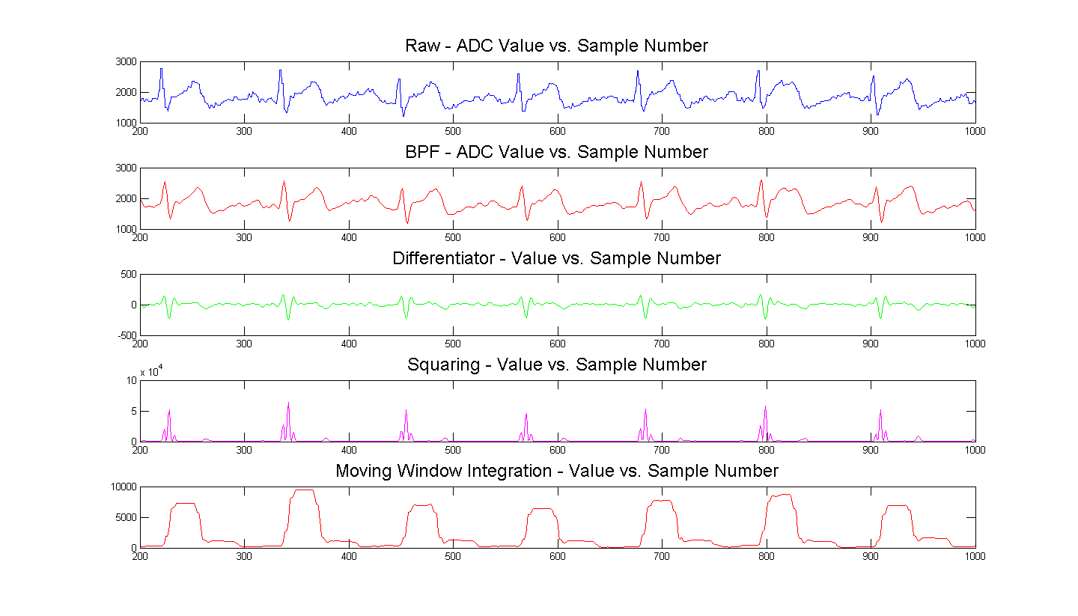

Squaring
Next is the squaring stage. We square the signal to make all data points positive and to provide some nonlinear amplification to the output of the derivative to make some emphasis on higher frequencies. The equation that was used can be seen below:
Y[n] = (X[n])²
The squaring plot in figure 4 shows a sample output of the squaring function.

Lowpass Exponential Integration
Next, a lowpass exponential Integration has been used to obtain information about the slope of the QRS wave. It was calculated using
Y[n] = α X[n] + (1 – α) Y[n – 1]
The moving window integration plot in figure 4 shows a sample output of the lowpass exponential integration function.
The software filtering used for the Electrocardiograph is implemented according to the algorithms found in

QRS and Arrhythmia Detection
A reliable detection of QRS and Arrhythmia is a prerequisite to producing a good ECG. The raw ECG signal went through the series of filtering stages as described in Section 2.3.2 to produce a more reliable detection.
After obtaining this filtered ECG signal, thresholds were determined for the filtered ECG signal and analysis was done based off these thresholds for QRS and arrhythmia detection.

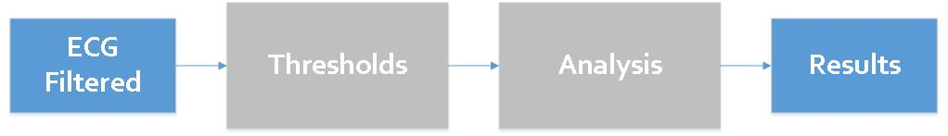
Figure 4. The decision process that was implemented for QRS and Arrhythmia detection.

QRS Detection
The filtered ECG signal that is outputted from the integrator is used along with some threshold to calculate the rising edge, which corresponds to the QRS interval.

Arrhythmia Detection
Arrhythmia detection is tied directly to the heart rate measured from QRS detection. Arrhythmia is detected if either bradycardia or tachycardia heart conditions are found.
Our threshold for a bradycardia was if the average heart rate was less than 60 BPM
ADD THRESHOLDS FOR BRAD AND TACH
- FUTURE WORK
The electrocardiogram has room for improvement, particularly regarding the types of heart conditions it is able to detect. Currently our design does not detect Premature Ventricular Contraction, or Premature Atrial Contraction. Additionally, displaying the PR interval of the signal could be added as well. The ECG signal could also be reduced in noise by making hardware modifications. By laying out the circuit on a printed circuit board, lots of the noise and grounding issues caused by extended wiring could be avoided.

CONCLUSION
The heading of a section should be in Times New Roman 12-point bold in all-capitals flush left with an additional 6-points of white space above the section head. Sections and subsequent sub- sections should be numbered and flush left. For a section head and a subsection head together (such as Section 3 and subsection 3.1), use no additional space above the subsection head.

ACKNOWLEDGMENTS
Our thanks to ACM SIGCHI for allowing us to modify templates they had developed.

REFERENCES
[1] “Target Heart Rates.” [Online]. Available: http://www.heart.org/HEARTORG/HealthyLiving/PhysicalActivity/FitnessBasics/Target-Heart-Rates_UCM_434341_Article.jsp#.WMhTDFXyu00. [Accessed: 14-Mar-2017].

ADD HOW QRS IS DETECTED

