

International School
Capstone Project 1
CMU-SE 450 – C1SE.15
Project Proposal
Version 1.0
Date: August 22, 2025
CapSys - Smart DTU Capstone Project Management
Submitted by
Kiet, Vo Huynh Tuan
Hue, Nguyen Thi Kim
Quang, Truong Minh
Dung, Nguyen Van
An, Ngo Nguyen Truong

Approved by
Msc. Vo Dinh Hieu
Proposal Review Panel Representative:
Name Signature Date

Capstone Project 1- Mentor:
Name Signature Date

PROJECT INFORMATION

Project acronym | CapSys
Project Title | Smart DTU Capstone Project Management
Start Date | August 27, 2025 | End Date | December 12, 2025
Lead Institution | International School, Duy Tan University
Project Mentor | Msc. Vo Dinh Hieu
Scrum master  / Project Leader & contact details | Kiet, Vo Huynh Tuan  Email: vohtuankiet@dtu.edu.vn  Tel: 0366383967  ID: 28211122790
Partner Organization | Duy Tan University
Project Web URL
Team members | Name | Email | Tel
 | Kiet, Vo Huynh Tuan | vohtuankiet@dtu.edu.vn | 0366383967
 | Hue, Nguyen Thi Kim | nguyentkimhue13@dtu.edu.vn | 0763130637
 | An, Ngo Nguyen Truong | ngontruongan@dtu.edu.vn | 0919499505
 | Dung, Nguyen Van | nguyenvandung19@dtu.edu.vn | 0906577651
 | Quang, Truong Minh | truongminhquang@dtu.edu.vn | 0912314189

DOCUMENT APPROVALS
The following signatures are required for approval of this document.
Msc. Vo Dinh Hieu  Mentor | Signature | Date
Kiet, Vo Huynh Tuan  Student ID: 28211122790  Scrum Master | Signature | Date
Hue, Nguyen Thi Kim  Student ID: 28201154111  Team Member | Signature | Date
An, Ngo Nguyen Truong  Student ID: 28211134788  Team Member | Signature | Date
Dung, Nguyen Van  Student ID: 28219050114  Team Member | Signature | Date
Quang, Truong Minh  Student ID: 28211101410  Team Member | Signature | Date

REVISION HISTORY
Version | Date | Comments | Author
1.0 | August 22, 2025 | Initial Release | C1SE.15

TABLE OF CONTENTS
Contents
1. Project Title 1
2. Team Members 1
3. Supervisor 1
4. Problem Statement 2
5. Survey / Existing Solutions 2
6. Objectives and Scope 3
6.1. Objectives 3
6.2. Scope 4
7. Key Features & Requirements 4
7.1. Functional Requiremets 4
7.2. Non-Functional Requirements 5
8. Constraints and Assumptions 5
8.1. Constraints: 5
8.2 Assumptions: 5
9. Target Users / Stakeholders 5
10. Technology Stack 5
11. Methodology & Development Plan 6
11.1. Methodology 6
11.2. Development Plan 8
12. System Architecture Overview 8
12.1. Architecture 8
12.2. System Context diagram 9
13. Potential Risks and Mitigation Strategies 10
14. Expected Outcomes / Deliverables 11
15. References 11

1. Project Title
Smart DTU Capstone Project Management

2. Team Members
Full Name | Student ID | Email | Role
Kiet, Vo Huynh Tuan | 28211122790 | vohtuankiet@dtu.edu.vn | Lead, Backend and AI Developer
Hue, Nguyen Thi Kim | 28201154111 | nguyentkimhue13@dtu.edu.vn | Frontend Developer and Tester
An, Ngo Nguyen Truong | 28211134788 | ngontruongan@dtu.edu.vn | Design and Frontend Developer
Dung, Nguyen Van | 28219050114 | nguyenvandung19@dtu.edu.vn | Design and Frontend Developer
Quang, Truong Minh | 28211101410 | truongminhquang@dtu.edu.vn | Frontend Developer, Tester

3. Supervisor
Full Name | Msc. Vo Dinh Hieu
Faculty/Department | International School, Duy Tan University
Email | hieuvodinh98@gmail.com

4. Problem Statement
In higher education, particularly in engineering and technology programs, the management, tracking, and evaluation of Capstone projects are often performed manually or semi-automatically. This approach presents significant challenges for instructors, including difficulties in allocating time for guidance, monitoring student progress, and compiling evaluation results. The current manual methods lack systematic organization, which can lead to overlapping schedules and require a considerable amount of time for data aggregation. Amid the ongoing digital transformation in education, there is an urgent need for a comprehensive system to support instructors in managing the entire Capstone project lifecycle. Such a system would not only minimize manual processing time but also enable a more scientific, objective, and visual analysis of student progress.

5. Survey / Existing Solutions
Current graduation project management systems mainly operate as web-based platforms with basic functions such as managing project lists, assigning supervisors, and entering grades. Some systems have applied techniques like cloud data storage and Excel file integration, but they still lack intelligent analysis features.
Notable systems:
● Capstone Management System – FPT University: A simple web system that allows project registration, mentor assignment, and grading. However, it does not support AI or data analysis.
● Thesis Management System – Ho Chi Minh City University of Technology: Includes role-based management (Faculty, Department, Lecturer) but still relies on manual data entry and lacks recommendation features.

Table 1. Comparison

Features | Capstone Management System | Thesis Management System | CapSys
Project management | + | + | +
Suggest a suitable defense schedule | - | - | +
AI-based project summarization | - | - | +
Grade prediction using machine learning | - | - | +

6. Objectives and Scope

6.1. Objectives
Develop a comprehensive CapSys Smart DTU Capstone Project Management in the form of a web application, supporting instructors in tasks such as creating defense committees, recording mentor evaluations, and entering defense committee grades.
The system integrates advanced AI modules to support analysis and decision making, focusing on the following features:
- Topic idea summarization from proposals using NLP models (such as T5, BART), helping instructors quickly grasp the main content.
- Proposed score prediction based on historical data and machine learning models (e.g., regression), supporting instructors in making fairer and more objective assessments.
- Comment and feedback analysis from mentors and defense committees through sentiment analysis and topic classification, to evaluate trends as well as common strengths and weaknesses of students across cohorts.
- A demo version will be implemented, and the system’s effectiveness will be evaluated through instructor feedback and metrics such as prediction accuracy, system reliability, and user satisfaction.

6.2. Scope
- Administrators:
  - Group students into teams.
  - Assign mentors to student teams.
  - Manage submitted proposals/topics.
  - Assign defense committees.
- Lecturers:
  - Evaluate and grade student projects.
- Students:
  - View their defense schedule.
- AI Modules:
  - Automatically summarize project proposals.
  - Generate detailed score suggestions based on overall evaluations.

7. Key Features & Requirements

7.1. Functional Requirements
Table 2. Function requirement
FR01 | Group Students into teams
FR02 | Assign mentors to student teams
FR03 | Manage submitted proposals/topics
FR04 | Assign defense committees
FR05 | Evaluate and grade student projects
FR06 | View their defense schedule
FR07 | Generate detailed score suggestions based on overall evaluations

7.2. Non-Functional Requirements
Table 3. Non-Function requirement
NFR01 | Protect sensitive student data
NFR02 | Usability for users
NFR03 | Scalability for 200+ concurrent users

8. Constraints and Assumptions

8.1. Constraints
- Limited time (Aug-Dec 2025)
- Tools: C#, ASP.NET Core, ReactJS, Python
- Database: MS SQL Server.

8.2 Assumptions
- Students and lecturers have internet access.
- Users have basic computer literacy.

9. Target Users / Stakeholders
Stakeholders | Benefit
Faculty members | Evaluate and grade student projects
Students | Check schedules for defense
Admin | Manage accounts, assign mentors/committees, manage committees

10. Technology Stack
Database:
- Storage: MS SQL Server
Backend:
- Programming Language: C#.
- Framework: ASP.NET Core.
Frontend:
- Programming Language: JavaScript
- Framework / Libraries: ReactJS, Tailwind
- Web Browser: Chrome, Firefox, Microsoft Edge.
AI core:
- Classification Algorithm: Scikit-learn (Random Forest Classifier)
- Regression Algorithm: Scikit-learn (Random Forest Regressor)
- Natural Language Processing - NLP: TensorFlow (T5, BART models), Scikit-learn (sentiment and topic classification)

11. Methodology & Development Plan

11.1. Methodology
We will follow an Agile methodology, developing the AI-based platform in iterative sprints. The project will use the following technologies: C# (ASP.NET Core) for the backend development, scikit-learn and TensorFlow for implementing classification and regression algorithms, and React for the front-end interface.
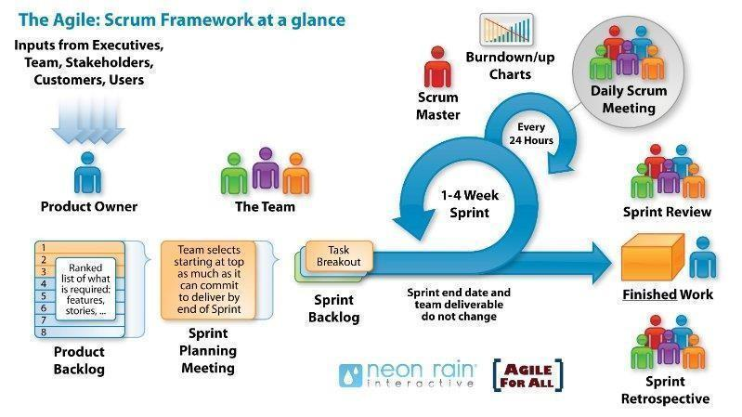
Figure 1. Scrum Process

- Scrum is an iterative and incremental agile software development framework for managing software projects and product or application development.
- Scrum focuses on project management institutions that are difficult to plan.
- Mechanisms of empirical process control, where feedback loops that constitute the core management technique are used as opposed to traditional command-and-control management.
- Its approach to planning and managing projects is to bring decision-making authority to the level of operational properties and certainties.

11.2. Development Plan
Table 4. Development plan
No. | Task Name | Duration (Day(s)) | Start | Finish | Effort work  (hrs.)
1 | Development | 69 | 05/09/2025 | 10/12/2025 | 2180
1.1 | Sprint 1 | 10 | 05/09/2025 | 18/09/2025 | 400
1.2 | Sprint 2 | 10 | 19/09/2025 | 02/10/2025 | 320
1.3 | Sprint 3 | 10 | 03/10/2025 | 16/10/2025 | 240
1.4 | Sprint 4 | 10 | 17/10/2025 | 30/10/2025 | 240
1.5 | Sprint 5 | 10 | 31/10/2025 | 13/11/2025 | 400
1.6 | Sprint 6 | 10 | 14/11/2025 | 27/11/2025 | 180
1.7 | Sprint 7 | 9 | 28/11/2025 | 10/12/2025 | 400
2 | Project Meeting | 2 | 08/12/2025 | 09/12/2025 | 10
3 | Final Release | 3 | 10/12/2025 | 12/12/2025 | 15
 | Duration | 71 | 04/08/2025 | 12/12/2025 | 2205

12. System Architecture Overview

12.1. Architecture
- Web-based client-server system with role-based access.
- Includes AI modules integrated into backend services.

12.2. System Context diagram
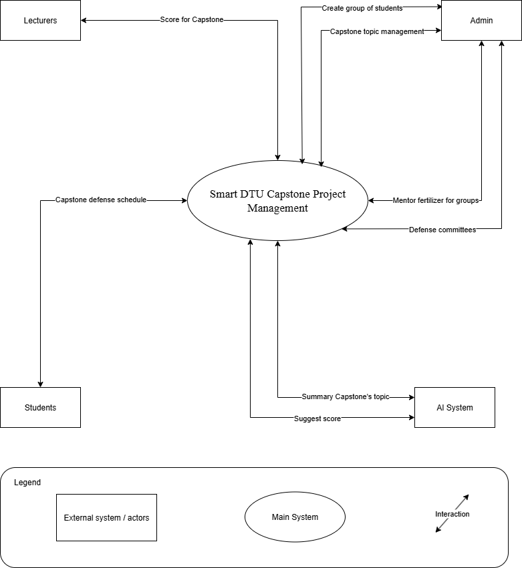
Figure 2. System Context Diagram

13. Potential Risks and Mitigation Strategies
Table 5. Risk and Mitigation
Technical Risks
Risk: AI Model Inaccuracy
Mitigation: Regularly retrain and validate models with updated datasets, compare outputs with lecturer assessments, and ensure AI acts as a support tool only, not a replacement.
Risk: Installation or Environment Configuration Issues
Mitigation: Standardize installation guidelines, package the system with Docker or setup scripts, and test on multiple machines to ensure reproducibility.
Risk: Data Security on Personal Computers
Mitigation: Encrypt database files, restrict access to local storage folders, and avoid sharing sensitive data via unsecured channels.
Financial Risks
Risk: Unexpected Software or Tool Costs
Mitigation: Prioritize free/open-source tools (e.g., SQL Server, Scikit-learn), and leverage academic licenses when available.
Risk: Hardware Failure on Personal Devices
Mitigation: Perform regular database backups to external storage (USB/HDD/Google Drive), and prepare alternative devices when needed.
Time-Related Risks
Risk: Project Delays due to Environmental Issues or Member Dependency
Mitigation: Ensure all team members can run the system locally, use Git for version control, and synchronize development work to avoid bottlenecks.
Risk: Slow Testing due to Manual Deployment
Mitigation: Automate build and test processes with scripts, and modularize system components for independent testing.
Operational Risks
Risk: Data Loss from Local Machine Errors
Mitigation: Schedule regular SQL backups, commit code frequently to GitHub, and maintain copies of important data on external drives.
Risk: User Resistance or Difficulty Adopting the System
Mitigation: Provide user manuals, design an intuitive interface, and conduct live demos during defense sessions to improve acceptance.

14. Expected Outcomes / Deliverables
- Website capstone management
- Source code
- Technical documents

15. References
[1]. Scrum (software development): https://en.wikipedia.org/wiki/Scrum_(software_development)
[2]. Agile and Scrum: https://www.atlassian.com/agile/scrum
[3]. Scrum Methodology: https://www.digite.com/agile/scrum-methodology/
[4]. The Scrum Guide: https://www.scrum.org/resources/scrum-guide
[5]. LangChain API Reference - Core Documents: https://python.langchain.com/api_reference/core/documents/langchain_core.documents.base.Document.html
[6]. ASP.NET Core Documentation: https://learn.microsoft.com/en-us/aspnet/core/?view=aspnetcore-8.0
[7]. Scikit-learn Supervised Learning: https://scikit-learn.org/stable/supervised_learning.html
[8]. React Quick Start: https://react.dev/learn
[9]. WebPageTest - Website Performance and Optimization: https://www.webpagetest.org/
[10]. Web Application Testing Guide: https://owasp.org/www-project-web-security-testing-guide/

