**TABLE OF CONTENTS**

**FOREWORD 1**

**SPECIAL ACKNOWLEDGEMENTS 2**

**PART I: IN TRODUCTION 3**

**PART II: THE CONTENT 5**

**CHAPTER I: SURVEY AND DETERMINATION OF REQUIREMENTS ANALYSIS SYSTEM 5**

1. If the problem 5

2. Survey the status quo. 5

Cosmetic Shop (No. 38-Yen Bai - Hai Chau Da Nang City.). 5

2.2 Status of the organizations in the survey locations 5

2.2.1 Organizational Structure. 5

2.2.2 Status. 5

2.2.3. IT applications: 5

**CHAPTER II: ANALYSIS OF DESIGN 6**

1. Chart Use case 6

1.1. Graph General Use case 7

1.1.1. Graph General Use case 7

1.1.2. Graph Use case User Manu 8

1.1.3. Graph Use case Admin 8

1.2. Graph Use case Decomposing function (Level 2) 9

1.2.1. Decomposing Use case Information Manager 9

1.3. Graph Use case Decomposing function (Level 3) 9

1.3.1. Decomposing Use case User Manager 9

1.3.2. Decomposing Use case Product Manager 10

1.3.3. Decomposing Use case Suppliers Manager 10

1.4. Description Use case 11

1.4.1. Usecase Login (User) 11

1.4.2. Use case Register Account: 11

1.4.3. Use case See Product Information: 12

2. Activity diagram 12

2.1. Function Register: 12

2.2. Function Login: 13

2.3. Function Order Buy: 13

2.4. Function Add Product: 14

2.5. Function Edit Product: 14

2.6. Function Delete Product 15

2.7. Function Search: 15

3. Chart Decentralization Function. 16

**CHAPTER III: DESIGN OF DATABASES 17**

1. Databases-Diagram. 17

2. Tabels Databases. 17

2.1. Table User: 17

2.2. Table Products: 18

2.3. Table Category: 18

2.4. Table Order: 18

**PART III: DESCRIPTION INTERFACE 19**

1. Homepage interface for customers. 19

1.1. Menu Product Category 20

1.2. Introduce Page: 21

1.3. Contact Page 21

1.4. Product Detail Page: 22

1.5. Login and Register Page: 22

1.6. Cart Page: 23

2. Interface Page for Admin 23

2.1. Created Account Page: 23

2.2. Created Product Page: 24

2.3. The Bill Information Page: 24

**PART IV: TEST AND APPRAISE PROGRAM 25**

1. Setup: 25

2. Testing 25

3. Appraise: 25

**PART V: CONCLUSION 26**

**APPENDIX 27**

**PROJECT MANAGEMENT PLAN DETAILS 28**

LIST OF FIGURES

Figure 1.1.1. Graph General Usecase 7

Figure 1.1.2. Graph Usecase User 8

Figure 1.2.1. Graph Decomposing Usecase Information Manager 9

Figure 1.3.1. Graph Decomposing Usecase User Manager 9

Figure 1.3.2. Graph Decomposing Usecase Product Manager 10

Figure 1.3.3. Graph Decomposing Usecase Suppliers Manager 10

Figure 2.1. Activity diagram fucntion Register 12

Figure 2.2 Activity diagram fucntion Login 13

Figure 2.3. Activity diagram fucntion Buy 13

Figure 2.4. Activity diagram fucntion Add Product 14

Figure 2.5. Activity diagram fucntion Edit Product 14

Figure 2.6. Activity diagram fucntion DeleteProduct 15

Figure 2.8. Activity diagram fucntion Search 15

FOREWORD

# 

# Nowadays, with the development of the country IT industry has experienced strong development and informatics incessantly became the key to success for many individuals in many fields, operations . With its application, IT industry has contributed to bring many benefits that no one can deny. Especially in the area of ​​economic management, information technology has contributed to the rapid changes to the social. Especially when the computerization in management, sales as one of the requirements necessary for enterprises today.

# From the management software makes the job of store sales are made quickly and easily, information technology today has grown stronger, Website launched not only meet the needs of customers to online Next store to buy the product, but it also served to customers at a distance. Moreover, the introduction, to promote the image of the store, the company is expanding on a large scale makes business, trade, exchange information much more favorable, bring economic benefits and create greater prestige among customers.

# Because Website brings benefits that stores, the company has applied it to the development of the business and introduce his shop. Among them, cosmetic is also a large employer to the Website. Therefore, you choose the subject heading Website design for cosmetics stores to give customers an ideal place to shop for beauty products, especially women.

SPECIAL ACKNOWLEDGEMENTS

# 

# We sincerely thank her teacher in the Center of Information Technology Softech Aptech has helped us throughout the project process. Thanks to just like friends and teachers of that group you've completed this Project 4 semesters.

# In particular, we would like to thank Mr. To Thanh Hai has dedicated guide, instructions, make comments very useful and valuable to us throughout the process of implementing this project.

# We would like to thank to all students in the class you Batch106-108A helped unload and provide useful material for the group.

# Despite the efforts of all projects implemented with determination but probably inevitable blueprints shortcomings. Group I am very happy to receive any comments of teachers and friends for their projects they become more complete and towards more practical application.

# Group sincerely thank you!

# *Danang, March 12th 2016*

# Student performing groups

# 

# Nguyen Van Ngoan

# Dinh Phuong Thuy

# 

PART I: IN TRODUCTION

1. Name of scheme.

Website Cosmetics Shop Online.

2. The reason for selecting projects.

Today, the application site in the business development of the shop became very popular and effective, including the cosmetic industry also uses many to Website to introduce and promote the products of the store, the his company. The online search and buy products became quite close to the young people today, especially the girls. Besides, the website also helps strengthen the image store to everyone. Therefore, they decided to implement group projects with the desire to offer more choices to our customers, and develop store on a larger scale.

3. The approach of the scheme.

The development of cosmetics stores for an average price.

4. Advantages and disadvantages of the scheme.

* Advantages:

- Introduction of store image to everyone.

- User friendly interface, easy to use.

- Buying and selling of products directly on the Website.

- Search product information, customer information, vendor information quickly and easily.

- Statistics sale, import, sales, the best-selling products quickly and accurately.

- Keep abreast of the latest fashion to customers fast.

* Cons:

- Some functions are not full or incomplete.

5. Meaning theoretical and practical implications of the scheme.

- Helps you understand group processes and online sales operations.

- Access and get acquainted with the actual requirements of the store for a sales website.

- Application of the scheme to process online sales for both stores.

- Upgrade Website to serve the requirements of the sales process of the store.

PART II: THE CONTENT

CHAPTER I: SURVEY AND DETERMINATION OF REQUIREMENTS ANALYSIS SYSTEM

1. If the problem

# Management of fashion shops is the operation of a large or small store, the employee must perform the tasks related to import, export clothes .... This very much affects the efficiency and time work. Besides, the number of people known to store large not only in a small scale. Therefore, the use of the Website for Sales and introduce stores is essential to develop stronger store.

2. Survey the status quo.

2.1. Study sites.

# Cosmetic Shop (No. 38-Yen Bai - Hai Chau Da Nang City.).

2.2 Status of the organizations in the survey locations

2.2.1 Organizational Structure.

# Shop owner: Responsible for the sale, import, sales manager of the store.

2.2.2 Status.

# Enter the new products for the store: When store imported 1 new books for the shop owner is responsible to update the product information (product type, quantity, price ....).

# Sales: When customers come to buy cosmetics, the shop owner to provide product information, pricing information and product supply to customers while agreeing to sell.

2.2.3. IT applications:

# The computerization of the management process will bring many benefits. Do not need more staff, but the level is still finishing the job well.

CHAPTER II: ANALYSIS OF DESIGN

1. Chart Use case

* **List of Actor**

|  |  |  |
| --- | --- | --- |
| **STT** | **Actor Name** | **The Meaning** |
| 1 | Manager | The managers who have full interaction with the system, the right to use all the functions that construction sites, control and control all activities of the website |
| 2 | User | Users here are those who visit the website can register as a member or not. Users only have a certain number of rights to the website |

* **List of Use case**

|  |  |  |
| --- | --- | --- |
| **STT** | **Usecase Name** | **The Meaning** |
| 1 | Login | Describe the function login into the User's system or Admin |
| 2 | Register | Description account registration function as a member of the User and Admin |
| 3 | Buy | Description of buying the product functions at the User's website |
| 4 | Payment | Describe the function payment of user |
| 4 | See Product Information | Description the functional see the product information on the website of the user |
| 5 | Search product | Describe the search function of the product on the user's website |
| 6 | Information Management | Description of management information such as User management, products, suppliers of Admin |
| 7 | Procduct Management | Describe the function of importing goods from Admin |
| 8 | Buy | Describe the function of online sales of Admin |
| 9 | Search Information | Description search function information such as products, customers, suppliers, manufacturers of Admin |

1.1. Graph General Use case

1.1.1. Graph General Use case

#### 

Figure 1.1.1. Graph General Usecase

1.1.2. Graph Use case User Manu

#### 

Figure 1.1.2. Graph Usecase User

1.1.3. Graph Use case Admin

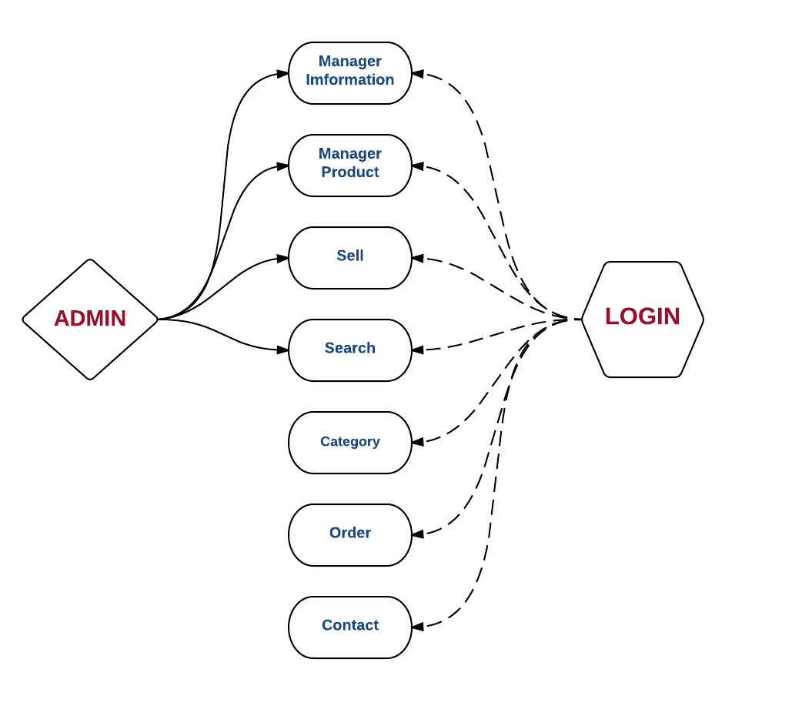

Figure 1.1.3. Graph Usecase Admin

1.2. Graph Use case Decomposing function (Level 2)

1.2.1. Decomposing Use case Information Manager

##### 

Figure 1.2.1. Graph Decomposing Usecase Information Manager

### 

1.3. Graph Use case Decomposing function (Level 3)

1.3.1. Decomposing Use case User Manager

##### 

Figure 1.3.1. Graph Decomposing Usecase User Manager

1.3.2. Decomposing Use case Product Manager

##### 

Figure 1.3.2. Graph Decomposing Usecase Product Manager

##### 

1.3.3. Decomposing Use case Suppliers Manager

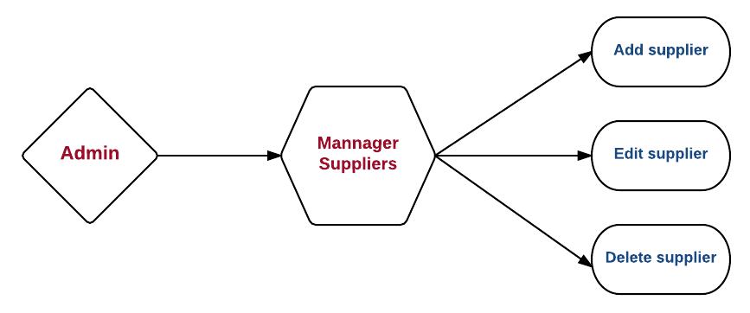

Figure 1.3.3. Graph Decomposing Usecase Suppliers Manager

1.4. Description Use case

1.4.1. Usecase Login (User)

##### 

##### 

1.4.2. Use case Register Account:

##### 

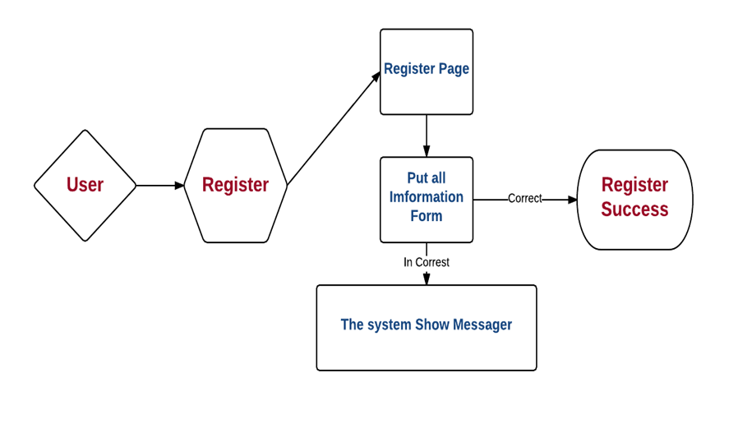

1.4.3. Use case See Product Information:

##### 

2. Activity diagram

2.1. Function Register:

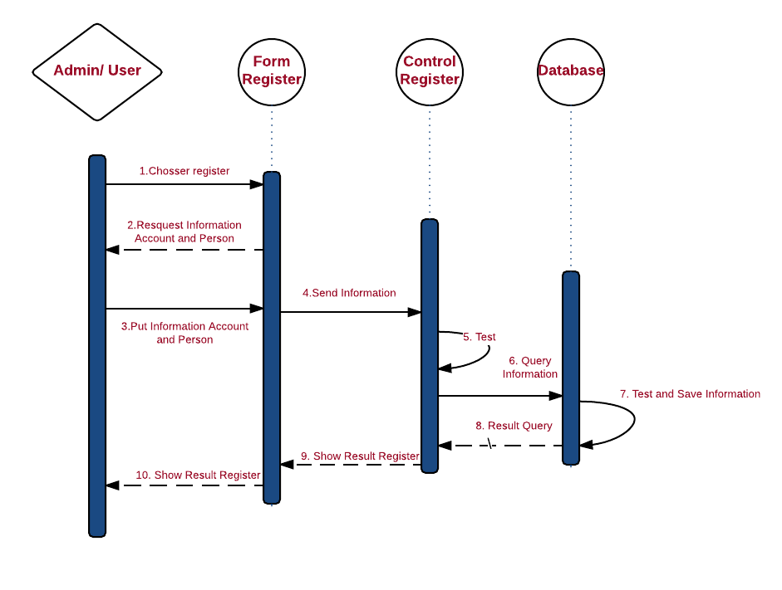

Figure 2.1. Activity diagram fucntion Register

2.2. Function Login:

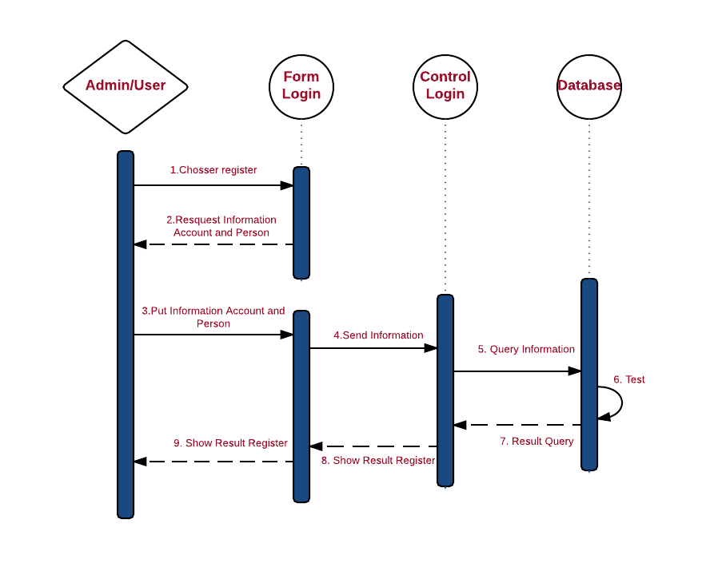

Figure 2.2 Activity diagram fucntion Login

2.3. Function Order Buy:

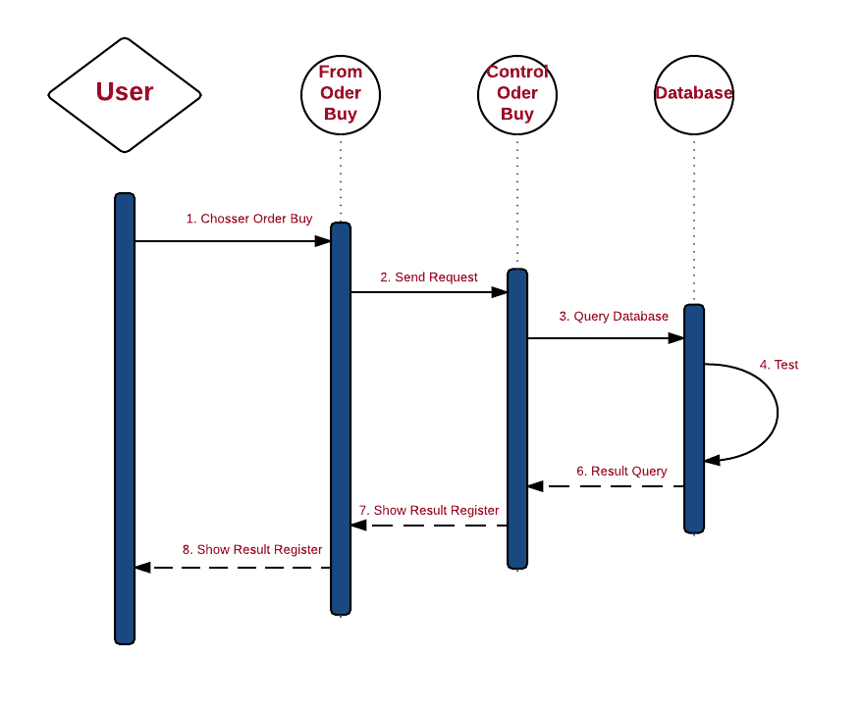

Figure 2.3. Activity diagram fucntion Buy

2.4. Function Add Product:

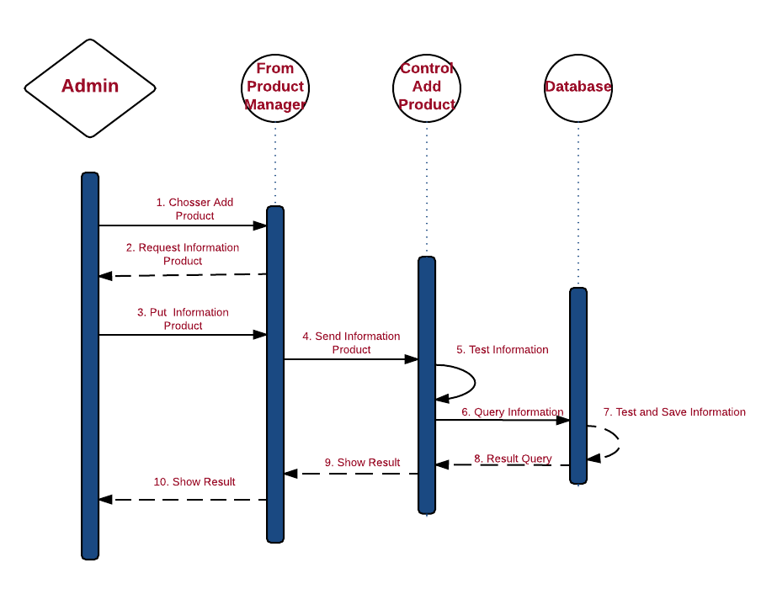

Figure 2.4. Activity diagram fucntion Add Product

2.5. Function Edit Product:

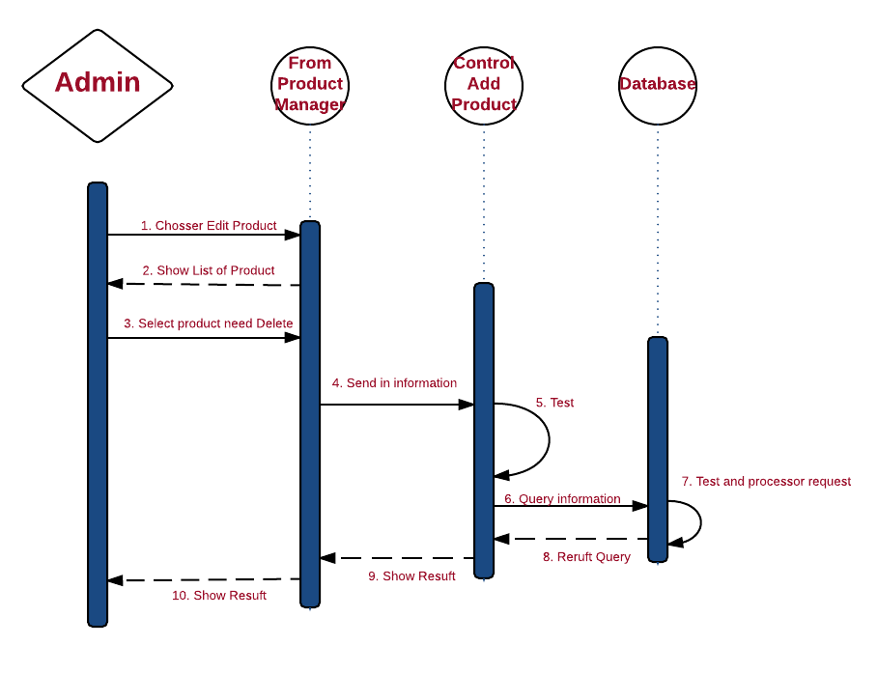

Figure 2.5. Activity diagram fucntion Edit Product

2.6. Function Delete Product

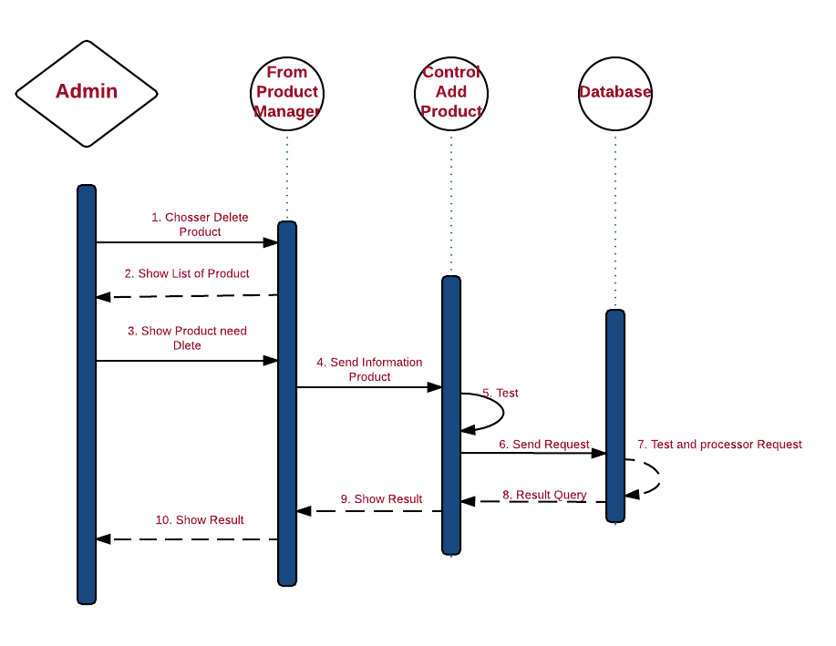

Figure 2.6. Activity diagram fucntion DeleteProduct

2.7. Function Search:

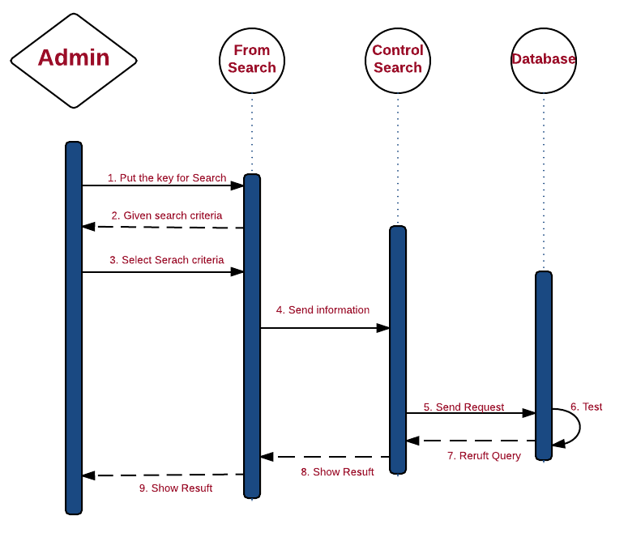

Figure 2.8. Activity diagram fucntion Search

3. Chart Decentralization Function.

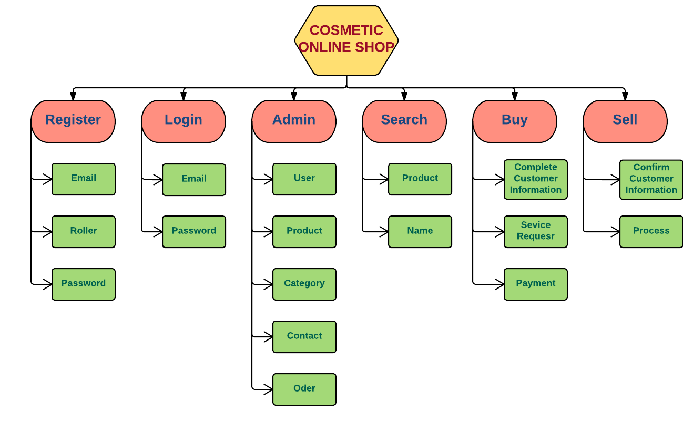

CHAPTER III: DESIGN OF DATABASES

1. Databases-Diagram.

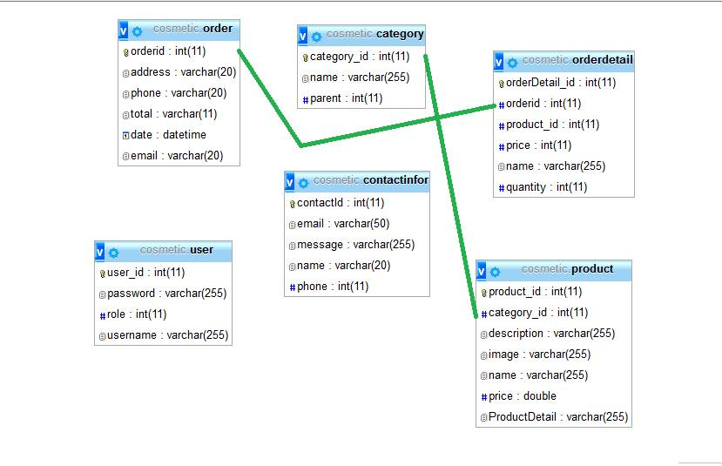

2. Tabels Databases.

2.1. Table User:

|  |  |  |
| --- | --- | --- |
| Column Name | Data Type | Allow Nulls |
| User_ID (Primary Key) | Int(11) | Not Null |
| UserName | Nvachar(255) | Null |
| Password | nvachar(255) | Null |
| Role | int(11) | Null |

2.2. Table Products:

|  |  |  |
| --- | --- | --- |
| Column Name | Data Type | Allow Nulls |
| Product_ID (Primary Key) | Int(11) | Not Null |
| Category_ID | Int(11) | Null |
| Discription | nvarchar(255) | Null |
| Image | varchar(250) | Null |
| Name | Varchar | Null |
| Price | double | Null |
| ProductDetail | nvarchar(255) | Null |

2.3. Table Category:

|  |  |  |
| --- | --- | --- |
| Column Name | Data Type | Allow Nulls |
| Category_ID (Primary Key) | int | Not Null |
| Category_Name | nvarchar(250) | Null |
| Parent | Int(11) | Null |

2.4. Table Order:

|  |  |  |
| --- | --- | --- |
| Column Name | Data Type | Allow Nulls |
| Order_ID (Primary Key) | int | Not Null |
| Address | datetime | Null |
| Phone | int | Null |
| Total | nvarchar(250) | Null |
| Date | nvarchar(250) | Null |
| Email | nvarchar(250) | Null |

PART III: DESCRIPTION INTERFACE

## The main interface of the program consists of two parts: for the administrator and parts for customers.

1. Homepage interface for customers.

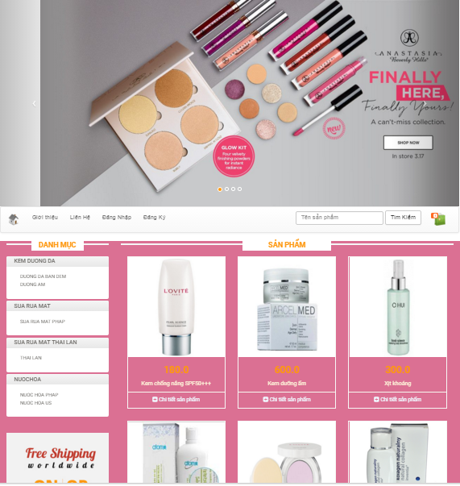

This site is divided into 4 parts:

- Part 1 of the site icon

- Part 2 - Horizontal Menu: Including the items, descriptions, registration, login, search. Each category links to a page with different content.

- Part 3: On the left is the bar menu to help customers seeking to review the information on products including lotion, cleanser, perfume.

- Part 4: In the middle is the information about the products displayed at the request of the customer or the information that the government provides to customers.

1.1. Menu Product Category

This menu contains a list of specific cosmetics. Customers can use this menu to work. Corresponding to a number of popular product lines for customers to search and select buyers.

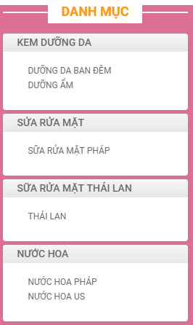

1.2. Introduce Page:

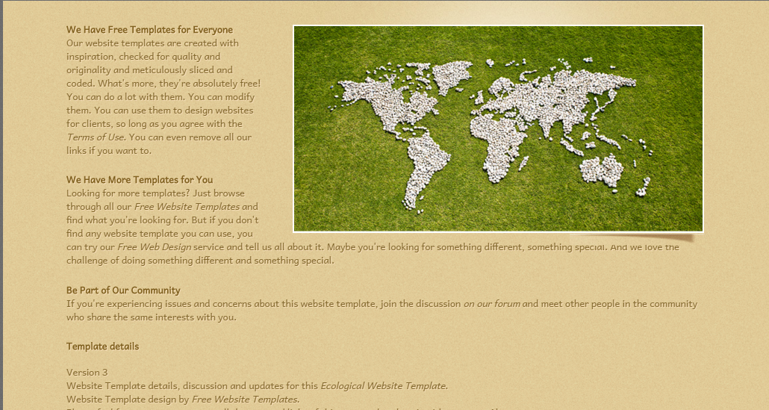

1.3. Contact Page

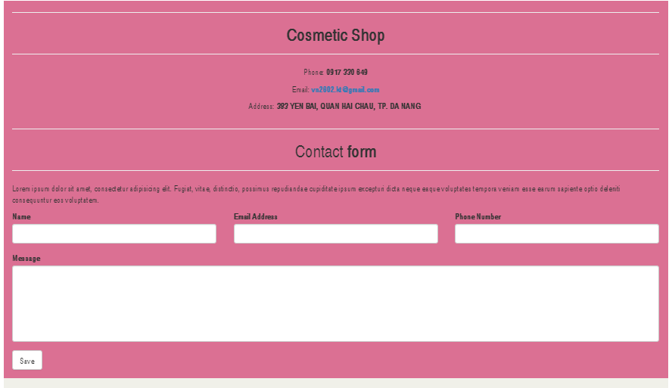

1.4. Product Detail Page:

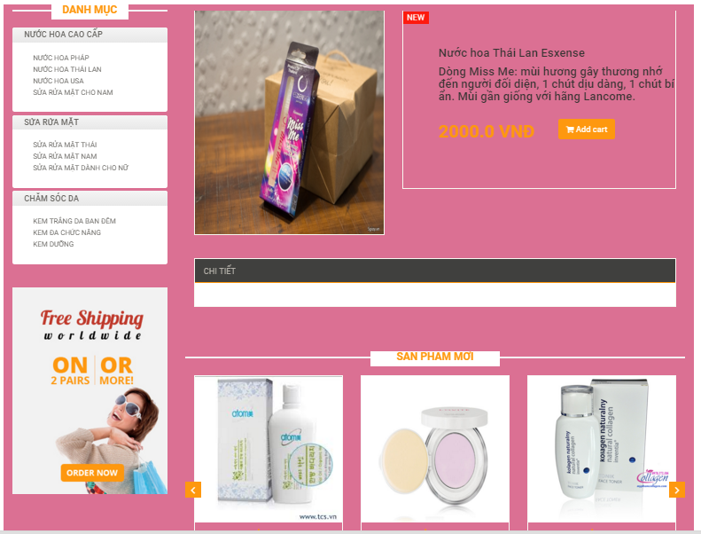

* 1. Login and Register Page:

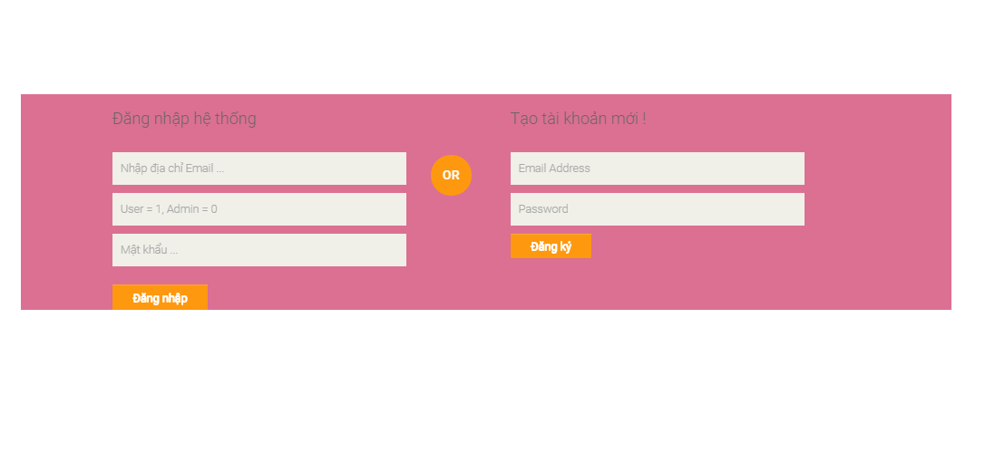

1.6. Cart Page:

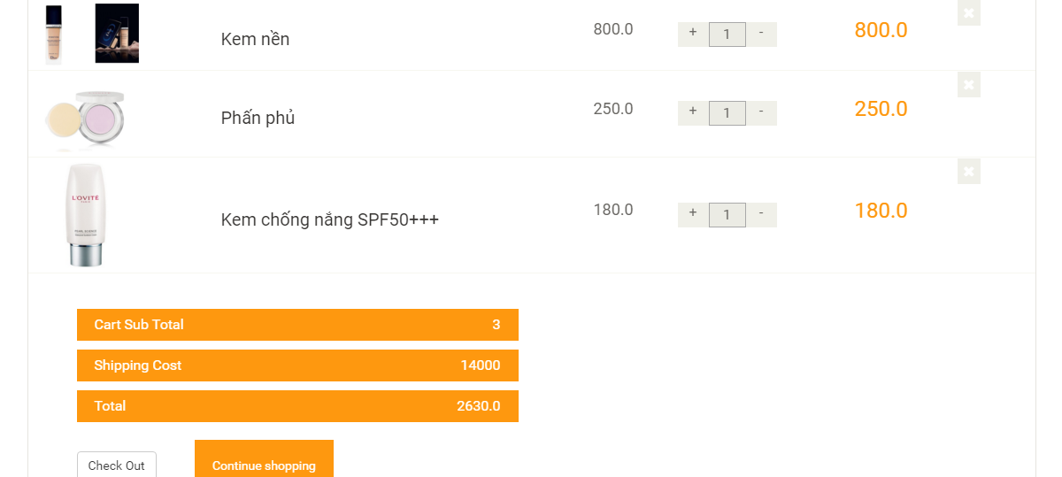

2. Interface Page for Admin

2.1. Created Account Page:

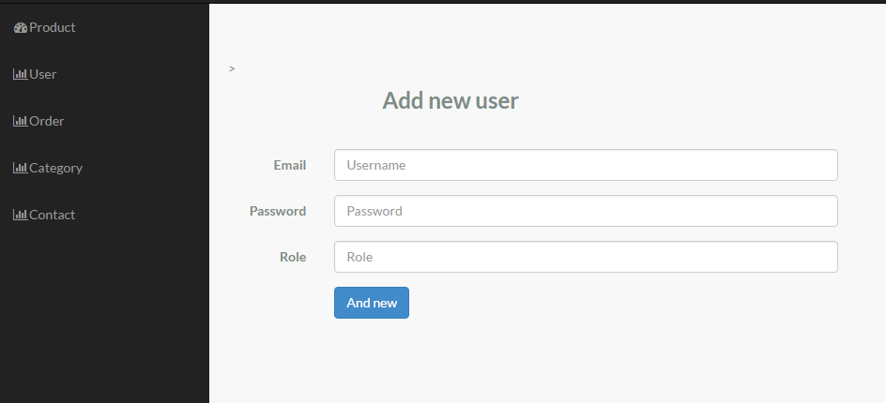

2.2. Created Product Page:

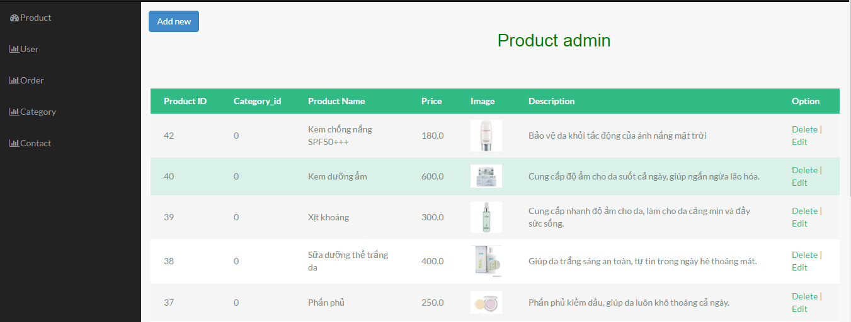

2.3. The Bill Information Page:

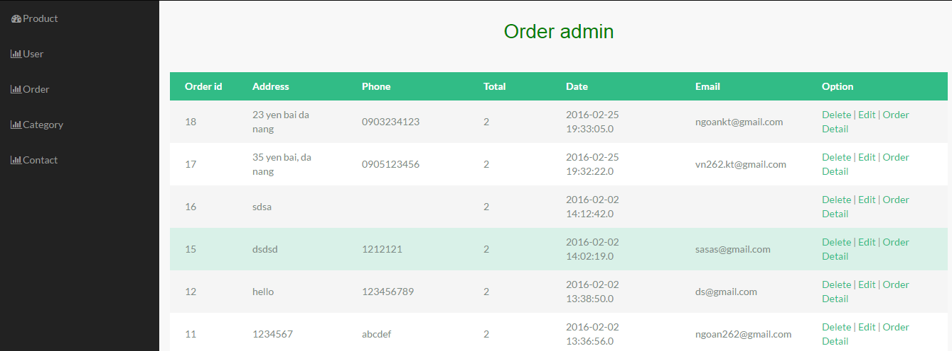

PART IV: TEST AND APPRAISE PROGRAM

1. Setup:

### Computer System Requirements Minimum::

### Operating System: Windows

### Computer with Internet connection

2. Testing

## Programs work best on the Web browser IE 7.0 and above FireFox and other browsers, Chrom ...

## The functional design and stable running properly.

## Browsing speed first program can not fast because of the admin interface is designed entirely on a jsp page.

3. Appraise:

## Basically, the website introduces and provides a full range of service functions necessary for the sale of store.

## Bringing images of Shop for many people.

PART V: CONCLUSION

During the implementation of the scheme, the group got together they split working arrangements sensibly. With their best effort of the members of the group, the group you have completed the prescribed time.

Finally, we sincerely thank.

The Result:

✓ Website Building successful Cosmetic online Shop, meet the requirements of users.

✓ Learn relatively hard about Website

✓ Learn relatively basic and comprehensive JSP, CSS, JavaScript, HTML ....

✓ Analysis of system design is relatively complete.

✓ Website designed interface simple, friendly and easy to use

Restrictions:

✓ The Performing the information on the website has not been flexible.

✓ Performing the information on the website has not been flexible.

✓ There isn't payment functions Online.

✓ Administrators still incomplete

Student performing groups

Nguyễn Văn Ngoan

Đinh Phương Thúy

APPENDIX

**1- PROJECT PLAN:**

1- Nguyen Van Ngoan : Team Leader

2- Dinh Phuong Thuy: Member

- Roles and responsibilities Table:

|  |  |  |  |
| --- | --- | --- | --- |
| **NO** | **full name** | **responsibilities** | **NOTE** |
| **1** | Nguyễn Văn Ngoan | - Survey required  - Research and technology  - Design home page , product detail , admin page,  - Design database |  |
| **2** | Đinh Phương Thúy | - Survey required  - Design page Login, Register,  - Testing  - Search product image  - Input product  - Document, Slide |  |

PROJECT MANAGEMENT PLAN DETAILS

|  |  |  |  |  |  |
| --- | --- | --- | --- | --- | --- |
| **NO** | **Task** | **Start Day** | **End Date** | **Member** | **Status** |
| 1 | Survey required  Research and technology  Design Web Interface, CSS | 01/01/2016 | 10/01/2016 | Ngoan | Completed |
| 2 | Survey required  Research and technology  Design database | 10/01/2016 | 20/01/2016 | Ngoan | Completed |
| 3 | Survey required  Research and technology | 20/01/2016 | 01/02/2016 | Ngoan-Thúy | Completed |
| 4 | Design Home Page, Product Page, Customer Page | 01/2/2016 | 10/02/2016 | Ngoan | Completed |
| 5 | Design Contact Page, Introduce Page, Home page, Login page, Regist page | 10/02/2016 | 20/02/2016 | Ngoan-Thúy | Completed |
| 6 | Design Admin Page, Cart Page | 20/02/2016 | 25/02/2016 | Ngoan-Thúy | Completed |
| 7 | Test and and Complete Website | 25/02/2016 | 01/03/2016 | Ngoan-Thúy | Completed |
| 8 | Design Search Page, Update Cart, Test Interface and Database | 01/03/2016 | 10/03/2016 | Ngoan-Thúy | Completed |
| 9 | Complete Document, Slide, Test and Complete Website | 10/03/2016 | 15/03/2016 | Thúy | Completed |