Quản trị mạng – Nguyễn Ngọc Thương - 19IT357

1. Creating and configuring GPOs

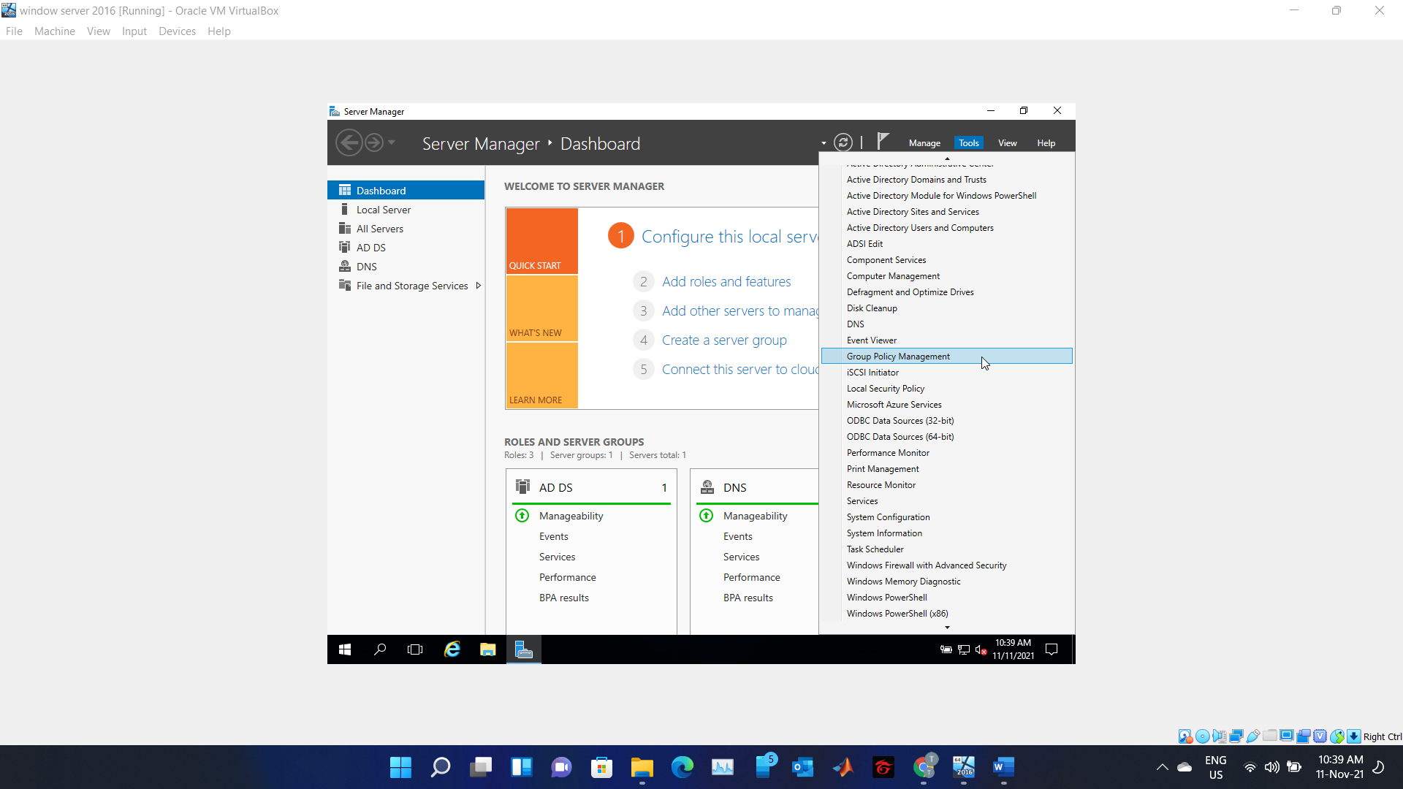

Hình 1 – Click Group Policy Management

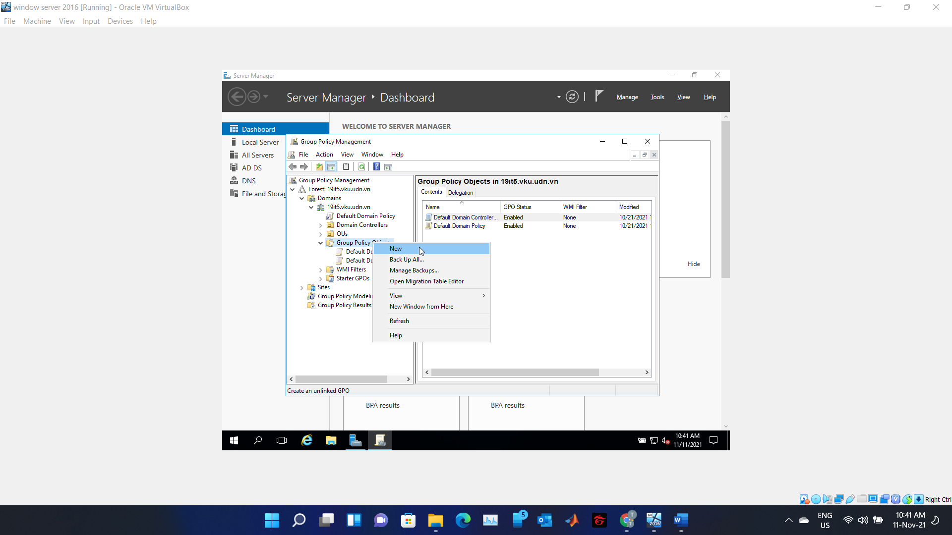

Hình 2 – Click New

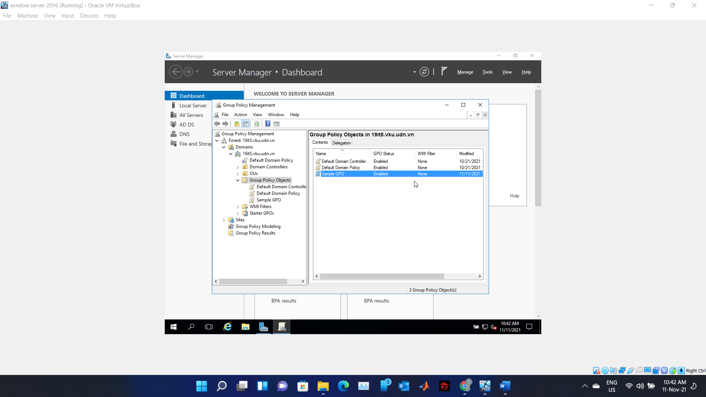

Hình 3 – Created GPO

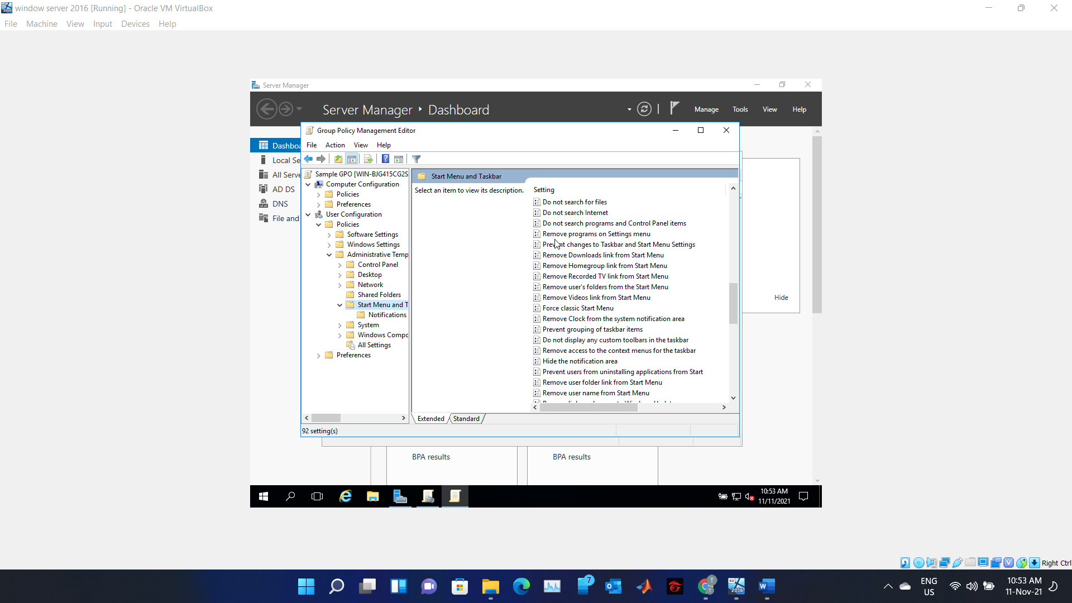

Hình 4 – Edit -> Start Menu and taskbar

1. Your manager asked you to use Group Policy to implement standardized security settings to lock computer screens when users leave computers unattended for 10 minutes or more

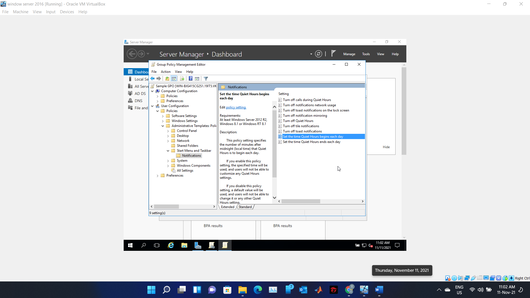

Hình 5 – Click Set the time Quiet begin each day

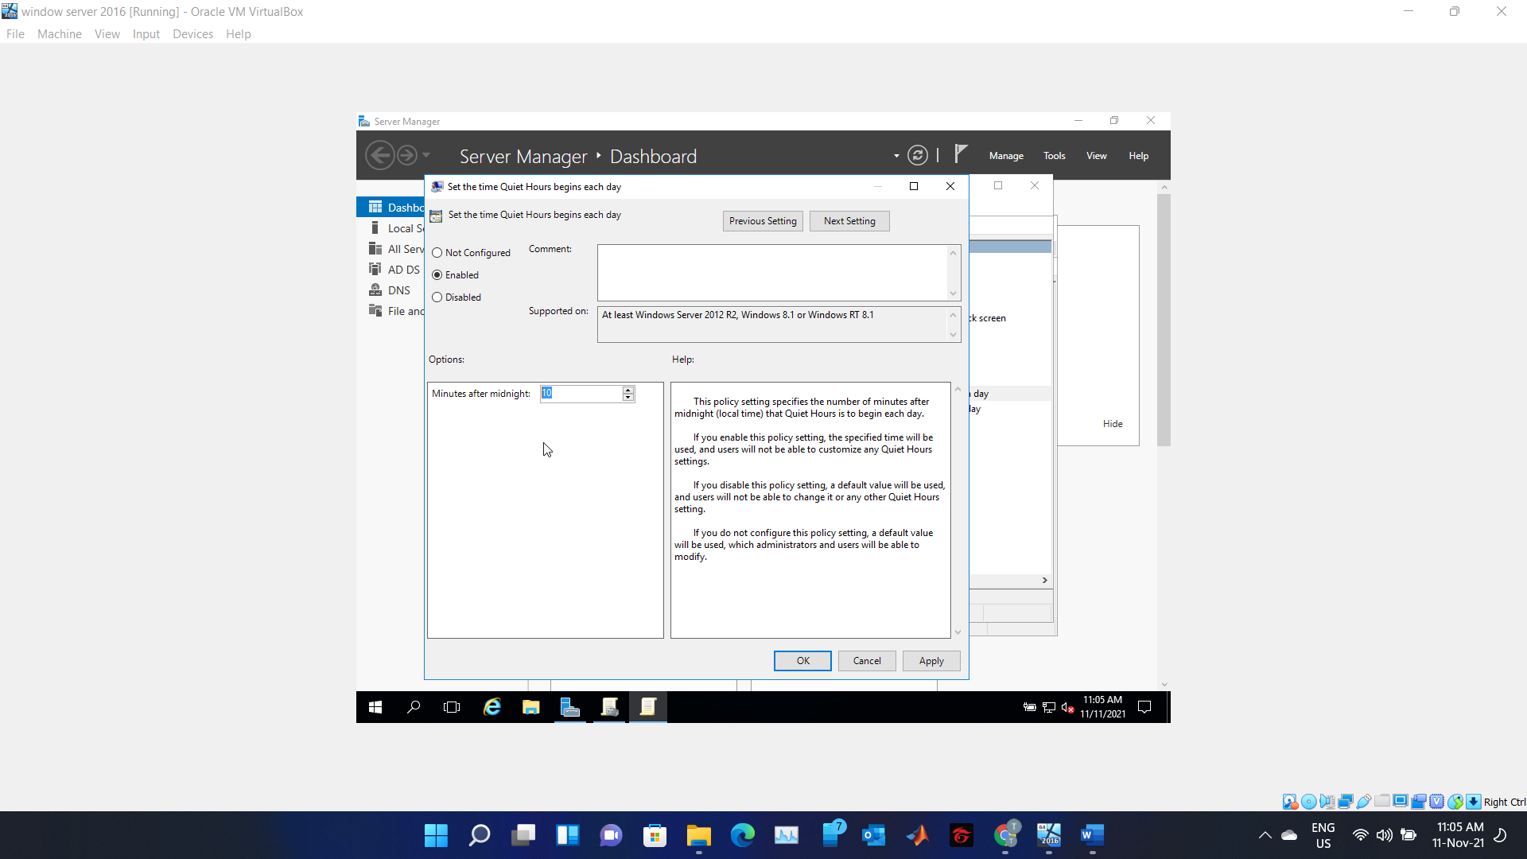

Hình 6 – Set up time off

Then click Apply and OK

1. Link GPO

