Bài tập thực hành Quản Trị Mạng – Nguyễn Ngọc Thương_19IT357

1. Steps to setup DFS Share in the network are given below:

Enabling Server

1. Open Server Manager, click on Manage -> Add Roles and Features. This will open the add roles and features wizard.
2. Click Next to start set up.
3. Select role-based or feature based installation.

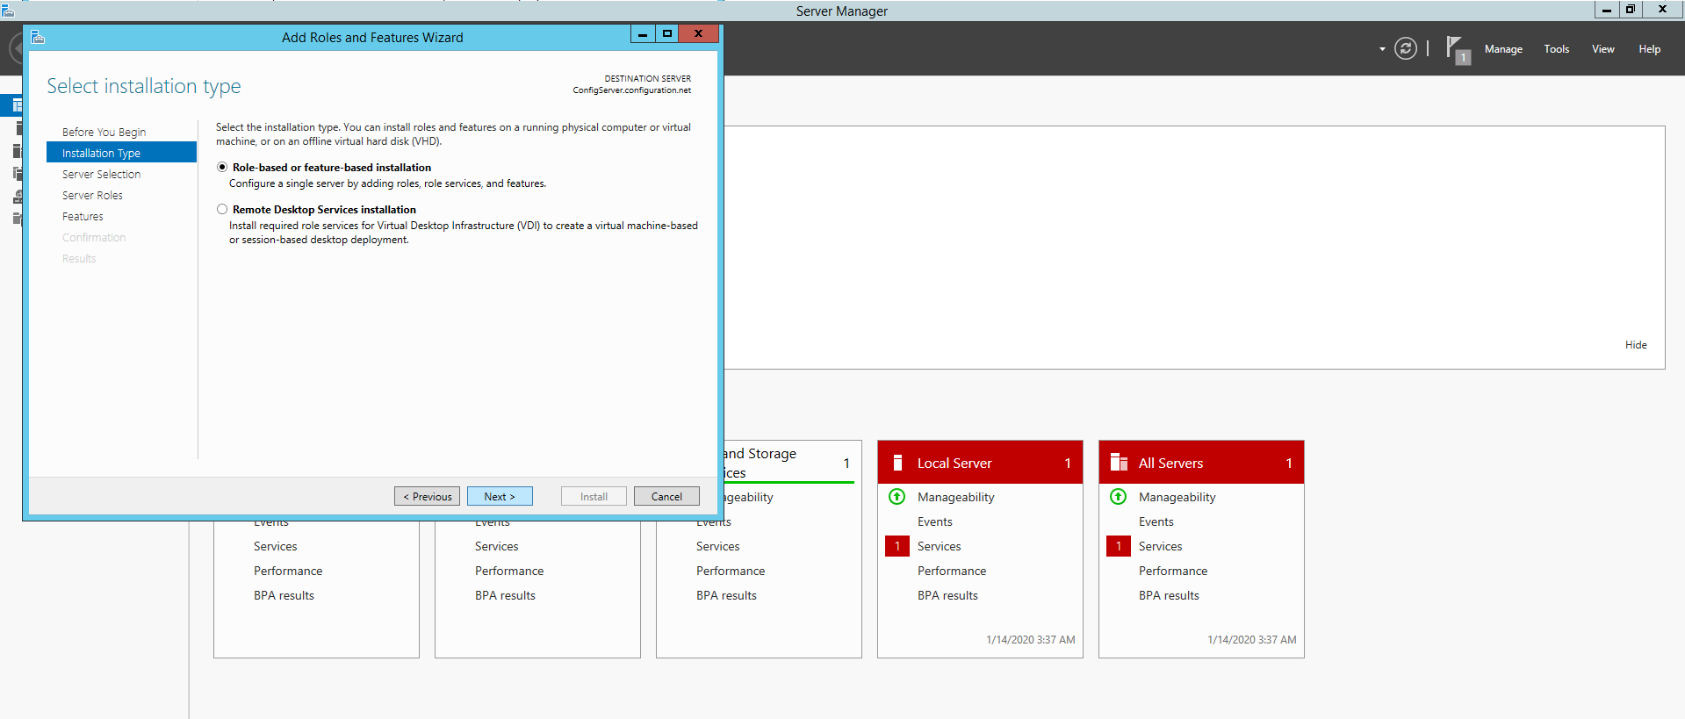

1. Select the server.
2. The next section is Server Roles under file and storage services.
   * Check DFS Namespaces and DFS Replication both on this(your main) server.
   * When you go to check Namespaces, there will be a pop up that asks you if you would like to add features.
   * Click Add Features.

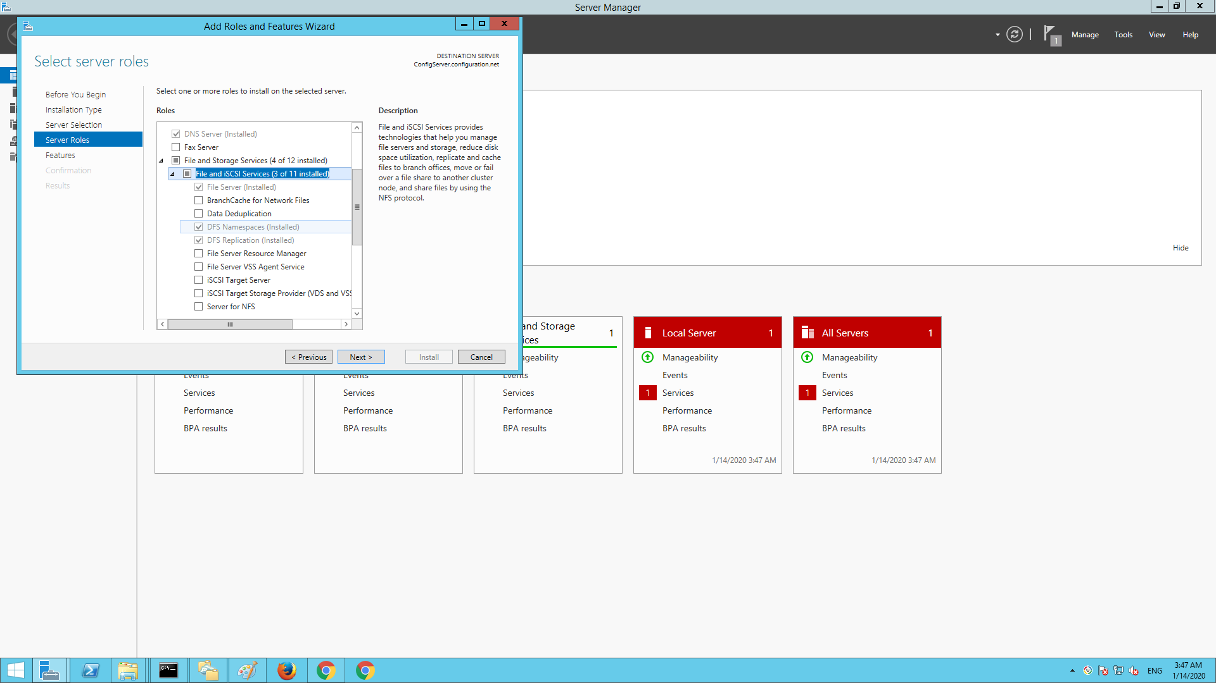

1. Result

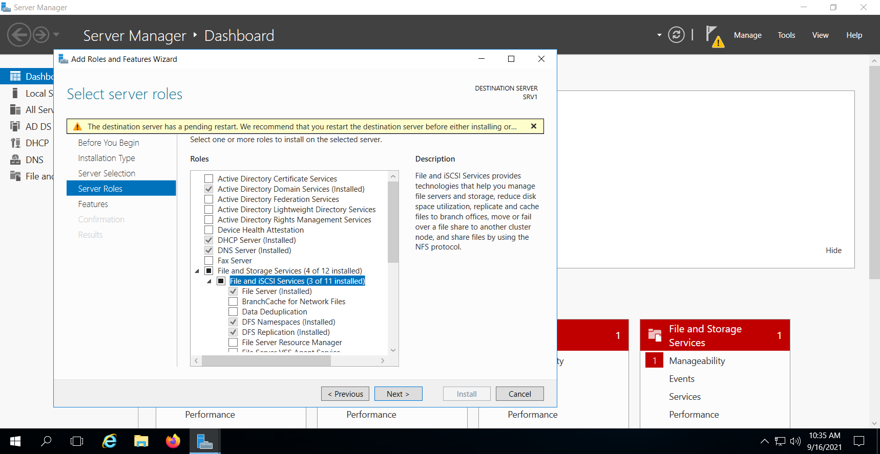

Figure 1 – Installed DFS for TOR-SVR1

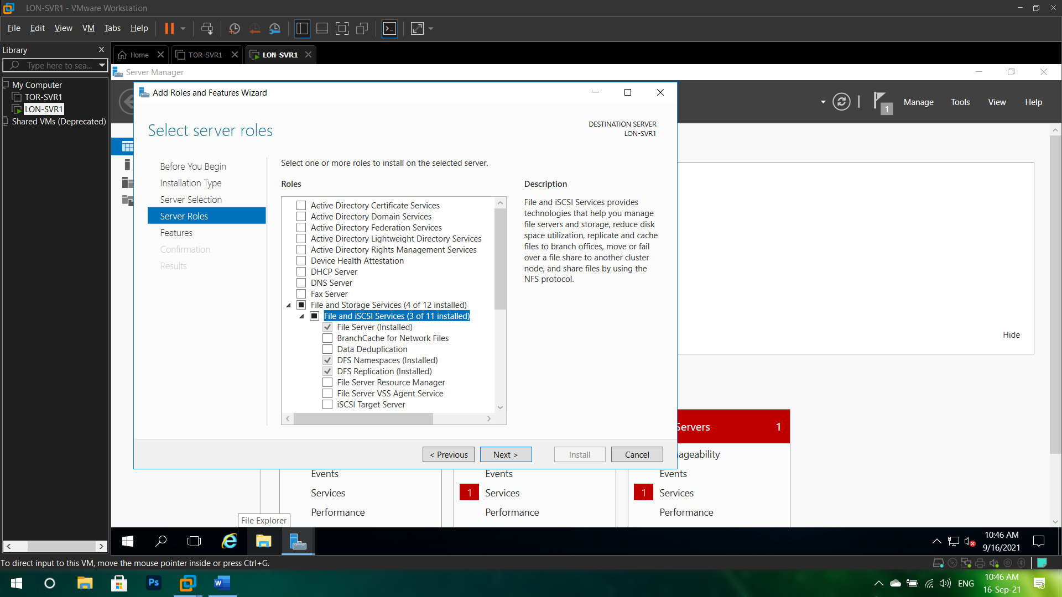

Figure 2 - Installed DFS for LON-SVR1

1. Create the BranchDocs DFS Namespace.
2. Install

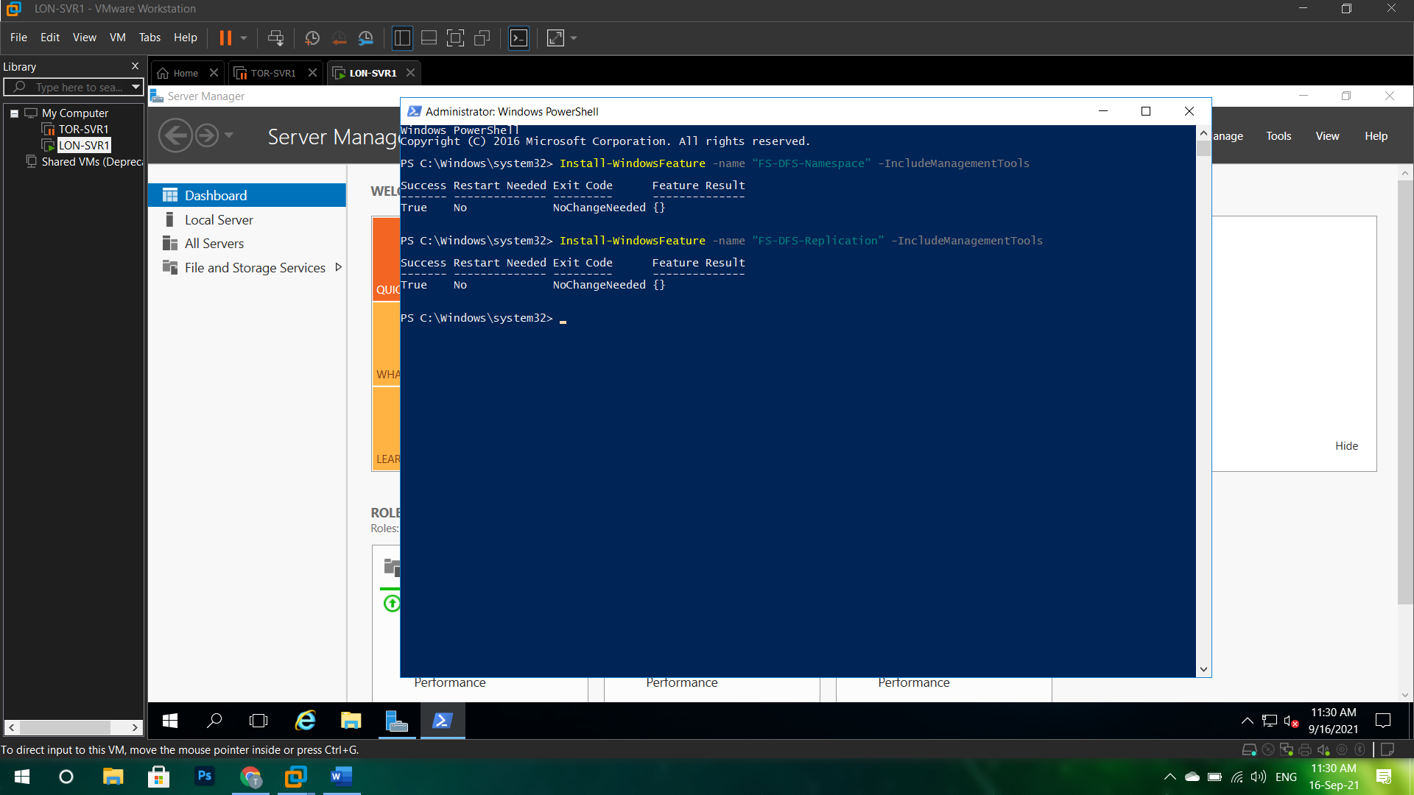

1. command **dfsmgmt.msc.**

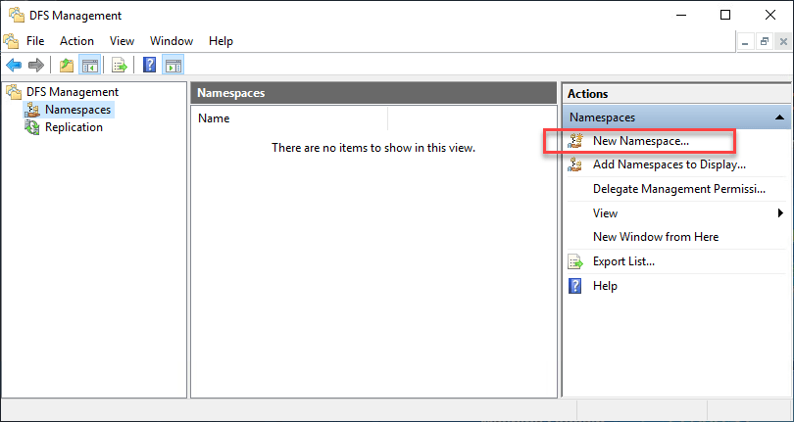

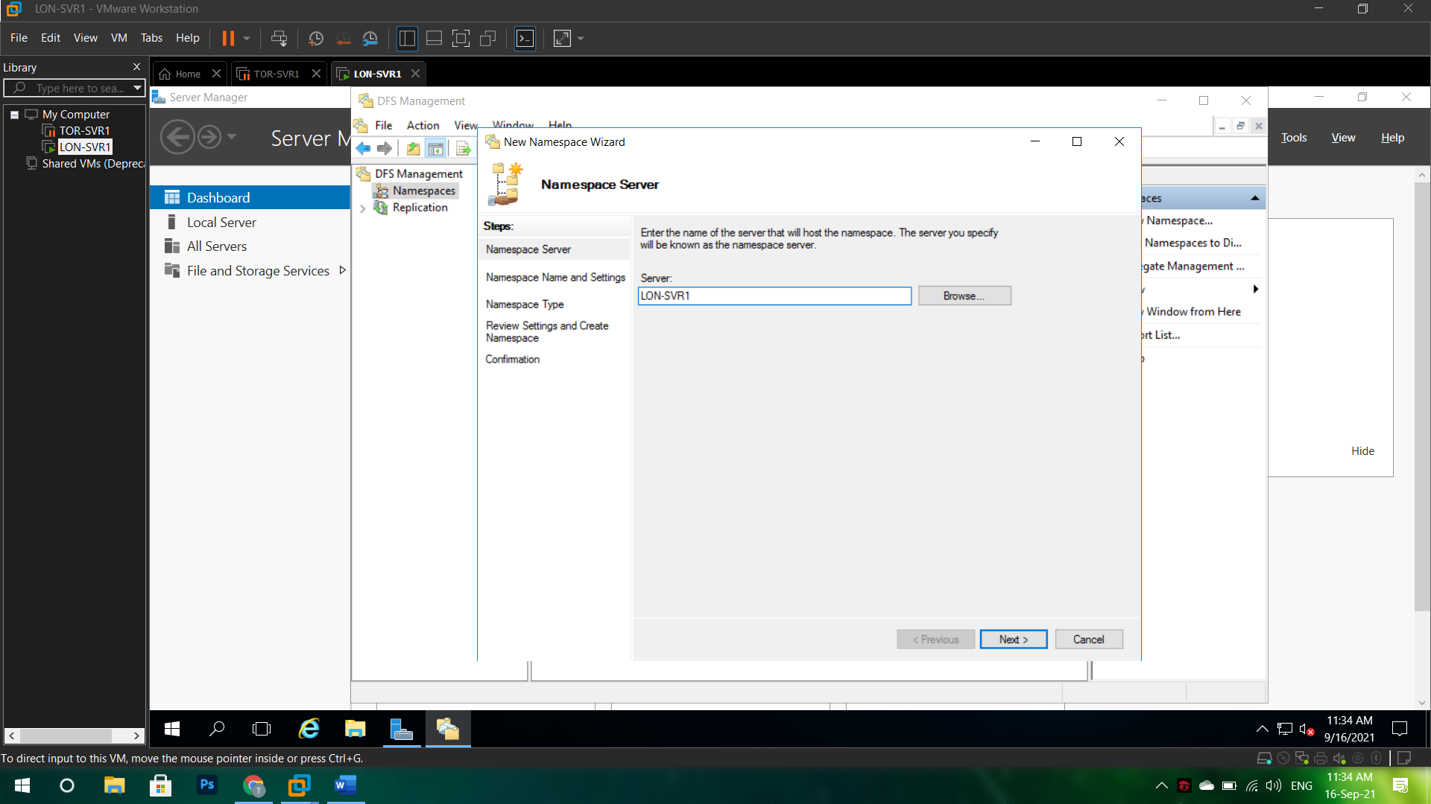

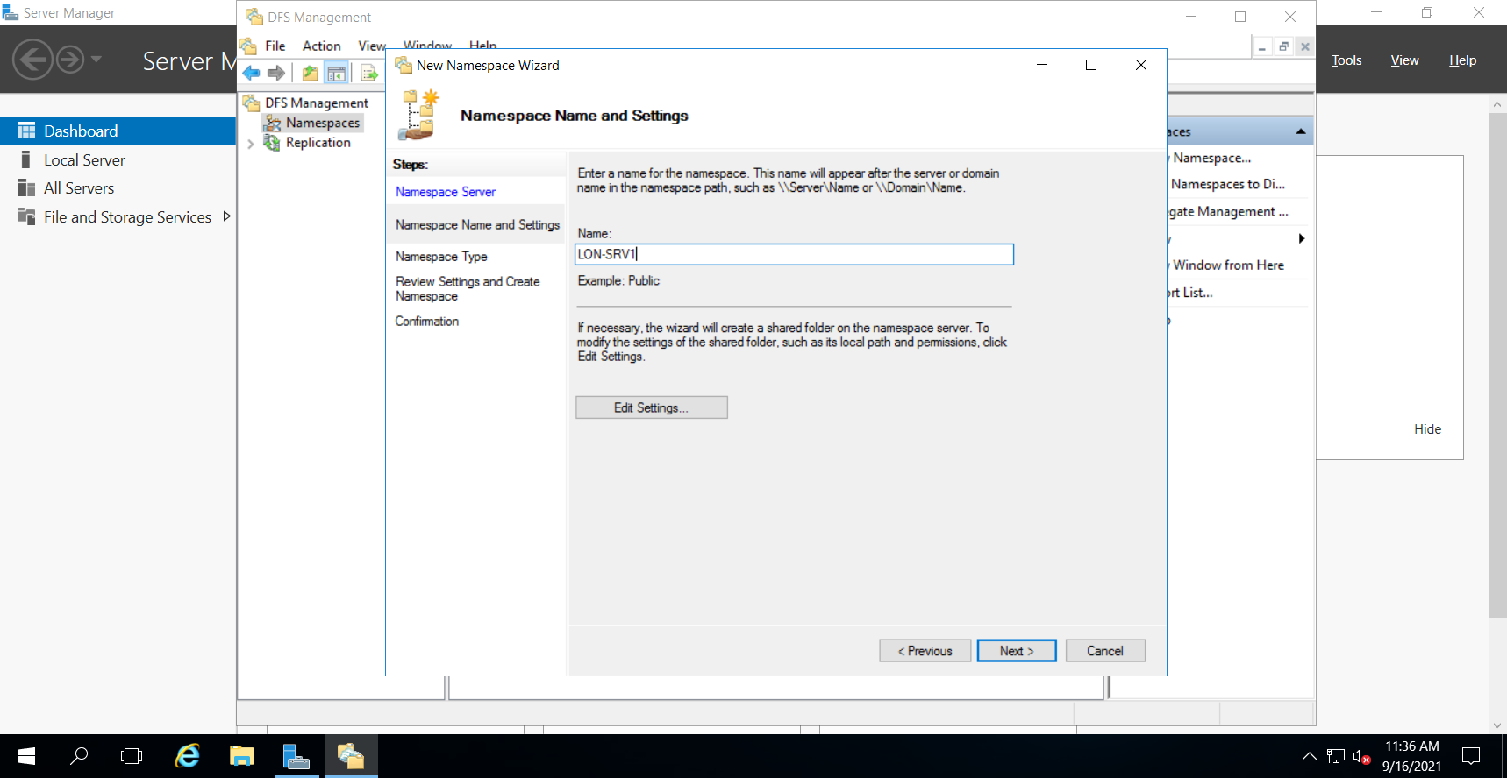

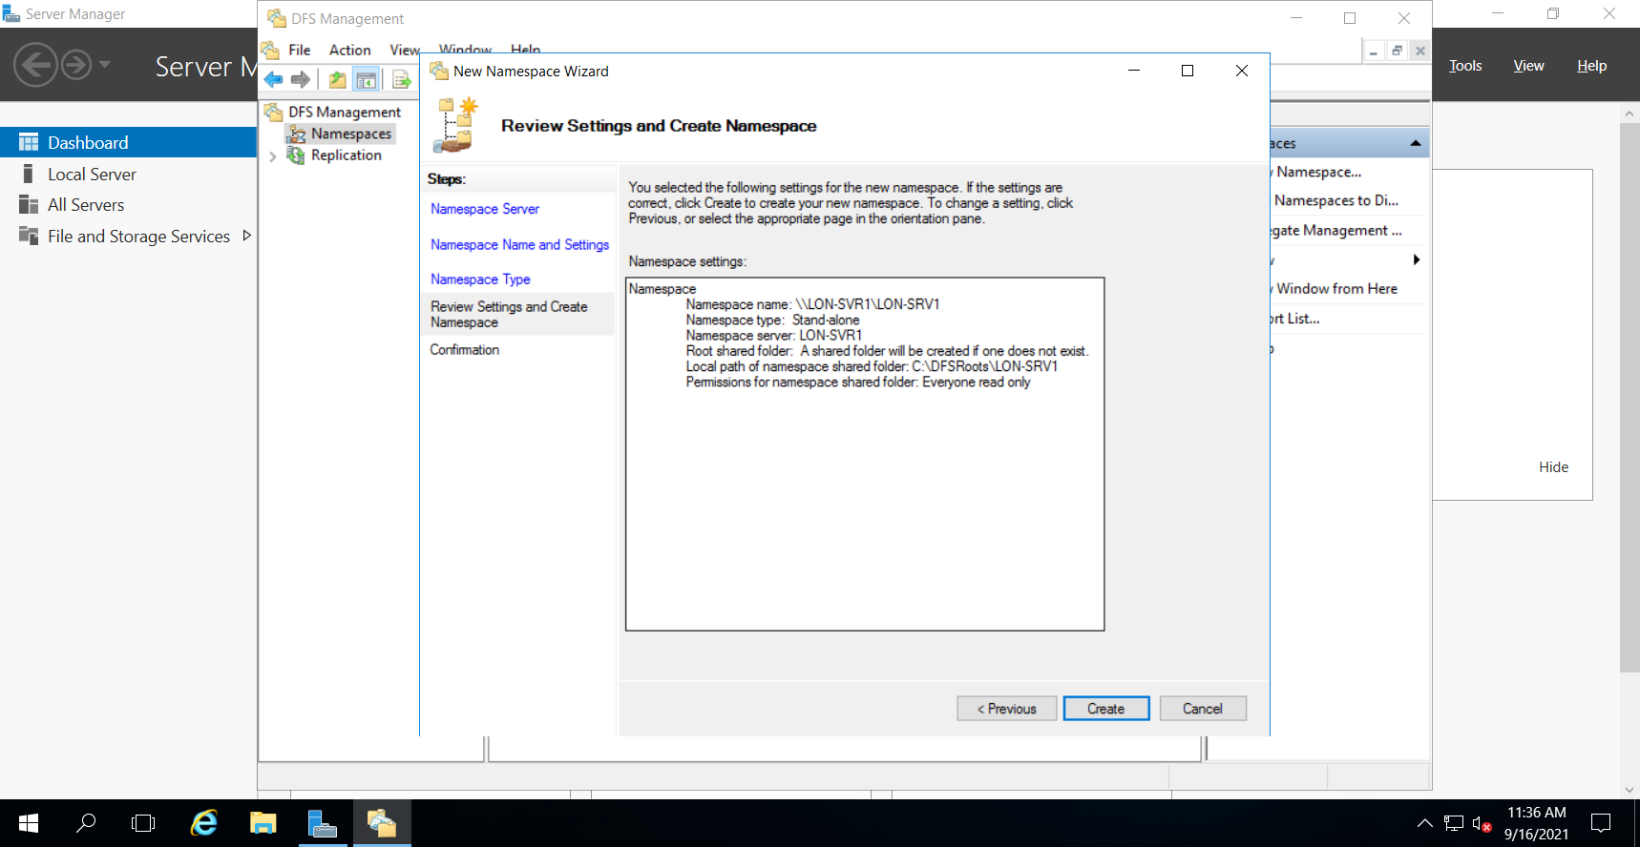

1. Adding a DFS Target to a Namespace

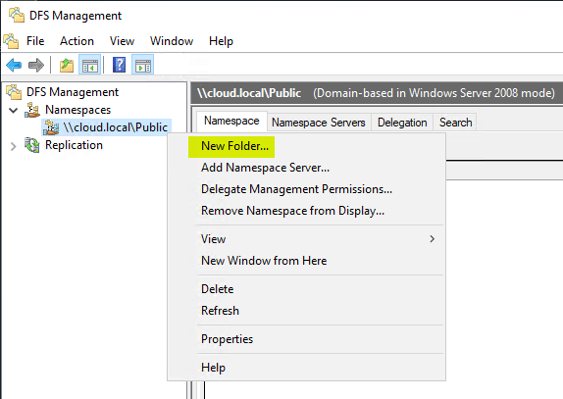

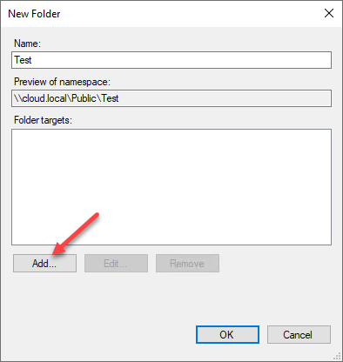

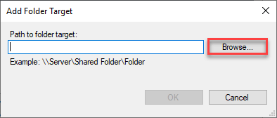

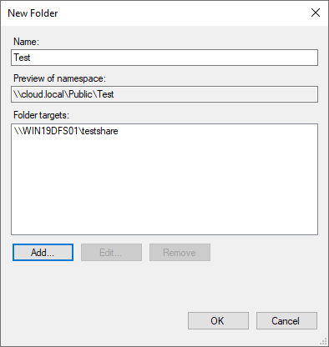

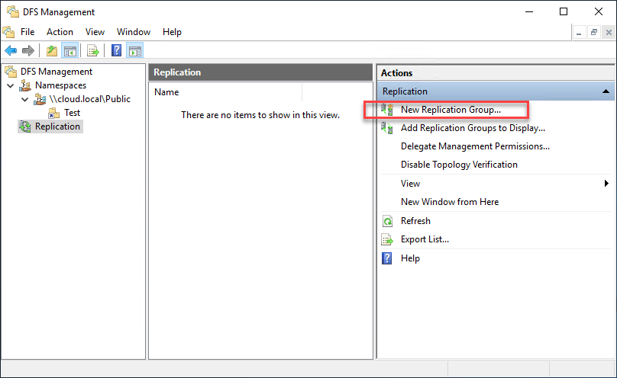

1. Configure replication for the namespace.
2. In the DFS Management home windows, right click on new replication group.

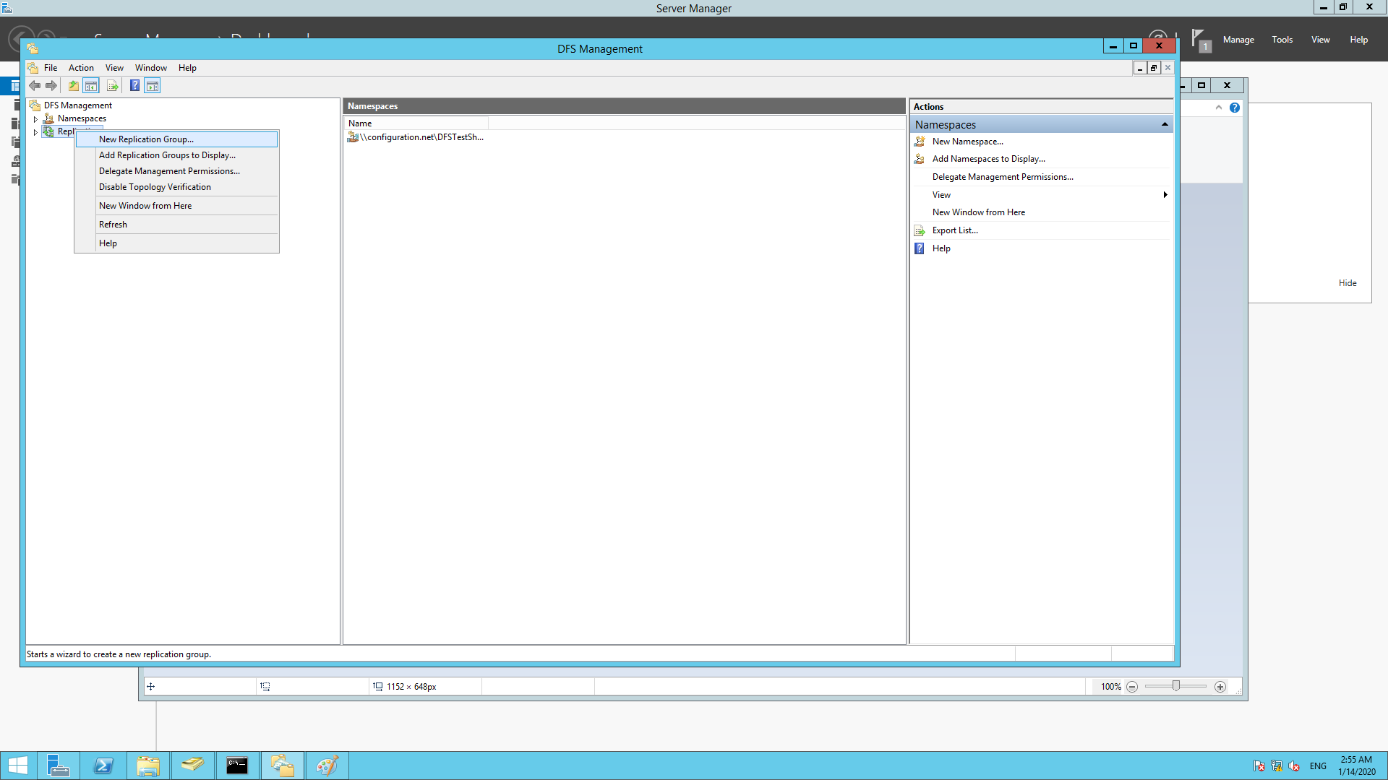

1. Provide the name of the replication group and click Next.

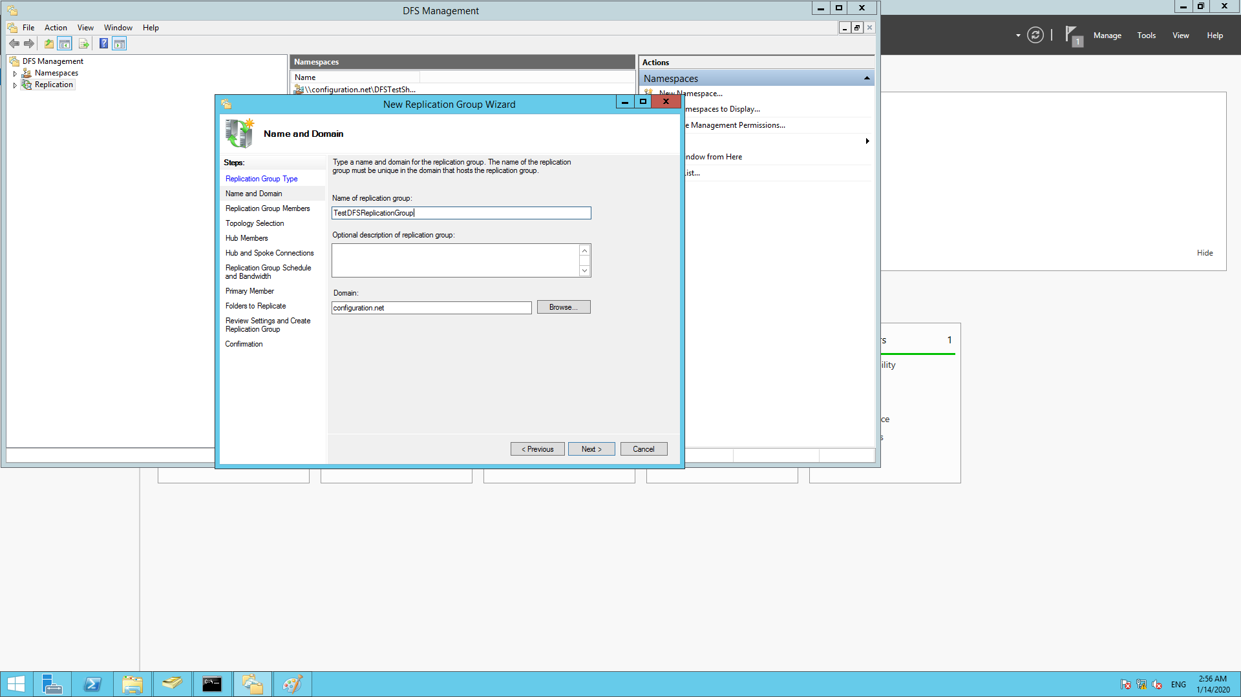

1. Add the servers to the replication group.

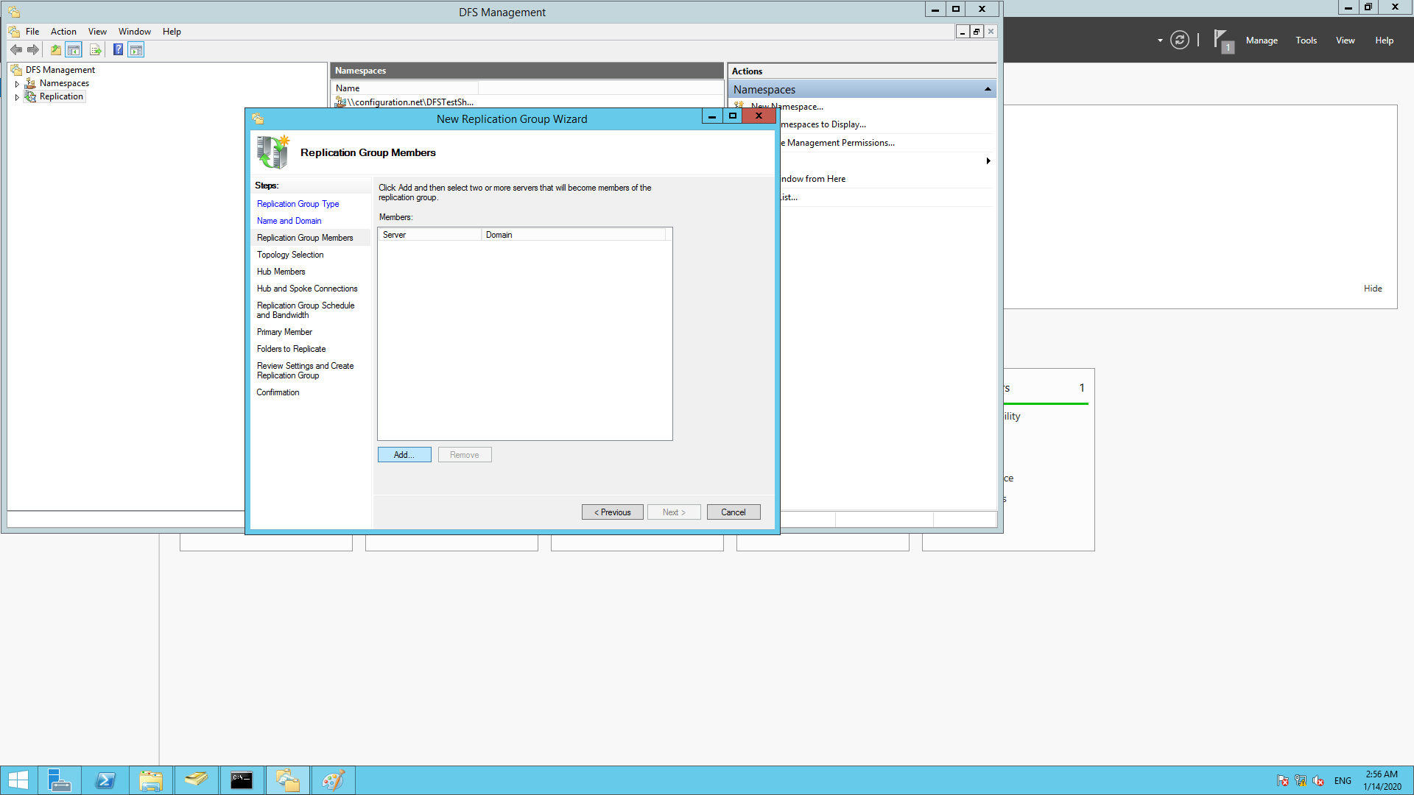

1. In the next window, select Full Mesh(recommended). This will ensure that anything on the first server will be on the other server and vice versa.

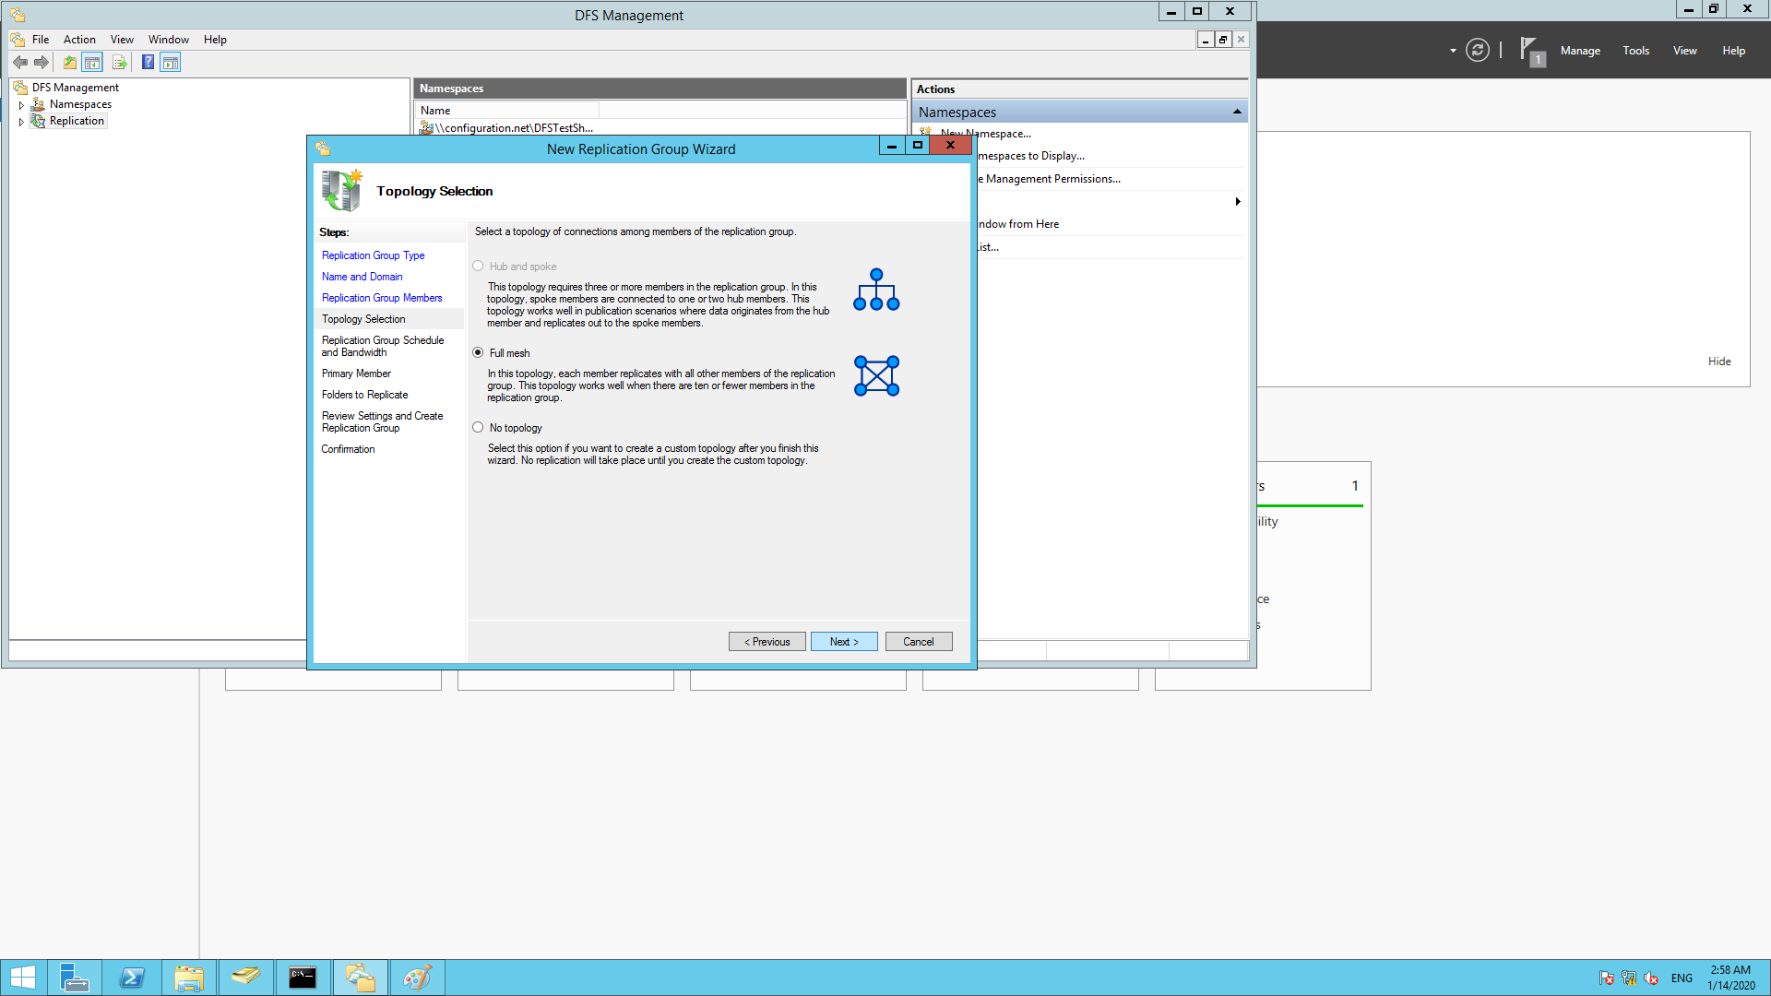

1. Next, set the bandwidth. Consider your network traffic and set it accordingly.

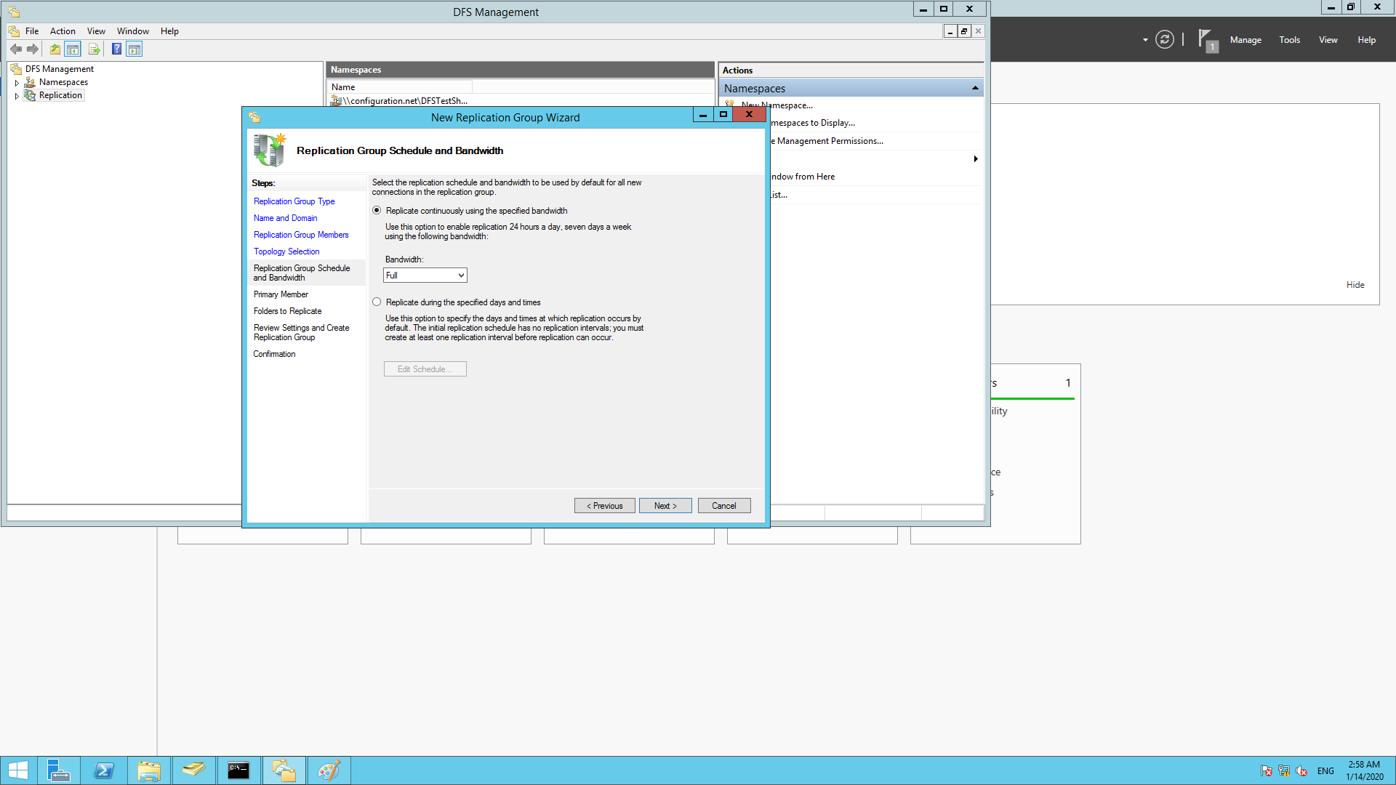

1. Select the primary server and then add a local path of a folder to replicate.

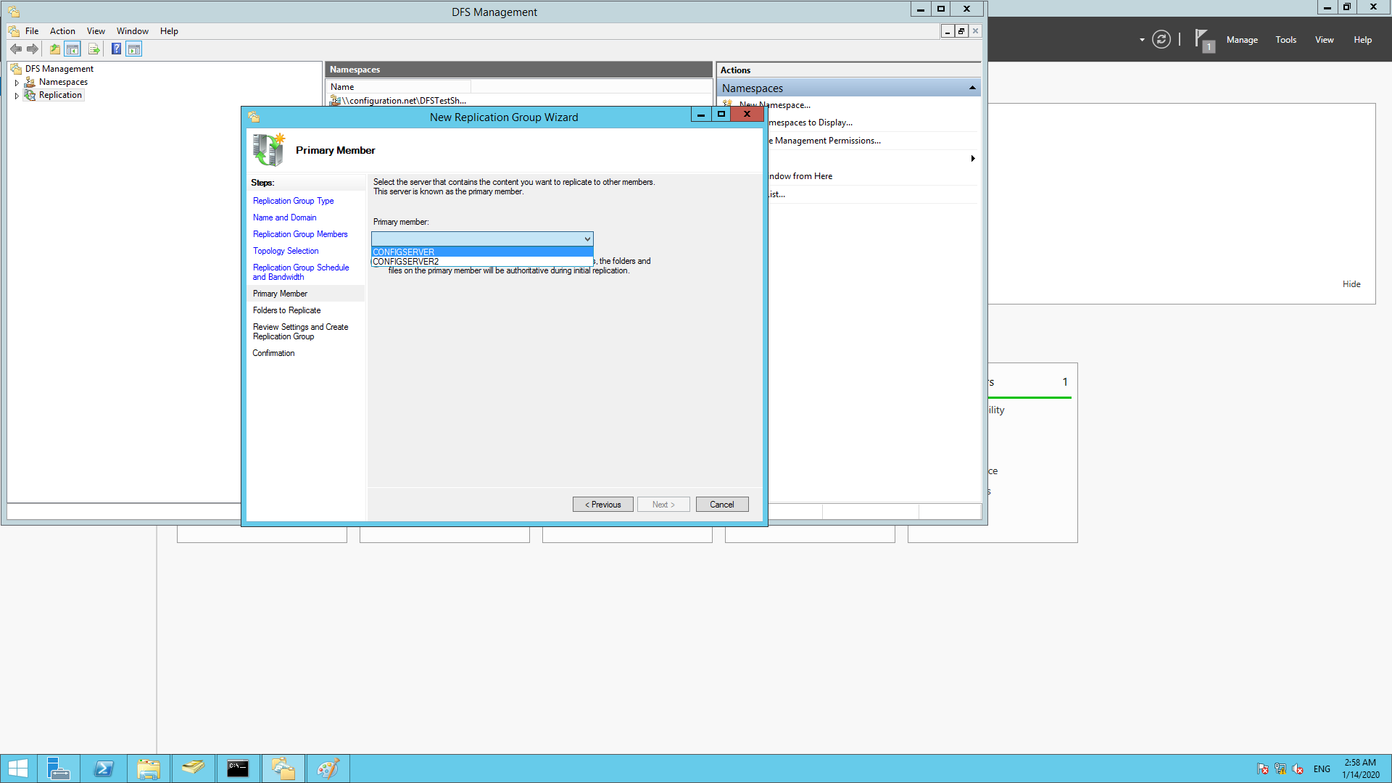

1. Select Permissions ->Custom Permissions, to add groups and provide the necessary permissions. Click Next once the changes are made.

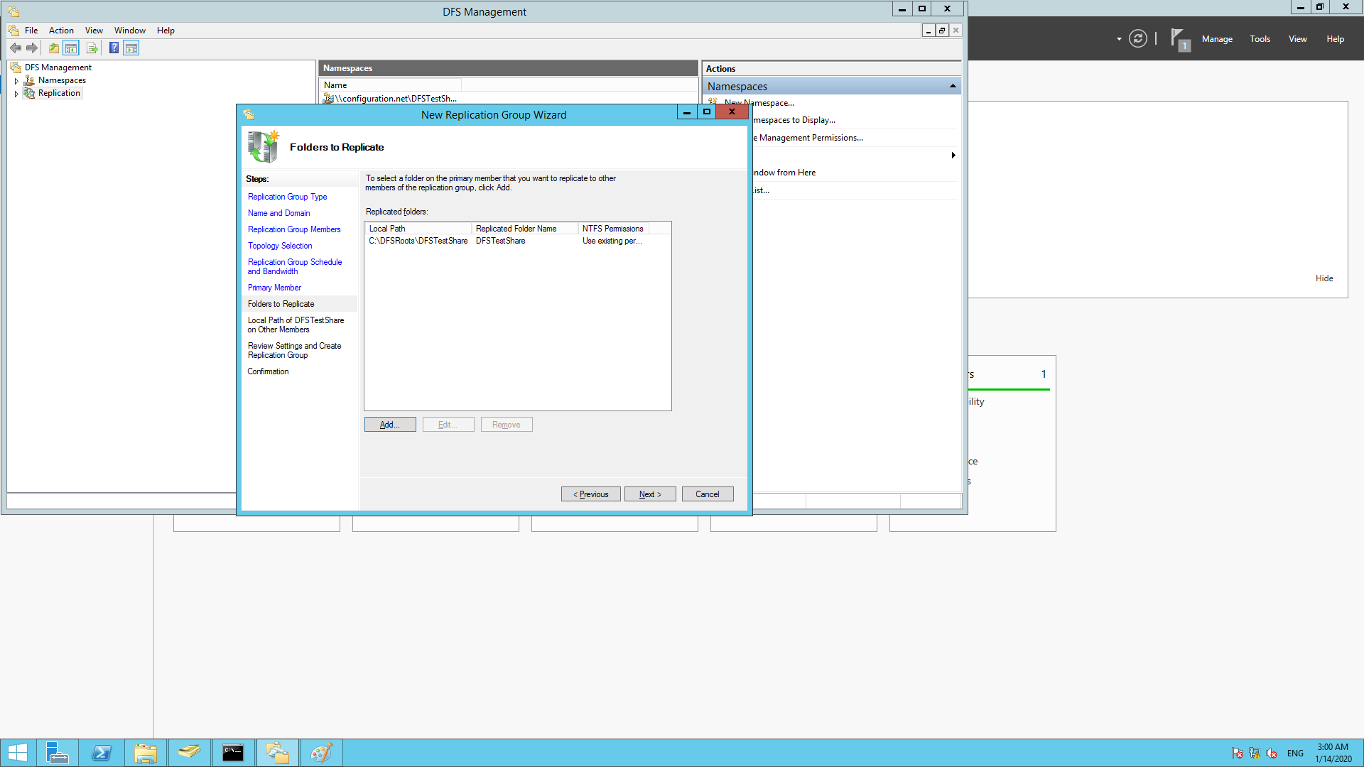

1. Double click on the servers listed to enable them for replicating.

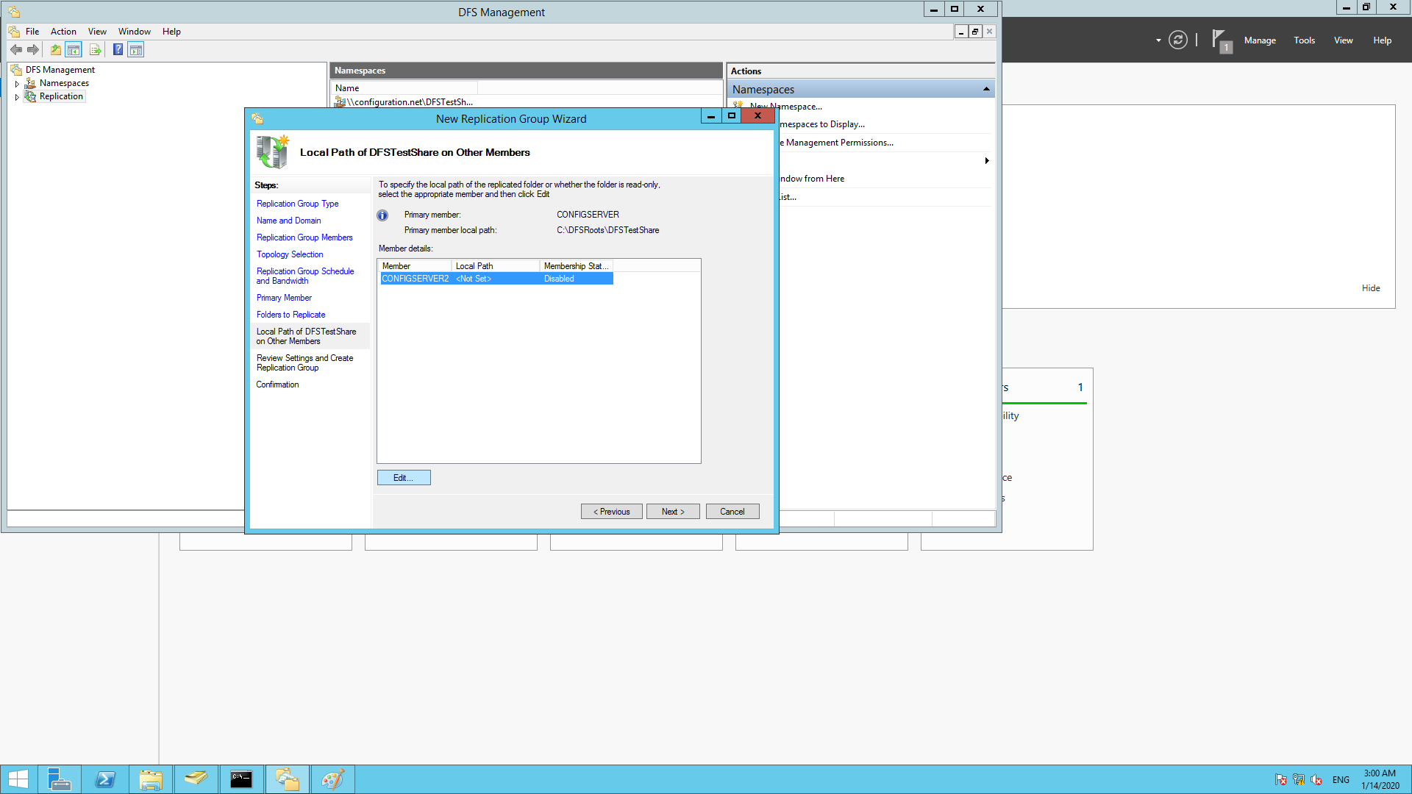

1. Click enable and specify the path that needs to be synchronized with the server.

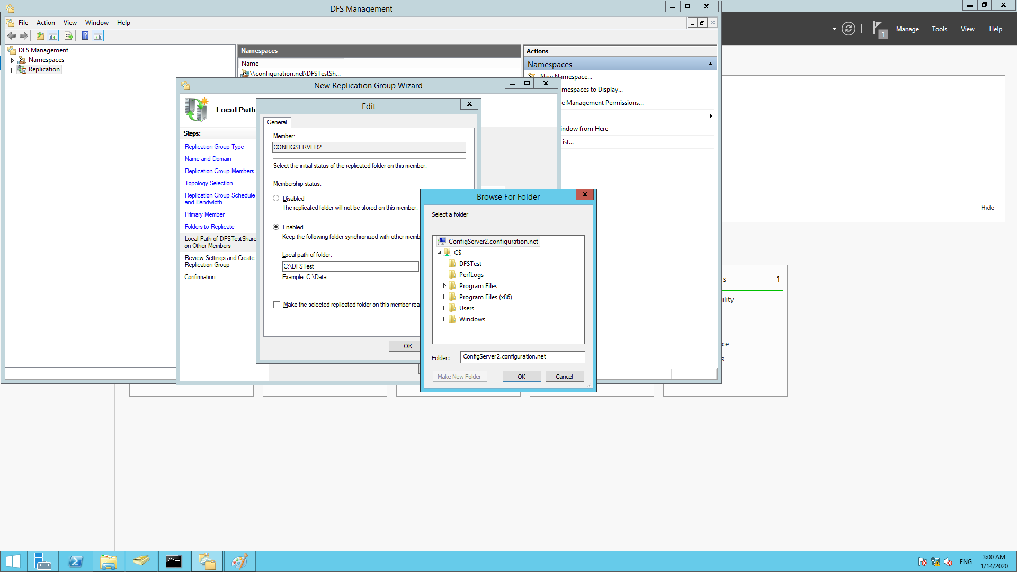

1. View the summary of your selections and click create.

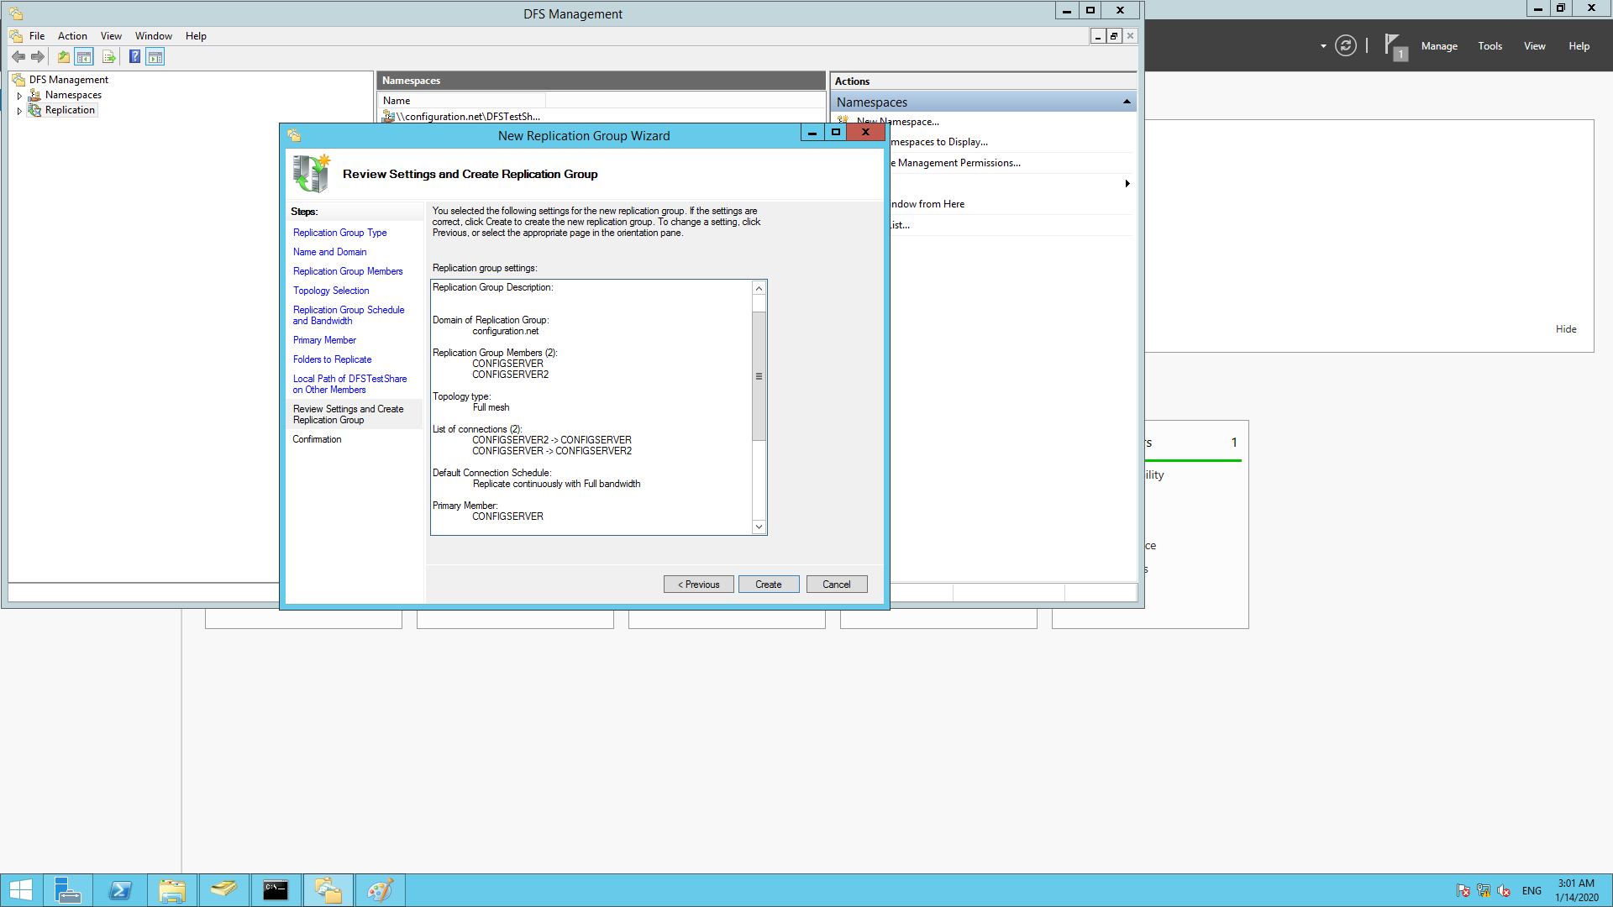

1. In your DFS Management Console, double click on your replication folder and go to the Replicated Folder tab.
2. The publication status will be displayed as "Not Published". Right click on that and select Share and Publish in Namespace.
3. Click next until you get to the Namespace path. Browse to the parent folder and name the folder.
4. A preview of the namespace path will be listed. Click next to view the summary and click on Share.